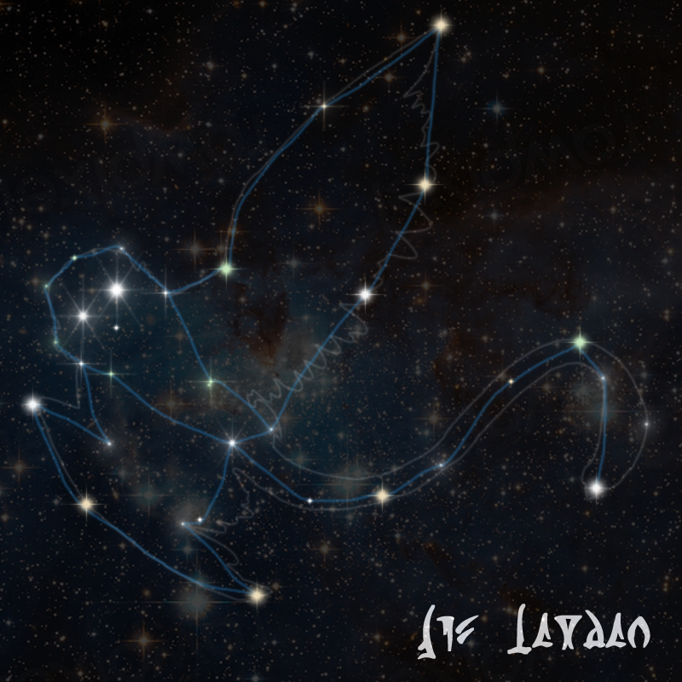

The Convor Constellation

Visible from Wasskah's southern hemisphere, the constellation named for the Trandoshan Bird or Convor includes several other mid-rim stars. The Convor, an avian native to the forest moon of Trandosha in the Kashyyyk system is a species of owl that has a particularly wise look, thanks to its large eyes and long tail. Believed to resonate strongly with spiritual and Force-attuned individuals, the bird was a popular pet and came in several colors of plumage. Wasskah itself is primarily used as a game preserve by hunting guilds of the Trandoshans, although tribal species have survived, generally under the radar for generations, deemed unworthy of the hunt. It is thought that the tribes themselves were initially seed stock for their cruel games, and their willingness to absorb those who survive modern hunts seems to lend credence to that.

The stars of Concord Dawn, Centares and Ossus along the Parmelemian Trade Route make up the constellation's tail, while the bright yet distant stars of Ord Mantell and Vortex are thought of as eyes. Local lore suggests that the folded wing contains most of the inner core as if it is protecting it, while pointing to the edge of the galaxy with an outstretched wing as if beckoning those to explore the universe. Old legends and mythology whispered of the Mother Convor as a matronly deity to all those who survived the endless hunts of the Trandoshans, hoping to steal one of their ships and escape the cruelty of the place. The tribal legends also say that she placed herself up among those distant lights as a way to show them the way to places that had yet to be mapped or discovered. To this day, members of those tribes on Wasskah will sometimes carry a hand carved talisman with the Convor constellation inscribed on it as a lucky charm.

