Name: Suit Medical Injector
Universe: Deadspace
Rarity: Uncommon Armour Enhancement or Equipment
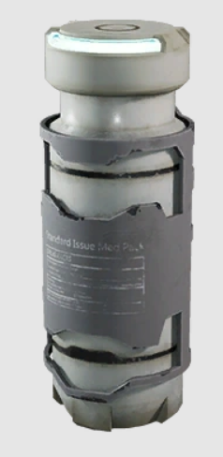
Description: The suit injector uses a manufactured chemical known as Somatic Gel to heal the body of injuries rapidly. Often used by those allergic to Bacta, the injector slots into a modified port on an existing suit of armour and is triggered by a command in the armour, usually bound either to a certain hand motion or blink click within a visor. It is strong enough to heal a single serious injury such as a gaping wound or a fractured bone, but cannot heal dismemberment or a full break of a bone.
Justification: It’s small, it fills a niche (our current med kit is three use only heals minor injuries this does 1 more serious). We also don’t have a lot of armour enhancements at the moment, having some of the more expensive suits have slots like vehicles would be cool.
Shop: Antares Consolidated Armorers

