[Ziost] Regular Forces Advertising Campaign:

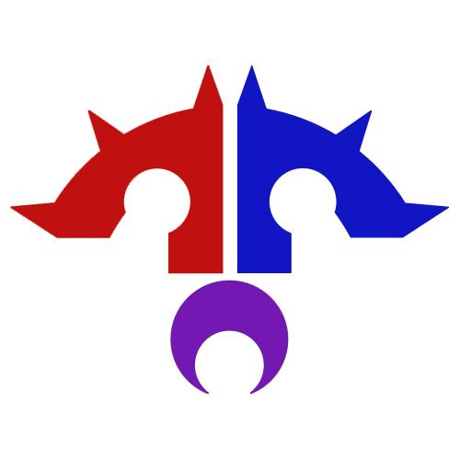

Contents

Introduction:
Plan:
Conclusion:
Participants:

Introduction:

In this report our team will attempt to put across ideas to you that demonstrate examples of advertisement that the Dark Jedi Brotherhood will be able to use in its Advertising campaign to attract new members. We have included a two part plan below with two different ideas. The second part of the plan involves examples written by our own team that should enable you to get an idea of what we are looking at.

Plan:

The first part of our team’s plan is to create a series of PSAs that will be sent out across several social media websites, Facebook/Twitter/Etc. The images themselves will be iconic pictures and posters but with variants placed upon them and links to the Brotherhood’s website.

The reason for the iconic images is because we want to draw the eye of the people. They see an iconic image they investigate and then upon reading a bit about it they could get interested and find themselves drawn to the DJB.

In order to not infringe upon Fair Usage and Copyrighted material, we plan to use talented artists in the DJB to create our own images in the style of the iconic posters. As an example of what we mean please see the image below:

The fundamental idea behind the campaign is a simplistic bait and hook tactic. The target readers are unfamiliar with our specific setting and characters, so if we make advertisements with images of our past Grand Masters, for instance, readers might be disinterested. So, we draw them in with images that they recognize and are already interested in. This is the bait. Once we get them interested enough to visit the DJB website, we can expose them to our wonderful unique lore and organization, which they will then fall in love with. That is the hook.

Steps to produce this idea are fairly simple:

- First we find iconic images associated with the Star Wars brand and modify them. One way this could be done would be to modifying existing images in our database to resemble iconic Star Wars posters. Eventually we would switch to more unique content.

- Then we overlay these new images we have created with a link to the main page of the DJB, to direct the reader to our site. We want to use as few actual words as possible as not to distract reads from the iconic imagery itself and make the link to the DB website more visible.

- The last part of this plan will be to disseminate these images on various social networking sites such as Facebook and twitter. We would schedule to release these images at regular intervals in order to garner a larger following and increase awareness of our organization.

Another stage to this plan that could be added is what we have called, “Bob the DJK”. This part would use some of the linking banners we would post places to take people to youtube videos. The videos would show things like DJB guild Ops runs, or Flashpoints. It could have commentary from the participating members and at the end of each video would be a google hangouts style group interview with the participating members, during the interview the member’s Dossier and Character sheet could be shown, as well as any TOR characters they have in the guild. These videos can also show that the Brotherhood isn't just about gaming and that a large fictional element does exist within its confines, existing members could explain this at some point during the game commentary.

The “Bob the DJK” campaign would help to show potential members that we aren’t just a bunch of random people in a TOR guild, it will show them that in the Brotherhood you will actually get to know the members that you operate alongside. Another potential to this piece is that different Clans and Houses can be showcased in each video. A video could be put together showcasing the Journeyman, to show potential new members that even the lowest ranked people are able to join right into the party and have just as much fun as any of the elders.

Below are four examples of what we call the “Bob The DJK” plan:

“Hi.
I live in Texas.
I am 27 years old and have been a huge Star Wars fan for 15 years.
As an artist and aspiring author, imagination is a huge part of my life, and as an adult with high-functioning autism, the support of my friends is something I need in order to achieve my goals. At the Dark Jedi Brotherhood, I found the support I need and even made friends for life within a diverse community of Star Wars and other sci-fi fans.
My name is Fet’ai’narun and I am a Dark Jedi Knight.
cue half-screen with character graphic by Jet
What’s your calling?”

“Well hi there.
I live in Dundee in Bonny Scotland.
I’m 25 years old and have been a fan of Star Wars for what must be about 20 years, having grown up with it with my family.
I’m a computer games development student and being within the DJB I have plenty of time to practice my various coding skills as well as developing my love for reading and writing skills. The brotherhood allows me to develop my social skills as well as my skills at working with others, which is a great help as I aspire to be a teacher. The friends you make are irreplaceable and be you a fan of gaming, writing or just kicking around and being there for people the Brotherhood has a home for you. Be it in the dark, or with our lightside brothers in the other Houses.
My name is Deimos d’Tana, Dark Jedi Knight of Arcona. What’s your calling?”

“Hey there.
I live in Cornwall in the UK.
I am 17 years old and have been a loyal fan of the Star Wars franchise for around 12 years now. I am a music student and session guitarist, I also have a passion for reading and writing fictional stories. The Dark Jedi Brotherhood has given me the confidence to socialise with other Star Wars fans as well as expand on my artistic and writing skills. I can now play with other people on some of my favourite games, getting rewarded for doing so as well. I have developed a talent for working with others to achieve things that I could never do by myself, whether this be in a small team or a large unit of other Sci-fi fans. The friendships I forged with other people seem infinite and show no signs of breaking. It is definitely a life changing experience.
My name is Kalon Tsucyra Entar, Sith Warrior of Clan Arcona. What’s your calling?”

“Hi.
I live in California.
I’m 40 years old and have been a fan of Star Wars for about 15 years.
I’m a computer programmer/builder. I also have a passion for designing costumes and jewelry. I am naturally a very shy person that tries to keep my life private. Me and my husband joined the Dark Jedi Brotherhood about a year ago as an activity that we both could enjoy. The Dark Jedi Brotherhood has allowed me to develop the confidence to reach out to new people, while working on my social skills. I have been able to try new activities and improve on old ones. I have found other individuals in the Dark Jedi Brotherhood that I can relate to and talk with. I have been able to work on multiple teams to fulfill goals.
My name is Riverche, Dark Jedi Knight of Arcona.
What’s your calling?”

As you can see each blurb is individual to the player. It touches on many things, but generally what the Dark Jedi Brotherhood has done for our players and what it can do for the people. Be it provide them confidence, let them develop skills or just meet new people. The Brotherhood is a family, we need to get this across to people and we need to open ourselves up to them to make them aware that we are just everyday joes like them. I believe a lot of people look at gaming clubs as elitist snobs and they are best to be avoided. While this may be true in some cases I think the “Bob the DJK” idea is very human and down to earth and would be a brilliant way to advertise who we are and what we stand for. The fact it’s tagged onto video footage of our guys having fun in Op’s and FP runs will add to the allure of a fun friendly gaming clan.

Conclusion:

In conclusion we feel that using the bait and hook technique to draw in potential members and appealing to the sense of humanity is the perfect way of advertising the Dark Jedi Brotherhood to the masses. As it stands we have a lot of good and talented people, and using their skills and personal experiences to push through what we are about and what we stand for is the perfect way to advertise us.

Participants:

Deimos d’Tana - 8106
Riverche - 13521
Kalon Tsucyra Entar - 12247
Marrek Gunstinson - 13600
Etah d’Tana - 8075
Fet’ai’narun - 3325
Strategos Thanatos Entar Arconae - 1279

