A proposal discussing how to effectively market the Dark Jedi Brotherhood

Naga Sadow Special Forces Advertising Team:

DP Darth Vexatus (Sith) / PCON / Clan Naga Sadow #188
DA Macron Goura Sadow (Sith) / House Shar Dakhan of Clan Naga Sadow #4856
SWL Malik Sadow (Sith) / CON / Clan Naga Sadow #97
OE Methyas L'eonheart (Obelisk) / RM-Wiki / House Shar Dakhan of Clan Naga Sadow #10901
OT Rosh Nyine (Obelisk) / House Shar Dakhan of Clan Naga Sadow #12671
OE Teu (Obelisk) / LHoJ-QUA-PROF / House Marka Ragnos of Clan Naga Sadow #9811

Stage 1 | We must learn to walk before we run into advertising

1.1 The need to first acknowledge where advertising strategies have failed in the past

The Dark Jedi Brotherhood must first identify what makes it different to the many other Star Wars clubs that exist. This is critical with the growing threat of competition, with the popularity of Star Wars on the rise again thanks to The Old Republic, and very soon the arrival Episode VII.

It takes more to advertise a new cola than the fact it is a beverage and any advertisements trying to market the Dark Brotherhood must emphasise what makes us the real Coca Cola.

This, however, is where the Facebook campaigns attempted in the past have made mistakes.

Frequently, the Dark Brotherhood has tried to sell itself as offering everything: gaming, fiction, and role playing. This has always left target audiences seeing the club as a jack of all trades by failing to focus on any of the club’s actual unique selling points. If you look at any supermarket advert, they do not show you every food item on offer, but focus on the Christmas turkey and what makes their turkey better than all the rest, and this is what the Dark Brotherhood must do.

1.2 The Ten Second Rule

This is no longer the 1990s or even early 2000s and the Dark Brotherhood must contend with far greater competition than ever before. This competition for audiences’ time and attention is a challenge that will not be beaten by naively believing that an audience cares about our club or is even interesting in learning about us. We have to first make them want to find out more.

This is why the very first step is making an entirely new audience want to learn more.

Despite the failures of the Emperor’s Hammer, it was very successful in doing this because it used its Sub Groups to distill its advertising messages and target specific consumers. For example, the TIE Corps had the Unique Selling Point of its vast archive of custom missions.

The Dark Jedi Brotherhood must do the same thing to reach out to entirely new audiences.

Stage 2 | Identification of Unique Selling Points

For all its past advertising mistakes, the Dark Brotherhood has two readily identifiable USPs:

2.1 Multimedia roleplaying

There are many fanfiction communities that write Star Wars stories, such as the fanfiction community on TheForce.net. There are many graphics communities that make Star Wars images, such as individuals on DeviantArt or the Star Wars Artists Guild.

But there are very few that combine these things. In how many places can you write a story and get your own character featured in a comic?

This is a Unique Selling Point. It is something that makes the Dark Brotherhood special.

2.2 An 18-year-old community

There are many Old Republic guilds. There used to be many Jedi Academy guilds. But where a guild is focused on a game and running flashpoints and operations for better gear, the Dark Brotherhood is greater than this. The community it has built has survived for 18 years, venturing into the unknown and creating a rich lore that any member can use and expand upon.

This, again, is a Unique Selling Point. It makes the Dark Brotherhood different.

These are far from the club’s only USPs but they highlight how for a marketing strategy to be successful, it must first be clear about what we offer that other Star Wars clubs do not.

Stage 3 | Creating a marketing brand

3.1 The need for a ‘corporate identity’

Every successful business in the real world has a distinctive brand. McDonalds is known all over the world for its golden arches. Most companies will also have a phrase or slogan that is used in conjunction with their logo on all advertisements to build awareness. The ‘i’m lovin’ it’ motto at the beginning of this document with the Lion of Tarthos logo is again from McDonalds as an example.

This is something the Dark Jedi Brotherhood has always lacked.

On first loading www.darkjedibrotherhood.com one is not greeted with any form of consistent identity. In the top left, the words Dark Brotherhood are written not as advertising but as part of the drop down menus for navigation. In the centre, the phrase Dark Jedi Brotherhood -- now with the word Jedi added -- forms an animated image that is not found anywhere else, and which is not designed to be easily transcribed atop any other image or video. In addition, it is notable that even this logo is not made to leap out at the viewer but blends into the background.

Furthermore, there is no sign of any consistent logo, such as the Star of Antei that might have once been found on the front page of the old Codex, or in the DJBWiki timeline stamps.

Therefore before any final advertisements can be made, it will first be necessary to design a clear, consistent brand identity. This can be recreated and used on posters, T-shirts, YouTube videos, websites, and everywhere else that we plan to market ourselves.

3.2 Less is more: why the brand must be kept simple
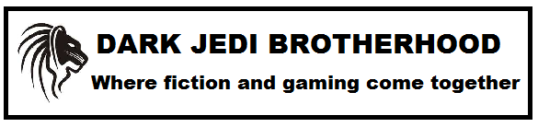
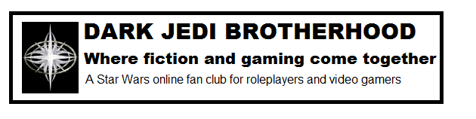
The above images are for example purposes and not intended for use. There is a need for an actual graphics artist to create a professional image, and a team to come up with an agreed slogan. The images have been included to demonstrate how the Dark Brotherhood at present lacks any kind of comparable marketing identity that could be easily replicated.

In addition, the images highlight the difficult line that must be balanced:

Image 1: In the first image, the reader quickly takes in the whole image.
Image 2: It is again easy for the reader to take in the image, but the existing Star of Antei image does not yet have the same brand distinctiveness of the more original Lion of Tarthos.
Image 3: In the third image, more detailed information is offered, but the eye quickly wanders.

This is the dilemma faced by the Dark Brotherhood in any advertisements: it must create a unique identity that is easily relatable and not generic. The Lion of Tarthos has been used here as an example and it is not being suggested here as an actual logo for the club; and it must succeed in selling its image without asking more of its audience than absolutely necessary. This is something that the third image fails at by trying to include too much information.

This is where it is necessary to acknowledge that the phrase “Dark Jedi Brotherhood” already establishes that it is a Star Wars club with the word ‘Jedi’. This is why the shorter, concise wording of the first image is far preferable to the three lines on the third image, because the advertisement itself is what will establish what the Dark Brotherhood is. This is illustrated if one compares the first image above with the advertising image used by the Tesco supermarket:

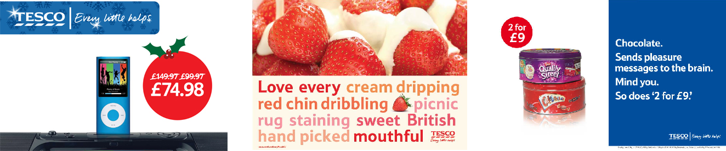

In all three of the above advertisements, the viewer is targeted with a specific product. What unites all three, however, is the brand identity that is found somewhere on all three. This is what the Dark Brotherhood has consistently failed to deploy in any of its past campaigns and serves to demonstrate what the first step must be before even beginning to create any adverts.

Stage 4 | The Impact after the Advert

4.1 The lack of a welcome page
It is not enough to simply come up with the best advert in the world. It is of no use if we get people into an advert, thinking that it is exciting, only to then have all our efforts fall at the last hurdle because we failed to land the deal. With this in mind, the Dark Brotherhood needs a proper welcome page that gives people an idea what the club is about. At present, when they come to the website the first time, they are met with random reports or news posts that in most cases would confuse people. Even the Join button is not prominent for members not logged in.
One thing to add to the welcome page would be a link to the ‘About the Dark Jedi Brotherhood’ page and a link to the comics list. Despite the welcome page being central to recruitment, and the comics list a Unique Selling Point that has already been acknowledged in Dark Council reports, at present both of those sites are hidden away in a submenu instead of being easily found by people visiting the page for the first time.
This is therefore a major hole in any recruitment strategy that needs to be sealed.
On that note the ‘About the DJB’ page itself is in urgent need of an overhaul. The pictures are from the old site and the character sheet examples are the old character sheets. This at present means that the recent improvements are not being used where they are most beneficial: to sell the website to new visitors in order to increase the number of visitors that choose to then join.
4.2 Targeted welcome pages
Due to the current front page being more for the existing membership, it would be beneficial to make the redesigned welcome page the default you go to if you’re not logged into the DJB site.
We could even have different welcome pages depending on who you’ve aimed a specific advertising campaign at, so one aimed at writers would send them to a welcome page highlighting the fictional aspects of the club, while a campaign aimed at gamers would send them to a welcome page highlighting the gaming aspect of the club.
We could also take it a step further and create different welcome pages for each unit, where if a member clicks the join button on that they will be placed in that unit. It would give the units an added incentive to do their own recruiting as well as what the club will be doing as a whole.

Stage 5 | Reaching out to more than one audience

We are not just a collective roleplaying club. Our members do far more than that. Among the Brotherhood are artists, writers, gamers, role-playing gamers, poets, code-writers, and much more. We collectively need as a group to reach out to these different and diverse groups. As much as we have to offer them, they have to offer us as active members.

In order to achieve this, we must learn from the marketing examples already discussed. As the Tesco advertisements above demonstrate, it is worthless to talk about pork pies when you want to get someone’s juices salivating about strawberries and cream. The same is true with our advertisements to gamers who are unlikely to be seduced into joining our club because of the Antei Combat Center, and vice versa the other way around. It is therefore necessary to accept that all advertising must exercise a certain degree of recruitment ‘triage’ in respect of ensuring that we recruit someone instead of aiming too high and consequently recruiting no one.

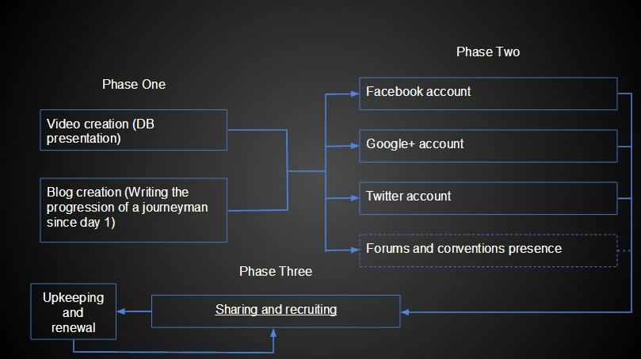

Phase One

- Video creation
An older example:
http://youtu.be/JZ2CdQ6EEC4
- Blog creation
An older example:
http://archive.bebo.com/Profile.jsp?MemberId=6770253676&ShowSims=Y

Phase Two

- Facebook account and how to share
  - In terms of a social media presence, Facebook allows the creation of specialised profiles which are specifically designed for groups, organizations, products and companies to reach out and connect with their fans and followers. These simple accounts are typically created and administered by existing users and can have a group of administrators, ideally our recruitment team, which can post to this profile and respond to posts as though they were the profile itself. Many organizations already do this with much success and create a deeper relationship with their users, fans and followers by allowing them to post to the group ideas, comments or simply fan art and the like. This relationship is also especially seen in a rapid response from the page’s administrators or even members of the page who can help. It allows for a broader point of contact for people who are not already part of the Dark Jedi Brotherhood and may want some way to ask questions without needing IRC or to locate a means of contact (of which none presently exists).
- Google+ account and how to share
(description on Google+ account name, benefits of circles, sharing information as in Facebook)
- Twitter account and how to share
  - In terms of social media, Twitter is ideal for those with a short attention span or people who want to get short and sweet updates throughout the day. In terms of our usage in recruitment and establishing an identity for the Dark Jedi Brotherhood, Twitter allows us to get out small bits of news or even updates to our members without need to place it on the main page or even to supplement it by informing followers of our Twitter account that something new has been uploaded to the site’s main page. Unlike Facebook, which can be used for larger posts and updates, Twitter can be updated more frequently as reminders of what is ongoing within the Brotherhood. A perfect example would be the Crusade; at present we have a countdown timer on the site itself for users which are logged in for them to know when the Crusade is over. This is a feature which can also be applied to Twitter every hour or even every couple of hours so that people can be aware of when their deadline is. As an added bonus, this can help keep all of our members, regardless of physical location and time zone, to know when a deadline is.
  - Applying hash tags to tweets to share information would also be useful. Tags such as #darkjedibrotherhood and #DJB are examples. Relevant accounts could be followed by Brotherhood recruiters so that potential new members would notice and become interested. Tweets should be done with the same frequency as the Facebook updates discussed earlier.
- Forums and conventions presence
  - Registering on important Star wars forums, like the Old Republic Forums is also important. Then links to items from Phase One could be shared in order to entice new recruits. once per month at maximum should be enough without causing issues on the forum boards. As well, Brotherhood members who can go to conventions and represent the club are one of the best ways to get our presence out there. This has been done in the past to some degree and was highly effective at Dragon Con in the United States.

Stage 6 | Conclusion

As with the earlier examples in this proposal, the discussions of the various social media and avenues that we can – and must – pursue to maximise the reach of our recruitment have been included here to serve as examples and it is accepted are not in any way near their final form.

After all, as previously acknowledged, until the Dark Brotherhood has made clear what its USPs and its recruitment ‘identity’ and ‘message’ are, it is impossible to begin making final adverts.

However, it is hoped that this proposal has illustrated where – and why – the Dark Brotherhood must urgently address the fundamental failings of its previous recruitment attempts, and shown that successful advertising is not in fact difficult, but largely a matter of ensuring that one gets the foundations in place first, before rushing out without a clear marketing strategy in place first, or ensuring that the website itself is made welcoming to visitors to avoid failing at the last step.

