SW Kz’set #13299
OE Tra’an Reith #9059
KP Arturis Schulen #6643

Propaganda Proposal

“Branding is about everything.”
― Tom Peters, The Little Big Things: 163 Ways to Pursue EXCELLENCE

At the heart of any successful product, service, company, or organization is having a clear and established brand. A good brand needs to be distinct, clear, and defined. Without a clear brand identity, any promotional campaign is doomed to failure. Any campaign needs to be focused on establishing and building a brand for the product or company, and the Dark Jedi Brotherhood is no different. Hence the first step in any successful advertising campaign for the Brotherhood will be establishing a defined brand identity for the organization We need to be clear what we’re about, what we stand for, and what we’re going to do in the future and be able to articulate that clearly to prospective members.

At the present time, though strides have been made, the Brotherhood presents a very muddled brand. We do a number of different things at the same time and while that’s good to create a fun and inviting atmosphere, at the same time it presents a challenge when it comes to promoting the organization. If presented incorrectly, the organization can look one sided. A person looking for a writing group might only see the gaming side of the group if they are presented with the wrong information. A gamer might only see the writing side of the group if left to their own devices. An artist might not see that aspect of the club at all without the right guidance. In order to appeal to the broadest base of people possible, we must present all the facets of the Brotherhood in a clear, concise, and easy way.

In this proposal we intend to show ways that the Brotherhood and define its brand far more than it is now, discuss ways of presenting that brand, and how to incorporate it into existing and potential marketing platforms in a way that requires minimal resource investment compared to the potential return.

"Your message is like your song, and you have to let it be heard. Believe in it, share it, and eventually, it becomes a natural part of your communication."
-Terri Sjodin, Small Message, Big Impact

Key to establishing a brand image, be it for a product or organization is messaging, specifically that of the first impression you make on a prospective customer or member. That first impression needs to be both distinct and memorable. It must hit on all the key aspects of your brand in a succinct manner while at the same time not being rote and boring. The message also has to be consistent across all marketing platforms from referral marketing (which we’ll go into later) to the website to social media. We must know it, share it, and believe in it.

One particularly popular technique taught to those in the business of outside sales is delivering a pitch known as an elevator speech. This is usually a short but clear statement of what a company or organization does designed to be delivered in a very short time period. While I doubt we doing much promotion in elevators, though it’s something to be considered for those who attend conventions (and don’t pass out from the funk), the concept is something that could be applied in other forms of marketing. It could be delivered in all sorts of forms from forum and IRC topics, to text or audio placed on the website, to YouTube and social media. The important part of the exercise is coming up with concise statement of what the Brotherhood is about. An example is included below as well as in the included audio file.

The Dark Jedi Brotherhood is a fan focused multi-layer story. Like a game, you can become anything you want to be if you're willing to earn it. Your character can become the evil Sith or the benevolent Jedi, if you're willing to learn how. Like all other forms of power, they come with time and advancement. With the creation of, iteration upon, and further development of your character, anything is possible in time.

The system has objectives, with referees to guide you and help you succeed, and to ensure that you play by the rules. With multiple units to choose from, you are free to craft an identity that fits within the organization and defines both yourself as well as your unit.

There are multiple paths of growth and power, and all skill sets can be used to get there from writing to gaming, or even various other ways of advancement. With time and dedication, your character will grow and evolve and unlock new and exciting abilities, clothing, and more that will be at your disposal.

With a dynamic development system, you are free to create a compelling backstory from over 34 races in the ever growing Star Wars Universe. With an ever growing archive of knowledge and new adventures, the possibilities are almost infinite.
(Link if non-functional: Voiceover)

As you can see this message puts out all the key selling points of the Brotherhood in a clear and succinct manner. It’s something that could be shortened for quicker pitches like the traditional elevator speech or similar in-person and online scenarios where time (or space) is an issue. It can also be expanded for situations where time isn’t an issue, such as on the website.

Sometimes though, words and sound alone don't quite get the message across. We have also prepared a multimedia presentation that uses the speech above. This could be deployed in a number of forms including at live panels, on the website, or via social media. For maximum effect, this should be played along with the audio above.

(Link if non-functional: Presentation )
"If you do build a great experience, customers tell each other about that. Word of mouth is very powerful."
- Jeff Bezos
Generally the best form of marketing for organizations like the Brotherhood is word of mouth and referral marketing. Members referred by other members tend to be more active and stay in greater percentages than those who stumble across the organization by other means. While we need to explore other ways of getting the word out about the Brotherhood, we need to remain focused on what has proven most effective historically. Another benefit to remaining focused on this sort of advertising is that it is free, requires minimal resources, and is not fraught with the intellectual property dangers that other forms advertising (most especially merchandising) can present. The branding and messaging ideas discussed in this proposal are an important part of how we can build on our success when it comes to word of mouth and referral marketing.
One problem that seems to extend beyond us personally is the fact that, at present, it's rather difficult to explain what the Brotherhood is about to a prospective member. The message can also vary from member to member based on their experiences, interests, and personal biases. While tailoring a message to a prospective member based on what they might be interested in, it would also be helpful to provide, and encourage the use of, a consistant, streamlined statement that will accurately reflect the Brotherhood. This might require devising different messaging statements that can be delivered to different segments of members, but should all be reviewed to ensure accuracy. They should also set reasonable expectations as to what the Brotherhood does and doesn't do. Many potential and new members have been soured because of the creation of expectations that we cannot or do not deliver on. Though this is mostly a member retention issue, the initial messaging can make retention either much easier or much harder depending on how it is approached. And as Mr. Bezos said, ensuring a positive member experience will generate more referrals and strengthen the recommendations being generated by our members. However retention and member experience issues is something that is outside the scope of this proposal.

"Your goal is not to make an image. It’s to make a statement!"
– Tom Asacker
Beyond referral marketing, there are other ways in which we can utilize the branding and messaging ideas mentioned above. One of the most important things we can do with them is use them to revamp our website to make it more informative and attractive to prospective members. The website as it exists now does very little to display what we're about and what we do in the front page, which will be the first thing most prospective members see. There is no succinct statement of what the Brotherhood is or does on the main page, it simply launches into information that's primarily for existing members. Ideally, it would seem that it would be most useful to have a separate landing page for non-members (i.e. a pre sign-in page) that focuses on displaying this information, but that might prevent a coding challenge. What wouldn't be a challenge would be to put something like the messaging statement above in a prominent position the main page. This would allow new visitors to get a quick impression as to what we're about without clicking around first. Another change that needs to be made is that the link to the "About the DJB" page needs to be put directly on the main page instead of buried in a dropdown menu as it is now. An example of what this could look like is included below:
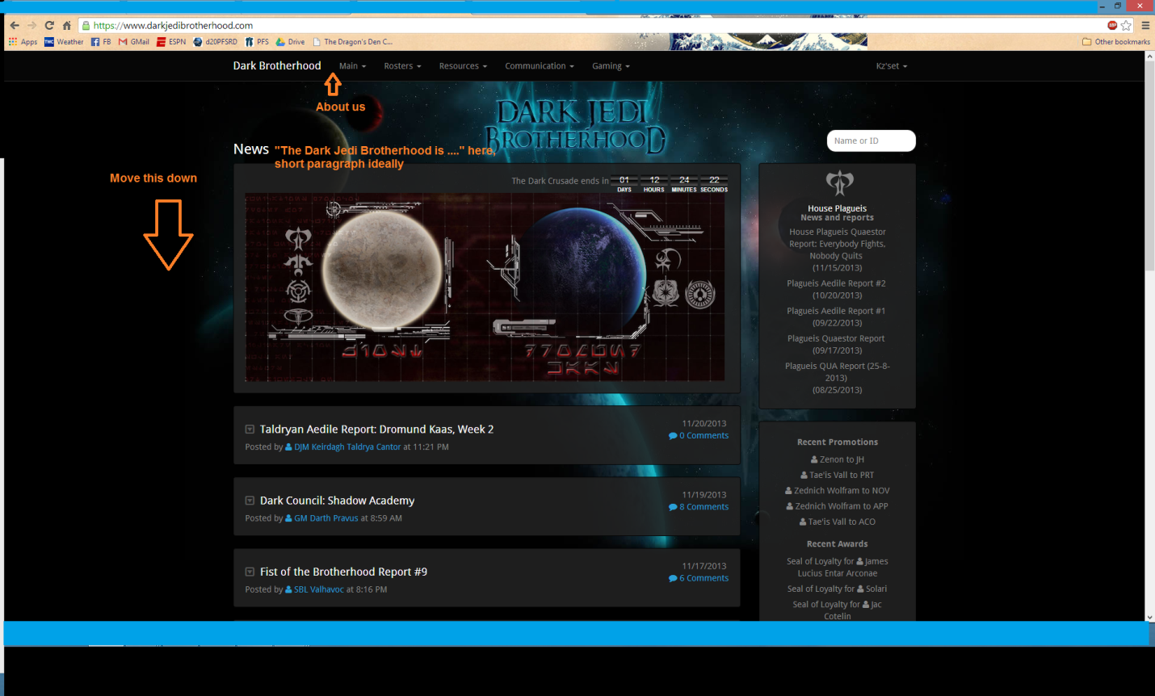While making changes to the main page is crucial to making a statement of our brand, we also need to revamp other parts of the website to make it a more valuable recruitment tool. Specifically we need to take a look at the "About the DJB" page and remake it so it can be of more use to new members. Right now it is a woefully out of date wiki page that talks more about things like robes and lightsabers that what we actually do. The real emphasis of this page needs to be on our activities and less on accessories. It needs to discuss the sorts of gaming we do, the fiction we write, and the other activities we organize so that prospective members can get a clear picture of what we're about.
"Fundamentals make the market."
T. Boone Pickens

When it comes down to it, that is what this proposal is about. Before we can embark on any major advertising or marketing campaign, we need to focus on some basic fundamentals of branding and messaging. Without locking these things down, any other campaign is just throwing something online and hoping it drives traffic. But driving traffic to our website means nothing if we can't sell people once they're there.

Thank you for your time.

