Nightstalk

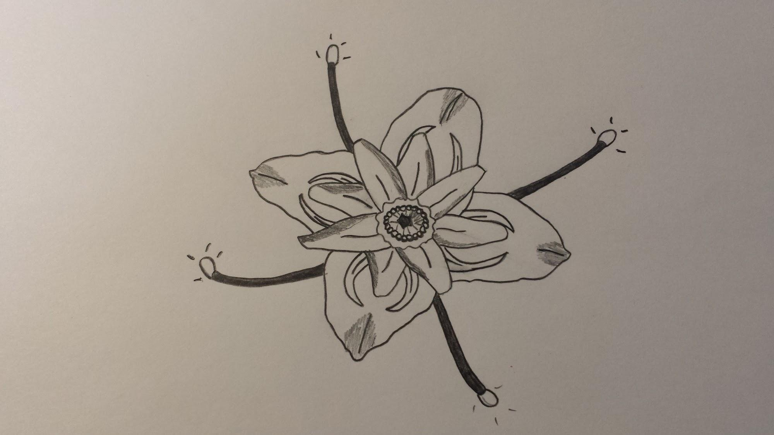

The Nightstalk is a flower budding plant that is reported to be located on the planet Baldavia. Typically only seen opened during the late night hours of the day, the plant is usually of vibrant color with mixes of purples, blues and greens with the center pod being red in color, ringed with small yellow seeds. The pincer design on it’s outer leaves are a defense mechanism to ward off predators seeking its seeds for sustenance through visual threat as well as emitting a foul odor.

During the day hours, the petals fold up and encase the seeds and pod center as the plant sinks further into the ground to keep from getting too much sunlight. The only thing seen protruding from the ground would be the very tip of the exterior petals and the stalks, to which the plant gets it’s name. During the day, the stalks take in as much sunlight as possible to feed the plant. During the night, the tips of the stalks glow a brilliant white hue.

It is said that when the stalk tips are glowing, they excrete an oil like substance that boosts the immune system of anything that consumes it. Even fewer people know that if you are able to find one of these plants, taking a few of the seeds, grinding them into a powder then adding the oil from the stalks creates a paste sweet to the tongue and soothing to the body.

