Children of Sin - Deimos d’Tana

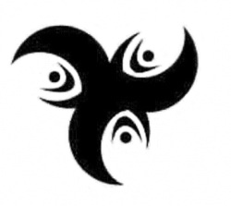

As darkness falls and the night drifts in,
We come for you we know your sin.

We are the hidden blade,
The tightening noose,
The spectre that stalks you,
The nightmare let loose.

For as Darkness falls and Night drifts in,
Shadow Gate comes for you oh Children of Sin.

