Instead of making a new character to be a stripper, I said, “What if Saronyx wasn’t a secret agent?” So, here she is stripping.

Stripper name: Purple Diamond
Birth name: Saronyx
Race: Twi’lek
Height: about 1.9 meters
Weight: about 160 lbs.
Physical description: Her brown eyes compliment her purple skin. As a rather average Twi’lek, her physical qualities are like others of her race.
Brief backstory: As a kid, Saronyx’s parents trained her to be a secret agent. She didn’t like being forced into a career. As she was visiting a cantina one day, she asked about being a stripper; she has worked there happily ever since. Whether she works there out of rebellion or pure enjoyment, only she knows.
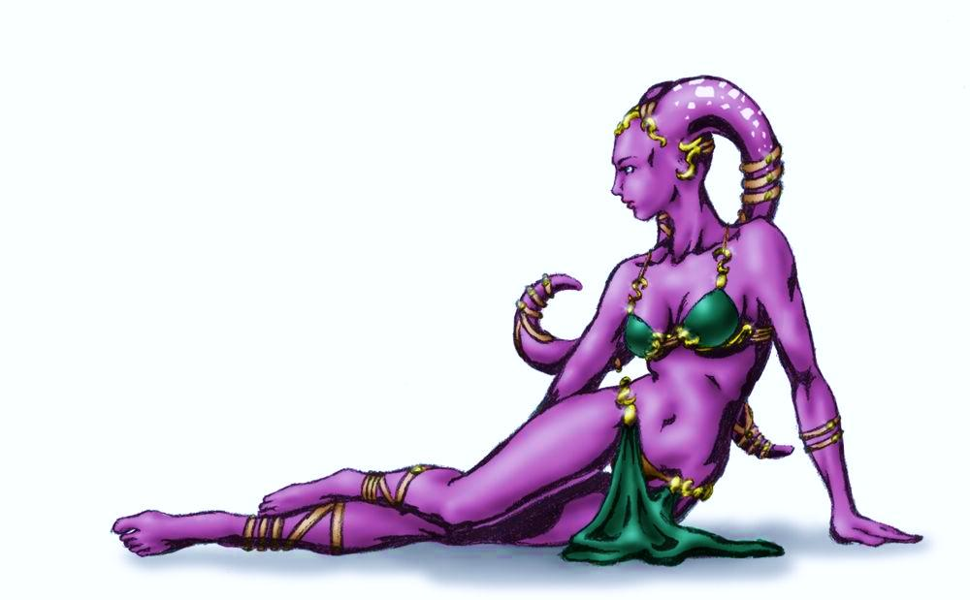
“Come at me, bro.” Saronyx winks.

