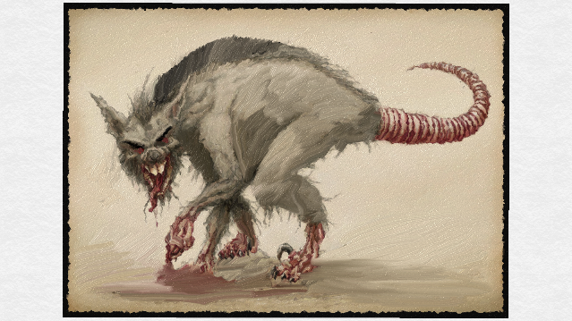

Name: Rattus Sanguinus
Designation: Non-Sentient
Classification: Rodent, Mammal
Skin: White
Hair: Black
Eyes: Red
Distinction(s): Ridged spine (dorsal-like)
Homeworld: Nintura, Jusadih System
Habitat: Underworld, Sewers
Diet: Omnivore

Overview

The 'Blood Rat' is a long-range scavenger residing on the planet of Nintura. Distinguished by a ridged back dorsal fin that exudes from their black hair, this species of rat is known for tracking the smell of blood. Possessed of a keen sense of smell, they are known to be able sense poisons, toxins, landmines and a multitude of other things; should they be trained to do so. After the fall of Nintura, during the Yuuzhan Vong Invasion, these rats were released onto the planet. Originally designed to assist in long-term cleanup by through biological waste management, these scavengers took an ill-fated turn towards unmanageable pest. Driven to a frenzy by the smell of blood, packs of rats were known to swarm larger prey that had drawn open blood. In 35 ABY, they took down a group of children whom had accidentally cut themselves during an attempt to salvage recyclable metals.

Origin

A simple rodent from Corellia, the scavenge rat was collected along with several native species. These creatures were brought to a remote orbital station located above the planet Morroth in the Jusadih System - the dominion of Clan Plagueis. Originally led by renowned Sith Alchemist Macron, the group of researchers attempted to create life capable of surviving on Vong terra-formed worlds. In an attempt to splice together favorable traits, the once seemingly prosperous experiments took an ill-fated turn. Macron nefariously began to experiment in secret on smaller animals; infusing them with new, dangerous traits that went undocumented. One such experiment was the combination of traits from the common Corellian rat and the Corellian Dire-cat; creating a blood thirsty rat.

Unknowing of these secret transformations, Braecen Kaeth turned the rats and several other species loose upon the world of Nintura. Each of the original animals were marked with trackers. At first, the experiment was applauded for the success rate of the animals and their hardy nature. Even as the Plagueis natives walked the streets of their cities they could not believe the marked difference. It was quieter, less vermin, and seemingly cleaner. Excited by the success, Braecen introduced more and more of the altered animals onto the planet; forcing their existence into will with a single-minded need to eradicate the taint of Vong terraforming.

Unexpected Results

The first reports of disappearances did not create alarm. It was not uncommon, in these days, for people to fall victim to the new biology of the planet. It was not until a pair of children cut themselves, while collecting scrap metal, that fear began to rise. The children's exposed wounds were smelt by a pack of the blood driven rats. At first the children thought the appearance of the rats was innocent; even feeding several of them from their personal rations. As more and more rats began to appear the children grew frightened and began to head back towards the center of town. Eager to chase, the rats, gathering in a swarm, began to overrun the children. Tearing at the wounds and drawing more blood, the children were soon knocked to the ground and torn to pieces.

Witnesses were mortified by the seemingly freak accident. This prompted Braecen to review the work of the Sith Alchemist and discover his deceit. Immediately, Braecen went to work augmenting the gene of the rat to render it sterile. He introduced this new rat into the population hoping that over time it may halt the rapid spread & bring about the eventual demise of the species. While the rats are defenseless alone or in small numbers, their greatest power comes from their ability to swarm at the scent of blood. Where sheer numbers outweigh the advantage that one individual may possess.

It is rumored that Journeymen of Plagueis, aware of the rat's attraction to blood, have led weaker rivals to the surface of Nintura. Once on the planet, they cut the rival several times - individually or as a group - and abandon them to the blood rat's hunger. Evidence of these reports could not be confirmed as the remains have never been found.

DA Braecen Kaeth (4520)

