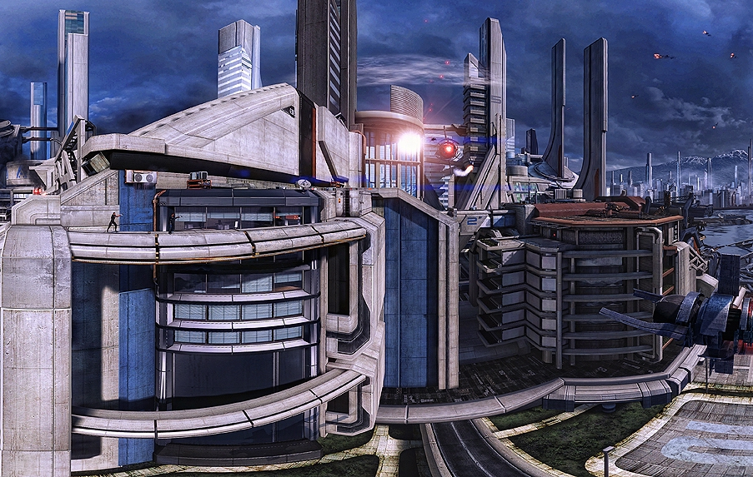

Hyperdyne's Corporate Headquarters

Image sourced from: http://riot23.deviantart.com/art/Mass-Effect-3-Attack-On-Earth-II-289180756
Currently hosted at: http://i220.photobucket.com/albums/dd223/dagent145/HyperdyneIndustries2_zps658f75e2.jpg

==Corporate Headquarters==

Hyperdyne began occupying its current corporate headquarters in 31 ABY after moving from a smaller structure adjacent to Cadinith’s main spaceport. The current building is a multipurpose complex consisting of several interconnected structures housed around a central courtyard. Most public areas are opulently decorated and impeccably maintained as Corvin Zexx is known to flaunt his and his company’s wealth. Other areas are more spartan and utilitarian in their design and appearance. The most important areas of the complex are the Administrative Tower, R&D Wing, and the Fabrication Center. Other areas of the complex house various support facilities, recreational areas, and storage and warehouse space.
<<< (Image sourced from: http://riot23.deviantart.com/art/Mass-Effect-2-Panorama-II-166963495)
(Image hosted at: http://i220.photobucket.com/albums/dd223/dagent145/885f5e74-1aaf-49fa-a08c-5152d40aff77_zps6ca1d229.jpg)
The Administrative Tower's Atrium

===Administrative Tower===

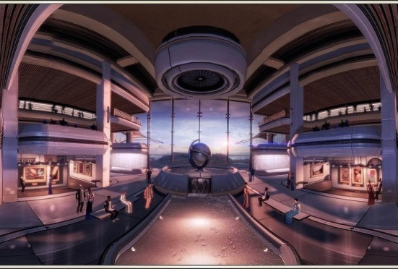
The largest structure in the complex is a thirty story office tower constructed of durasteel and featuring large windows on either side. At the tower's base is a three story atrium featuring a large fountain and polished floors made of exotic stone. Flanking the fountain are a pair of galleries, one featuring some of Zexx's galaxy spanning personal art collection, the other displaying artistic renditions of several of the company's designs, particularly those for starship interiors and aesthetic enchantments. The second level of the atrium is dominated by the two largest conference rooms in the building. Both are opulently decorated with the finest furniture and are outfitted with massive holotables for business meetings and presentations.

The levels immediately above the atrium house the main administrative offices for the company. Functions such as payroll, labor resources, and other management functions. These spaces are comfortable, but lack the luxury of the public spaces below. The next several floors contain laboratory space, primarily for metallurgical analysis and quality control of electronic components. The upper levels of the tower are occupied by lavish executive office spaces. Atypical of many such arrangements, the President's office is not on the top floor but rather on the lowest floor of the executive suite. This is the case due to Zexx having a mild fear of heights and even occasional bouts of vertigo at great heights. The building's roof contains a landing pad capable of handling a Lambda-class shuttle.

===Research and Development Wing===

Hyperdyne's primary research facility is located across the courtyard from the Administrative Tower and adjacent to the Fabrication Center. Security is tight in this area and access is limited to only a handful of entrances. Inside, the building is purposely laid out in a maze like fashion in order to make it more difficult for unauthorized personnel to find sensitive areas. While the labs can support all research to support all of Hyperdyne's varied product lines, the largest and best funded labs in the wing are devoted to starship internal electronics and computer components. Due to the demands placed on the researchers, this is the only part of the HQ complex to host dedicated employee housing.

===Fabrication Center===

While Hyperdyne's primary manufacturing facility is located off-site, the HQ complex contains a small, mostly automated factory. The Fabrication Center focuses on smaller components, ship furnishings, and electronics. For employee safety, no manufacturing involving hazardous or explosive materials is performed in this facility. The facility will also assist the R&D labs with prototyping on an as needed basis.

