Design our ACC venue.

The Library of Lears.

Within the grounds of Taldryan, there is a temple, devoted to the written word.
It holds volumes untold and tomes unnumbered within its massive walls.
The building is partially cut out of the rock face of a cliff, overlooking a large ocean.

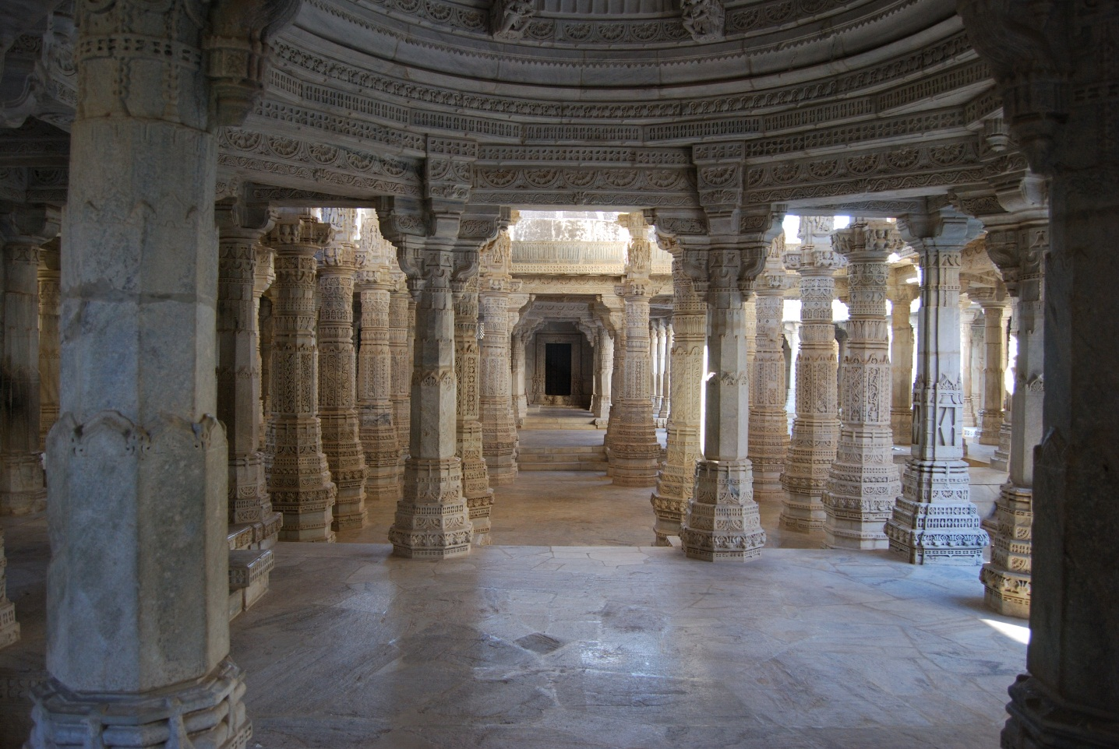

The thousand pillars that stand in the hallways and the flights of stairs that run up and down, are not only an architectural marvel to behold, but also make excellent defensive positions, should the Library ever be assaulted.

When walking these halls, you can smell the blood of history in its stones. All the knowledge you could ever want, can be found here. But tread with care! Some secrets are best left uncovered…

KP Lokasena Corvinus
#7384

