Oricon Kobold

A later creation of Darth Vitus’ research into Sith Alchemy, specifically the areas pertaining to genetic manipulation through the Dark Side of the Force, this is suspected to be an altered form of a small indigenous lizard. Quite literally bred to be single-minded servants and guardians of Darth Vitus’ compound on Oricon, these creatures continue to maintain the compound to this day.
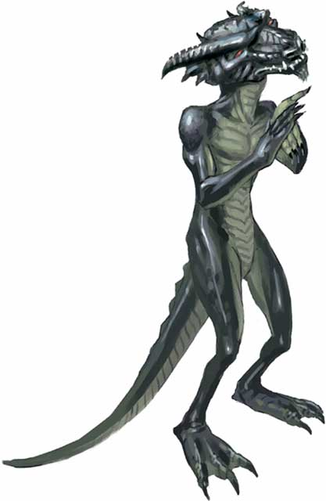
Appearance:
The creature appears to be a bipedal humanoid lizard about 2ft tall with a tail roughly the same length as its body. It has clawed hands and feet, with four digits including a thumb for hands and three digits for feet.
It has a greyish black hide, and a greyish green underbelly, with skin rather than scales. Its head is boney and wedge shaped with prominent bone ridges leading to horns on the back of its head, with solid red, pupil-less eyes. A visible canine tooth protrudes outside a closed jaw, with molars in the back of the jaw.
Please note, this appearance is its standard form, however this vastly randomizes upon injury.

Diet:
While fully capable of being an omnivore, with both canines and molars, the creature seems to mostly subsist upon a bland, nutrient-rich food paste, distributed from dispensers located throughout the research facility. As there are more of the creatures used to gather the biomass necessary for this paste, the supply seems endless.
However it should also be noted that, these creatures have often been witnessed eating anything they kill.

Characteristics:
To say that this creature is genetically unstable is the equivalent of saying that the Death Star is a firecracker. It is so unstable in fact that its tissues would quickly necrotize without a constant connection to the Force. Yet because of this alarming instability, it is potentially one of the most dangerous creatures, inhabiting Darth Vitus’ research complex.
As long as the creature’s tissues are undisturbed or suffer only minor trauma, they seem to be able to draw on the Force to continuously replicate, healing any scratches and making it immune from aging.
However, all this changes should the tissues suffer trauma, severe enough to disrupt a delicate equilibrium between the creature’s precarious genetics and the Force maintaining that balance. Any major trauma triggers an explosion of seemingly random genetic changes, healing the trauma and going even further to trigger an offensive evolution. An example of this can be observed upon cutting off an appendage; the wound would instantly heal over with a bulbous growth for a few seconds, after which, said growth would split apart, and out would emerge a new appendage featuring any number of traits, from acidic venom to razor sharp blades or claws. These offensive changes seem to be directed by the Dark Side of the Force, as they are always something with enhanced lethality.
This makes these creatures difficult to classify as anything other than a shape shifter, as no two injuries have ever been observed to yield the same result. While there are similar results from time to time, they are never exactly the same.
Furthermore, once the threat has been dealt with, the genetic equilibrium seems to reassert itself over time, causing the enhanced features to slowly necrotize and fall off, returning the creature to it’s original, diminutive size, shape and appearance of docility.

Behavior:
From initial observations, the creature appears to be totally docile, going about seemingly assigned tasks with very little interest to any changes in its surroundings, unless those changes affect its tasks. In this sense it is very similar to a simple servant droid, however the only way that was discovered to give or change its commands, is to telepathically link with it and to give it a chronological series of images of the tasks that you wish to assign to it.
It is likely this behavior, which has them performing the endlessly menial tasks and general upkeep of the research complex.
However, should the creatures become enraged or are given a live target, the creature’s behavior will immediately reverse, and will attack said target with reckless abandon, with no regards to self-preservation. Given this creature’s unique characteristics, this lack of self-preservation, proves to be extremely dangerous.
Once it no longer perceives a threat to itself or has eliminated its target, the creature attempts to consume as much of its prey as possible. After which, it will find a dark area, where it will hibernate for a short time, then return to its previously assigned task.

History:
The creature’s origin and method of Alchemy used to create it are known only to Darth Vitus; however he seemed to have used them in the place of maintenance droids, as they were cheaper and easier for him to produce and maintain. To aid in this, Darth Vitus seemed to have tagged each individual creature, assigned that creature a specific set of tasks and completely automated the process of replacing them. As deep within the lower levels of the facility, the machines still function; used to clone and alter the lizards, before being placed into one of the dozen maturation chambers, equipped with devices, capable of imprinting the creatures with their assigned tasks.

KP Altheseus Levathan (4954)

