I’m a what now?

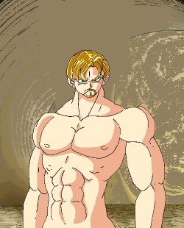Original
Genderbent image.

KP Lokasena Corvinus
#7384

