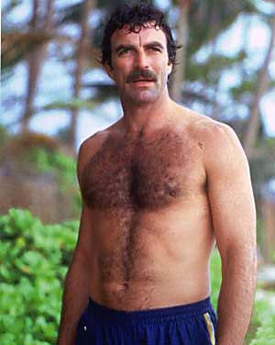
"Watch out for that centipede!"
- Kazmir Natas
Kazmir Natas is tall, handsome, athletic, charismatic, good-natured, and deceptively intelligent. A man with close ties to Taldryan’s Intelligence Service, the Echani kind of bumbles around with little direction or drive, and he can have a dubious work ethic at times. A big sports fan and a natural with hair grooming equipment, he is known as the caretaker of Keirdagh’s glorious beard. He is currently hired on an intern-contract; being put in charge of security of the home.
Specialties:
- Smashball
- Estate Security
- Facial hair grooming

