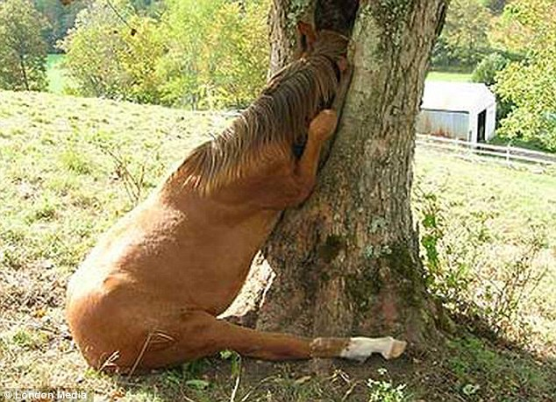

**Now, how do cats deal with this problem?**