Well we all know kaz is the Easter bunny, but how does he deliver all the eggs are the question. Here I will tell you how it happened this year….
Kaz has to make a lot of Easter eggs…. this is how there made.
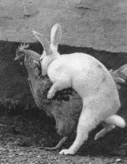
Poor kaz all that work and no play…no wonder he’s always perky, he’s high in Viagra…
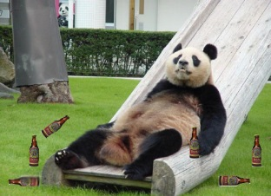
First of all Kaz loads his sack…not that sack you sick individual, get your mind out of the gutter…..then he proceeds to mount his steed. Well he can’t move fast enough on his own, so on his mount he goes, which happens to be a panda named Howie. Unfortunately Howie is drunk this day.

But with no other mount he set off to do his job anyway. Along the way the silly Howie, I mean panda keeps drinking… but first few continents down no drama. but panda is getting quite pissed now…he may have crashed into a wall and knocked himself out
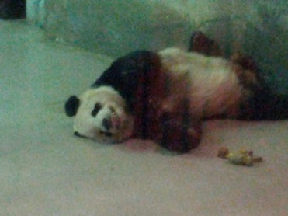
Not hurt in the crash Kaz is distressed at the mess of a panda… but his rage at him now from not being able to deliver his eggs is rising, he did start kicking the panda in his sack…..his grog sack, once again start thinking straight.
Now this rage had not gone unnoticed in the galaxy as rage is a path to the darkside… and who is more badass the the mighty ZOD…..
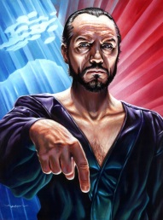
Now this dude is bad ass and went to see this rage that rivalled his own… The ZOD, commander of all, sees Kaz in his rage, kaz sees him and launched some sort of force attack called Kamehameha…….. Hang on, that’s not kaz its Vegeta….(yeah he borrowed gokus attack)
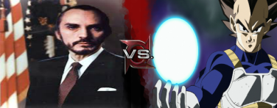
Now the 2 great men battled on and poor kaz paled into comparison as we all know ZOD is the shit, and of course made vegeman his bitch… but poor kaz couldn’t stand in the presence of the mighty ZOD and withered away….. Some ambulance found him and that’s how he really ended up in hospital.. and that also why my kids got no Easter eggs for Easter.

