Egregious 12800

Darth names are important

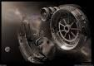
Egregious was born into slavery. Never having the pleasure of knowing his parents. Never fitting in with the other slave children. Never having a name as a child, he would fantasize about freeing himself and killing his captors. Even at an early age people would know something was different about him.

Having no knowledge of his birth parents, or knowing what world he was from, Egregious found himself set apart from the other children. It did not help that he seemed to have special abilities that most could not explain.

He would know how to fix things without prior knowledge. At times when he was being tormented and beaten by the mine’s froeman, strange things would happen. A rock crushing a worker here, a light crumpling into twisted metal there. It came to the point where he was just left alone. It was when he was alone he was most dangerous though.
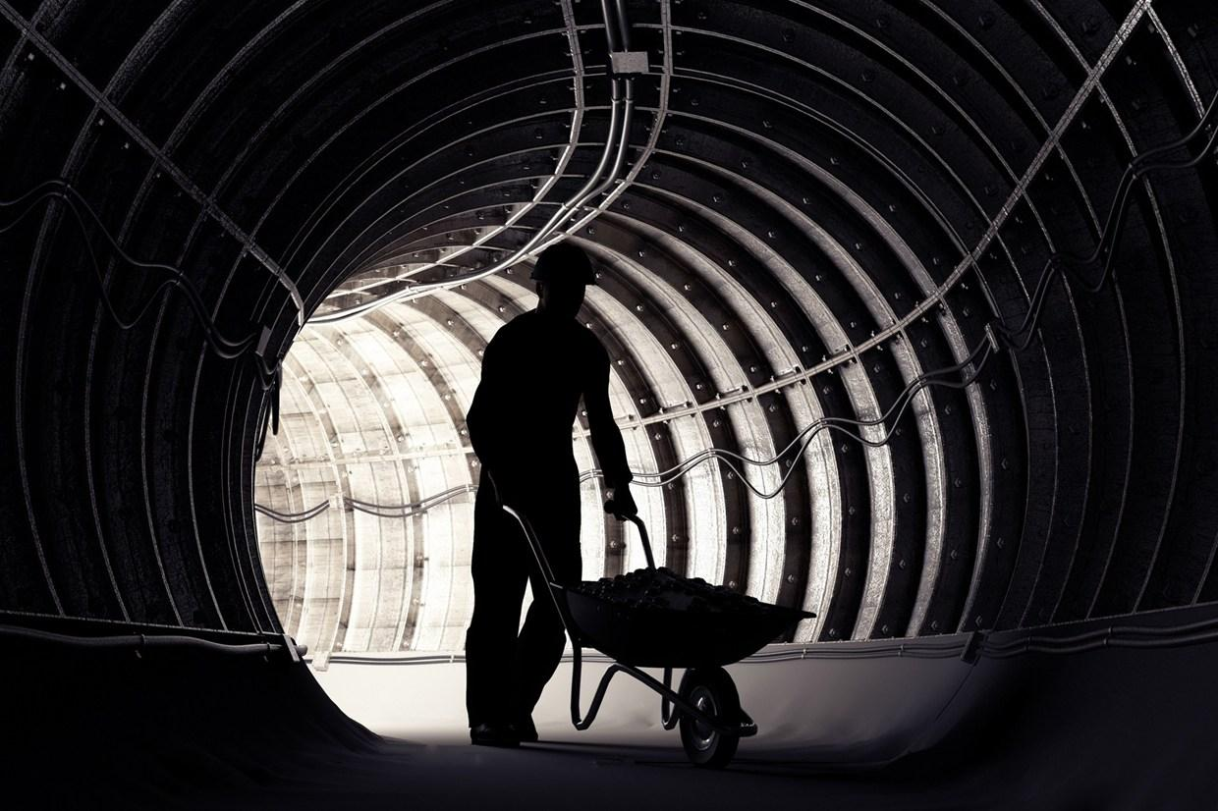
It was his time to plan and plot. Egregious, known then simply as slave #2122349, would start to rebel slowly and in horrible ways. Poisoning the foreman’s food and water supply, overloading power converters all over the base randomly, rigging the mining equipment to overload at opportune time; all of this was never linked to him personally, but secretly the other slaves started calling him Egregious. “ that boy is evil” on woman whispered in the small market area set up to furnish the slaves with needed items.

As one later freed slave once said “ if there ever was a saint that Egregious was never one”. Slave #2122349 knew of the snickers and rumors that were being circulated around the camps, and it made him smile, more than once he wanted it more. As never having been able to even own name, just a chain around his neck and fresh whip wounds, he started to think of himself as Egregious.

The name itself had power. slave #2122349 was just a number, but Egregious, now that was something. People feared it. He then started to make cave carvings with the name flourished script below. The foreman was enraged when he saw these, and decided to make the young slaves life miserable.

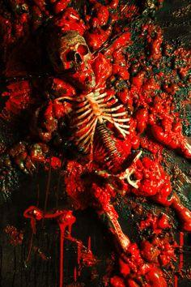
So when the foreman wanted to take out his frustrations on him that night, in a blind rage fueled with both spice and Corellian ale, Egregious reached into the dark and crushed the man with his mind. Of course the situation was reported and Egregious detained until an official from the core could come and investigate.

Witness reports were sketchy. Most reports read like the man just was folded up and squished in mid air to a pulp. That is to the ones that watched. All said that he just hung there off the ground, and the child was cowering there with his hand outstretched and clenching his fist. Then his legs and arms were forced into his body and his head sunk in crushed. Fluids leaked from his orifices and then with a pop, he was a ball of blood and guts floating in the air.

Not until Egregious collapsed did the mass of bio material fall to the ground with a splat. None screamed, mostly because all were disbelieving what had been done. A droid was sent to take the boy to the med center and to sedate him until the inquisitor could come and inspect the child.

After a few scans and a proper feeding the inquisitor took the boy in a hibernation tube to his secret base. After several tests and scans it was found that the boy had the force within him. and was a potential to be trained. The boy was awakened.

Scared and alone the boy found himself locked in yet another cage with yet again another captor. His mind betrayed him as he tried to figure out how he got here. Or even where here was actually as he was sure he wasn't in the mine anymore, it was to clean.

His clothes were different also. No more did he wear loose rags, but a white linen jumpsuit. Twice a day a droid delivered food on a tray. Twice a day he tried to escape. Twice a day he was electrocuted from various spots in the walls.

This went on for what seemed like years, until the one day that changed everything. As usual he waited for the feeding droid, but no droid came. Then he was electrocuted, however this time he was ready. In his mind he wanted the surge to be absorbed into him, but what happened was very different.

As the device tried to keep up with the power surge it over loaded and blew apart the wall. With this the young boy clammered through the hole and made his way down a hallway. Two guards tried to stop him. Egregious was blinded with rage. His untrained skill running wild as they soon found out.

Using his reflexes he dodged their stun blasts, running up the side of the wall he landed a jump kick to the guards chin pushing him into the other and when they fell the both stunned themselves.

During this Egregious did not notice that the man was at the end of the hallway with his hands clasped behind his back. Watching and waiting. Then he took a rod from his pouch and held it out in front of him. With a blur the rod stuck egregious in the back of the head.
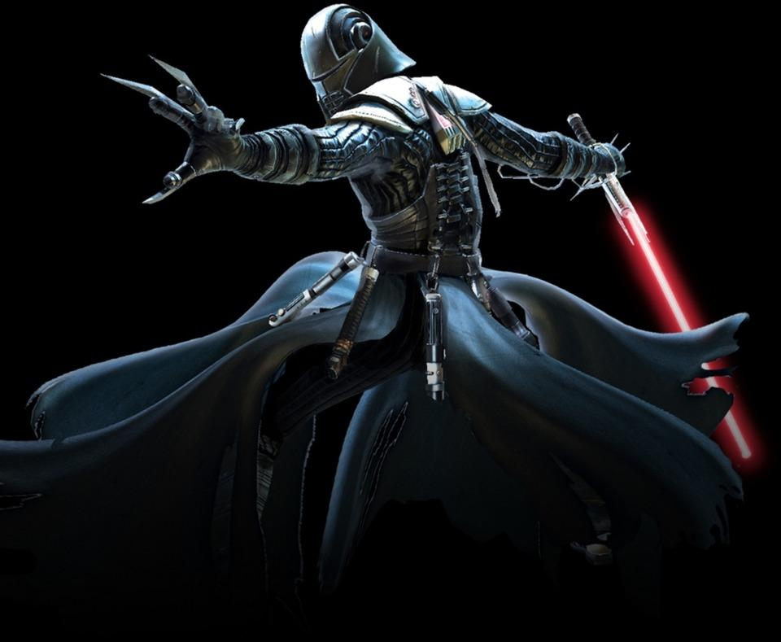
Then all went dark with a loud crack and a sharp pain in his skull. “w..haaa” he muttered as he crumpled to the floor. The man just strode towards his victim picking him up with the force and dragging him back to his lab. “ Its about time you escaped that room i was about to give up on you” he muttered as he strapped him to the med table.

The first thing he felt was the shackles around his wrists and ankles. His mind was fuzzy and so was his thoughts. Conflicted with dreams of rage and turmoil he began to feel his surroundings. The buzzing of medical equipment. the slow creaking of the droid joints. He cracked his eye and was greeted with a “ Well well it seems the subject is awake” the man was clad in a humorous outfit. He looked like he was in a full eviro-suit. but over the helmet he wore a paper face mask. and the apron was stain with what looked like at least three different kinds of blood.

The man, if it was indeed a man, walked over to a screen and rubbed his chin “ Slave #2122349 Who were your parentlings” he rounded on him fast to meet his eye.

Egregious spat “ I am not a slave” and with this the torture began. As sadistic as it was it still resulted in the same. Sarcastic remark from Egregious and pain soon followed. Until he screamed “ I AM EGREGIOUS!” and the man just stood there and chuckled “ yes and soon you will learn the power of the dark side”

