URGENT LEADERSHIP EYES ONLY

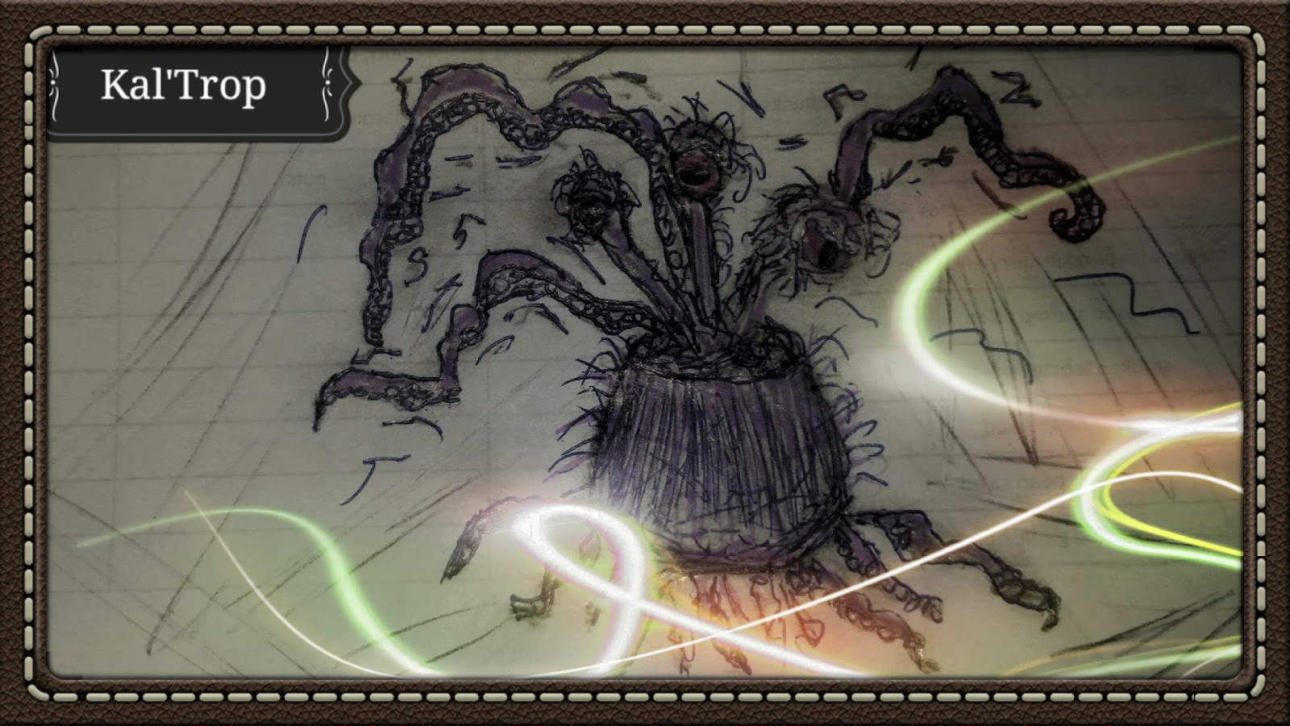

Kal’Trop

Height- 1-2 meters with tentacles reaching 4-5 meters
Weight- 1-2 kilos
Diet- Brain Waves, biomolecular transduction
Habitat- Highly adaptive invasive species

Origins of this species are unknown. Their discovery were on an isolated asteroid that had its own water supply deep in the rock. The miners discovered this species as they would fall from the cave ceiling and cling to their helmets.

The lower tentacles would dissolve the metals and devour the flesh underneath. The finer tentacles would actually connect with the victims brain and control the victims body. This is also how the beast fed on its victims only after implanting spores within the bloodstream.

There was a fatal flaw however. The body would quickly die as a result of lack of nourishment. This would happen right before the reproduction of the beast would occur and the new genetic line would bust out of the victims abdomen.

It was only a matter of time before the first team was fully infected. As the team winked out and the population of Kal’trop’s exploded, the managing company sent out a team to investigate.

It was first thought that these were un-sentient beings. As the first team of miners succumbed to the being, it seems they absorbed the brain matter and thus boosted it’s intelligence. When a team of mando’s were hired to investigate, they to were also similarly attacked.

Some think that this is how they were found on an abandoned freighter in the outer rim. Since the beast has tentacles, it was assumed that they got onto their transport and quickly dispatched the crew.

It wasn’t until a Dark Jedi stumbled across the abandoned craft, that they were first introduced to the force. The Jedi was investigating the asteroid as a possible base of operations in the sector.
At first the ship looked abandoned and was in pristine condition for being a floating hulk of a ship.

It wasn’t until he remotely sliced the ships computer did he find within the crews personal logs did he find evidence of the creatures presence. It seemed that the beast had a hibernation trait. As they originally came from a secluded asteroid cave it would seem that they can lay in wait and slowly dissolve metals and rocks to feed waitting for an organic life form to feed and to reproduce.

Cautiously the jedi captured a specimen for study. However this was a risky proposition. For the Kal’Trop escaped and fed on his dark side energies producing a new line of genetically dark forced beings.

This new genetic line had an affinity for force lightning, and could speak telepathically. Since it had dissolved and sucked out most of the dark jedi’s force powers as it slowly digested its brain matter.

Reports have come in around the rim about these creatures attached to hulls or in shady Cantinas.

Be aware and tell a friend.

Report transmitted…

