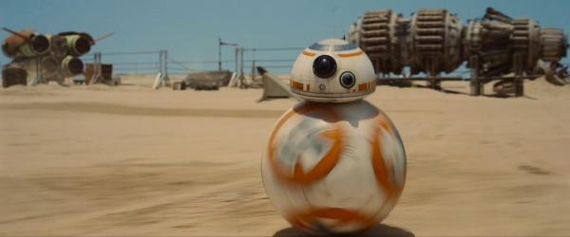
(http://badassdigest.com/2014/11/30/i-love-star-wars-the-force-awakens-ball-droid/ Photo credit)

S1-b1 Was a special droid. Originally Developed by Industrial Automaton, for the supervision of children. Having the ability to be loaded with educational and entertaining holo vids for many different species. Some nicknamed it the “Huttball Droid” or HB’s. Mostly since it looked like a astromec head riding on top of the popular sports ball.

Overall sales with the droid were nominal. While there was a spike with the resurgence of huttball most were just used as they were designed. Some markets found useful modifications that were used for other than intended purposes.

Having the roller capabilities gave the droid more speed and maneuverability, however its small size made it unusable in most practical applications. Also without the usual R series model tools mostly left the droid used for sensor readings.

It was supposed to be an educational and simple entertainment for the younglings of various species, how ever it became more of an annoyance since most models only spoke in chirps and beeps of droid speech. Since Voca units were too large to place in the device, and the inventor failed to add a data pad for text it was mostly used for holo displays.

Data cards with the holo vids or the educations programs were loaded into the droids software. The younglings then would interact with the droid and have play time and education all at once.

Most found them as a novelty. Some were capable to modify the programming of the droid to use it to eavesdrop on their other siblings. This was most notably used in the Hapan sector, with the Hapan squabbles between royal houses. Some even used it to Assassinate family rivalries.

Some pirate factions used the droid with a simple modification to the ball to add thrusters. This then gave the droid a way of being a sensor relay when jettisoned from the craft in certain areas. Since the droid was so small, it was rarely detected. And then it could relay the data back to the pirates it was a probable solution to most ship detection problems.

Some others had other ideas for the device. The were the more devious ideas. Like in anything, evil finds a way.

There have been reports of some using the ball as an intrusion device and used to assassinate targets that already had one of the droids in the domicile. A simple detonator and a charge fitted inside the droid would be used and the droid tasked with entering the home and rolling up to the target.

Some had it display a small holo vid as the countdown started and then it would simply explode. Others had them explode on contact with something or someone. All were deadly.

And yet other beings modified the programming to use the droid as a message relay system. The droids small size and swiftness made it a capable device to send clandestine messages. Where the holonet and comm signals could be eavesdropped, this provided a solution for some since the droid could encrypt itself.

