Mission Outline
Our forward fleet has emerged from hyperspace to find an enemy battlegroup in orbit around Korriban. These enemy forces *must* be destroyed so as to avoid any complications with the arrival of following Loyalist forces.

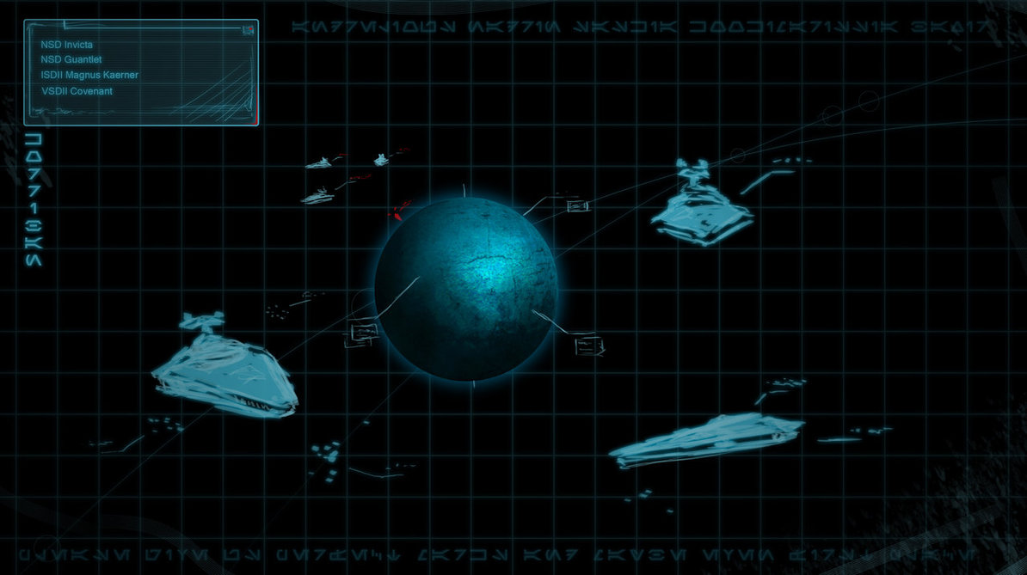

Objectives
- Full retreat or utter destruction of enemy forces around Korriban
- Preserve as much of the advance force as possible

Enemy Assessment
The enemy forces comprise of 3 ISD-II Destroyers and a VSD-II Destroyer. Preliminary scans point to them being members of Esoteric’s forces and we have been told that they are the Emperor’s Hammer group, the ‘Aggressor Strike Force’. The fighter complements of the enemy ships are a mixed bag, and we are working on old intel from a source within the planning group, however all signs point to the fact that the information we have received is correct. Force Assessment is as follows:
- ISDII Grey Wolf
  - TC Wing XIII
    - Vortex Squadron (8 TIE Advanced, 4 Missile Boats)
    - Phoenix Squadron (12 TIE Interceptors)
    - Crusader Squadron (4 Assault Gunboats, 4 TIE Interceptors, 4 TIE Advanced)
    - Odin Squadron (8 TIE Interceptors, 4 TIE Advanced)
    - Tartarus Squadron (4 TIE Interceptors, 4 TIE Defenders, 4 TIE Bombers)
    - Valkyrie Squadron (8 Assault Gunboats, 4 Missile Boats)
- ISDII Intrepid
  - TC Wing XIV
    - Copperhead Squadron (4 TIE Defenders, 4 TIE Advanced, 4 Missile Boats)
    - Krayt Squadron (4 Missile Boats, 4 Assault Gunboats, 4 TIE Defenders)
    - Viper Squadron (8 TIE Advanced, 4 TIE Defenders)
    - Asp Squadron (12 TIE Phantoms)
    - Cobra Squadron (4 TIE Phantoms, 4 Assault Gunboats, 4 TIE Vanguards)
    - Diamondback Squadron (4 Missile Boats, 8 TIE Defenders)

- ISDII Vanguard
  - TC Wing XV
    - Echo Squadron (4 TIE Interceptors, 4 TIE Bombers, 4 TIE Experimental Mk.1)
    - Scorpion Squadron (4 TIE Defenders, 8 TIE Advanced)
    - Mantis Squadron (4 Missile Boats, 4 Assault Gunboats, 4 TIE Defenders)
    - Wasp Squadron (8 Missile Boats, 4 TIE Defenders)
    - Hornet Squadron (4 TIE Advanced, 4 Assault Gunboats, 4 TIE Interceptors)
    - Python Squadron (12 TIE Advanced)
- VSDII Aggressor
  - Avenger Squadron (12 TIE Shadows - special craft)
  - One other squadron - TIE Fighters assumed
Friendly Forces
Our advanced force is made up of four capital ships from various members of the Loyalist Faction. While at first glance we appear to be well matched with the enemy ships, it is important to note that the NSD Invicta is not operating at full capacity thanks to the incident at Antei, and as such should be considered to be 70% operational AT BEST. Loyalist Fleet is as follows:

- NSD Invicta (~70%)
  - 3 XJ-Wing Squadrons (Black Wind, Lightbane, Void non-Dark Jedi)
  - 1 B-Wing Squadron (Scourge)
  - 1 E-Wing Squadron (Doto)

- NSD Gauntlet
  - 4 TIE Defender Squadrons (Marshal, Hegemon, Archon, Chamberlain)
  - 1 B-Wing Squadron (Chancellor)

- ISDII Magnus Kaerner
  - 2 TIE Advanced Squadrons
  - 2 TIE Defender Squadrons
  - 1 Scimitar Assault Bomber Squadron
  - 1 B-Wing Squadron

- VSDII Covenant
  - 2 HLAF-500 squadrons (Grek, Herf)
  - Delta Dx-9 Transport
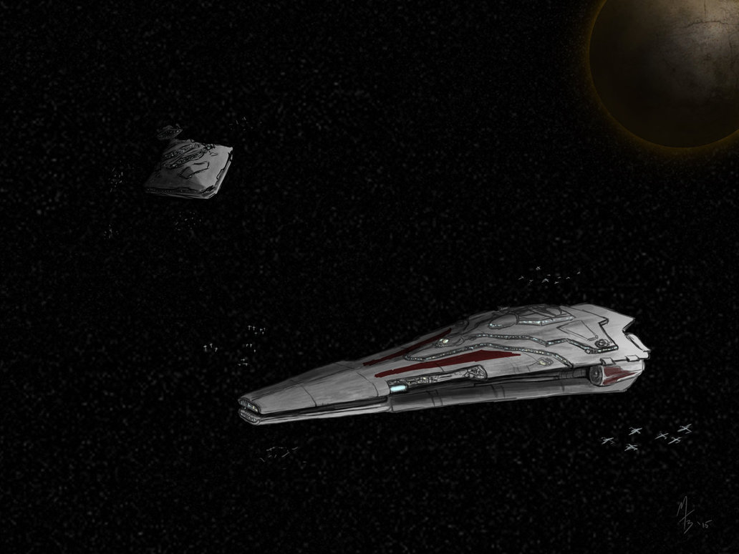

In addition to these forces, we also have a strike team of Dark Jedi from Arcona with the Loyalist Fleet. The members of this team are as follows:

Baxir Vol (Dark Side Adept)
Andrelious J. Mimosa-Inahj (Sith Warlord)
Nadrin Erinos Arconae (Sith Warlord)
Saskia Ortega-Inahj (Krath Epis)
Nikola Valtiere (Sith Battlemaster)
Kookimarissa Mimosa-Inahj (Krath Priestess)

We are fortunate in that this team’s members bring a variety of different skills to the table. For example, Andrelious is Arcona’s best fighter pilot, whilst Kookimarissia, despite her relatively low ranking as a Priestess, has demonstrated her skill with a lightsaber in addition to be adept with the use of disguise. Saskia is an accomplished slicer, while Valtiere models himself as a military commander and has been training himself in that area. Both Baxir and Nadrin are competent fighters with wide-ranging skillsets.

Primary Plan

Kookimarissia Mimosa-Inahj and Saskia Ortega-Inahj are to board an enemy ship whilst disguised. This will be achieved through Saskia falsifying an Emperor’s Hammer IFF code on one of our transports. To further help the illusion, we have arranged that Grek Squadron will harass this transport. This way, the enemy will hopefully be taken in by the deception. They will be given aliases and identity cards with details of their new personas. Once on board the two females will work together. Saskia will use her slicing ability. Kooki will keep guard and if necessary ward off any Stormtroopers by whatever means necessary. It’s highly doubtful many will make it out alive with such feisty females on board. Once Saskia has completed slicing and disabling the ship, and Kooki has finished attacking the soldiers in their way, they can aim it in the direction of other enemy ships. This will cause it to ram others and once done so, will self-destruct on contact. Once this is set up they must waste no time and disembark the ship as soon as possible.

While this mission is ongoing, the Loyalist Destroyers shall concentrate their fire on one enemy vessel at a time; given the similar strength levels of the two sides, getting rid of even one enemy ship can make a difference. Targets will be chosen by opportunity, however where there is doubt, Nikola Valtiere, acting as fleet commander, shall designate the target that is to be chosen. Given the Invicta’s current status, it will take a slightly withdrawn approach and will fight from the back of the formation. The formation intended for the team is to be shaped like a diamond. Opposite vertices with be located on different z axis, rather than the same. The reason behind is this is to create the best possible firing range for each individual Loyalist Destroyer.

With regards to the starfighter forces, Andrelious J. Mimosa-Inahj will be leading the arrayed Loyalist forces from his TIE Advanced, flying with one of the squadrons from the Magnus Kaerner. While he will be in overall command of the combined Starfighter force, this is made up of two key components; the bombers and a fighter screen. The bombers, comprising of all Loyalist B-Wings, E-Wings and Scimitar Assault Bombers, will be joining in the combined capital ship assault on the chosen enemy capital ship, helping to open up avenues of attack and potential breaks in the shield of our chosen target at the given time. Any fighters not in the bomber squad will therefore be placed in the fighter screen, acting as cover for our capital ships and keeping them free of enemy bombing runs which could prove particularly harmful given the predicted starfighter compliments of the enemy ships.

As has already been mentioned, the primary objective for this mission is the successful clearing of the system for the arrival of further allied forces. Whether by means of destroying the enemy fleet or simply driving them into retreat, as long as Korriban is secured for Loyalist forces.

- Infiltrate VSD-II Aggressor with Saskia, Kookimarissia and a team of Loyalist troops. Aim to self-destruct ship or use it to ram enemy, whichever is possible.
- Loyalist Star Destroyers concentrate fire on enemy ships, one at a time. Nikola Valtiere, as fleet commander, chooses target.
- Starfighter forces, led by Andrelious, split into two main groups; bombers (B-Wings, E-Wings, Scimitars) and fighter screen (remaining forces). Bombers to join attack on chosen enemy destroyer, fighter screen protects friendly destroyers.
- Destroy enemy forces or force them to retreat.

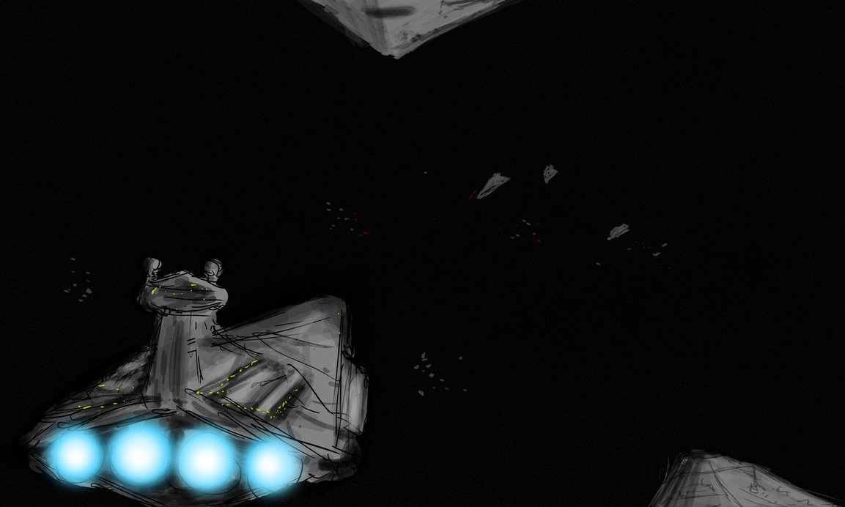

Contingency Plans

As it is already damaged, the Invicta may possibly be used to ram an enemy ship. The order to ram will be given at the time that the Invicta reaches 40% operational capacity or below.

Furthermore, ramming orders may be issued to the other Loyalist ships. This will be done only if the situation becomes otherwise unwinnable. In this case, any remaining starfighters will also be instructed to perform kamikaze attacks. The enemy ships are particularly vulnerable to this type of attack if their bridge deflector shields are eliminated - they have never bothered to rectify this design flaw. This, however, is a last-ditch attempt, and should only be used if victory in any other way is impossible.

Another eventuality to consider is the fact that Andrelious is emotionally connected to Kookimarissia (his wife), and Saskia (his daughter). If one or both of these are captured or killed during their part of the mission, we cannot anticipate how the Warlord will handle this. Especially as he and his wife have two very young children back on Corellia. If this were to happen, command of the fighter forces would revert back to the next most senior pilot, at Nikola Valtiere’s discretion.

- Invicta to ram enemy ship if it drops below 40% operational capacity
- If the situation becomes dire, elements of the Starfighter group can and will be used as kamikaze bombs, ramming enemy capital ships in sensitive areas (Bridge, Hangar) to expedite their destruction.
- As a last resort, each of the capital ships, starting with the most damaged, could be tasked with ramming different enemy ships so as to ensure their destruction.If things go particularly badly, other capital ships to ram enemy ships

Conclusion

Ultimately, the main point of this mission is to secure Korriban airspace for the arrival of further Loyalist forces as has been stated already. While we would aim to complete our objective with as much of the advance force as possible, every asset is expendable as long as it secures the objective. Any means necessary are allowed, and this operation is of the utmost importance. The system must be secured, no matter the cost.

