Gon Doru
12767
Competition: Tipsy Tusken's Signature Drinks

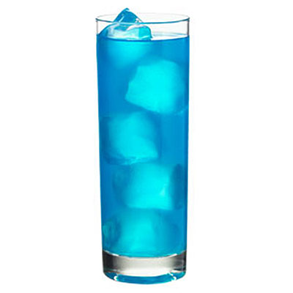Tusken Iced Water

This beverage was originally introduced by a Xenoalchemist passing through Mos Eisley Cantina. The original drink consisted of an ounce of an exotic blue liqueur, an ounce of Corellian Rum, and an ounce of Aldaraanian Gin. The remainder was filled with crystal clear water and five cubes of ice. This drink if consumed by a Tusken Raider would give lucid hallucinations, and the usual effects of hard booze. Not to mention several healthy components from drinking the mixture of alcohols. The non-Tusken drinker would find the beverage refreshing and crisp on a hot day. After the destruction of Aldaraan and some other unfortunate events this drink became easily forgotten until its reappearance on the menu of the Tipsy Tusken. Its appearance is a bit of a mystery, and is usually accredited to the closest thing to a Tusken on New Tython: the Jedi Gon Doru. Although he denies this fact, he orders it often. A few of the Alcohols had to be replaced with ones locally made, making for an improved taste. The water was exchanged for sparkling water, giving the drink a subtle effervescent appeal.

Ingredients:
2oz Blue-Orange Liqueur
1oz Corellian Rum
1oz Harakoan Gin
5oz Sparkling Water

