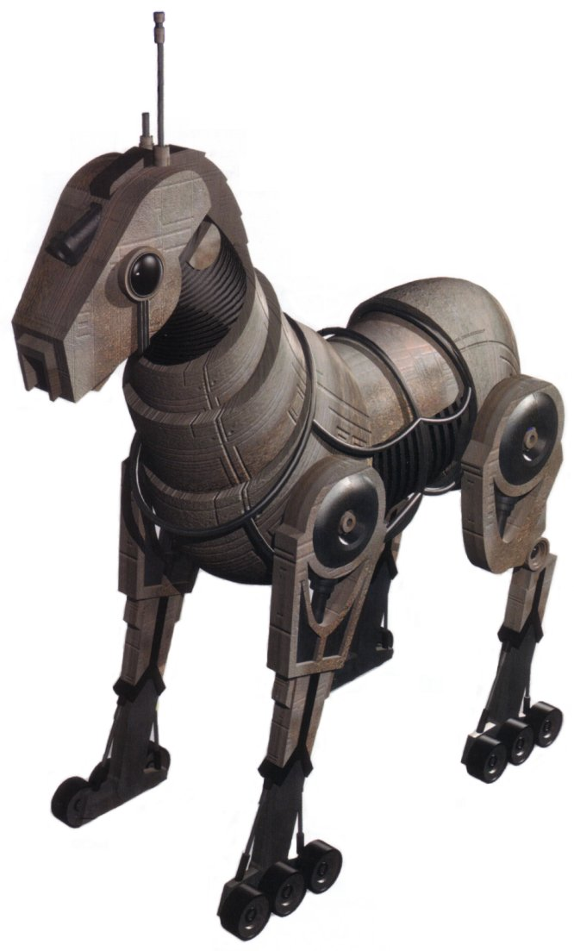

**FIDELIS**

*Female Basic voice modulator & artificial intelligence

*Translator database in memory module

*Laser mounted in the cranial compartment

*Armored casing

*Audio-Visual recording capabilities

*Communications array built in uplink

*500lbs carrying capacity