Situational Analysis

After a tough battle against O’reenian forces, in which we were victorious, a second, far larger fleet has arrived in the immediate area. This fleet is heading for Sanctuary, an Odan-Urr space station in orbit of the planet New Tython. Odan-Urr’s assembled ships took the brunt of the first battle, and are damaged, whilst the Arconan ships are still largely fully operational. Arcona’s ships are also still fully equipped with fighters, whilst Odan-Urr’s starfighter corps has already taken losses.

Objectives

- Primary: Defeat O’reenian fleet
- Secondary: Prevent loss of Sanctuary Station (below)

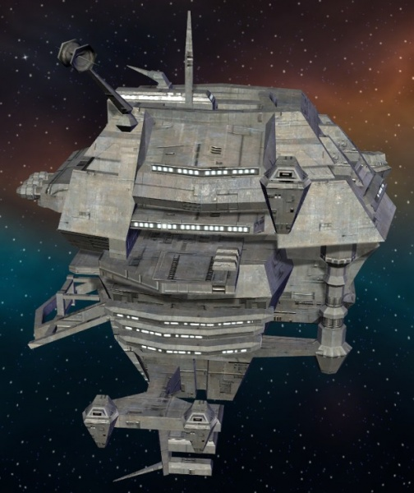

Defeating the O’reenian fleet is defined as either total destruction, or forcing it to withdraw due to large losses. Odan-Urr’s fleet command has requested that we elevate the loss of Sanctuary to a primary objective, however this has been declined as we cannot guarantee that we could both hold off the O’reenians and keep Sanctuary intact. Therefore, its survival is secondary.

Enemy Fleet Strength

The O’reenians have brought a large fleet in to defend their interests. Due to the fact that we have only recently become aware of the O’reenian threat, we do not have as much intelligence on their forces.

We have detected that the enemy fleet consists of the following.

Imperial-II class Star Destroyer x2
- Up to 6 squadrons each
Bakura-class destroyer x2
- Up to 3 squadrons each
Majestic-class heavy cruiser x2
- Up to 5 squadrons each
Immobilizer 418 cruiser x2
- Up to 2 squadrons each
Endurance-class Fleet Carrier
- Up to 11 squadrons

We do not have reliable intelligence on what type of fighters the enemy are carrying on board their ships, but are expecting that they are all fully stocked. For the purposes of this briefing, assume that the enemy’s fighters are similar or superior to our own - expect models like TIE Advanced, TIE Defender and the more recent classes of X-Wing.

Allied Fleet Strength

Our fleet comprises of the Arconan Expeditionary Force, backed up by additional forces from the Kotahitanga-Unity Defence Force. This gives us the following available:

- Nebula class Star Destroyer Invicta: 100% operational
  - 3 XJ-wing squadrons (Black Wind, Lightbane, Void)
  - 1 B-Wing squadron (Scourge)
  - 1 StealthX squadron (Void)
  - 1 E-Wing squadron (Doto)

- Nebula class Star Destroyer Encanis: 100% operational
  - 2 TIE Advanced squadrons (Messiah, Ignition)
  - 2 B-Wing squadrons (Sunsinger, Adjudication)
- Nebula class Star Destroyer Last Stand: Assumed 80% operational
  - 1 A-wing squadron (Nobilis)
  - 1 X-Wing squadron (Paladin)

- Acclamator-I class Assault Ship Shadehammer: 100% operational
- Victory-II class Star Destroyer Triumph: Assumed 80% operational
- Bothan Assault Cruiser Darkest Night: 100% operational
  - 2 XJ-Wing squadrons (Blue Mist, Black Tide)
  - 1 K-Wing squadron (Dark Sight)
  - 1 E-Wing squadron (Lucius)
- Bothan Assault Cruiser Shadow: 100% operational
  - 2 XJ-Wing squadrons (Black Malice, Silver Night)
  - 1 K-Wing squadron (Dark Rain)
  - 1 E-Wing squadron (Thanatos)
- Assassin class Corvette Pride: 60% operational
- Assassin class Corvette Proxia: 60% operational

Additionally, Warlords Andrelious Mimosa-Inahj and Nadrin Erinos are available from Clan Arcona, whilst Duelist Sa Ool will represent Clan Odan-Urr’s interests. Andrelious is a seasoned veteran in the cockpit of a starfighter, and also highly rated as a naval Captain. Nadrin brings a wide variety of combat orientated skills to the table, whilst Sa is primarily a lightsaber combatant, with expertise in various forms of hand-to-hand.

Primary Plan

Our main strength lies in the fact that our fleet possesses stronger capital ships. Our Nebula class vessels are generally considered stronger than an Imperial class Star Destroyer. Therefore, we will rely on the firepower of our three Nebula class ships to take on the enemy Star Destroyers. Meanwhile, we will use our fighters, led by Andrelious in his personal TIE Advanced, to clear a pathway for our B-Wing and K-Wing bombers. These bombers will be targetting the enemy Immobilizer 418 cruisers. We are looking to eliminate these ‘Interdictor’s fast so as to allow a withdrawal if things go wrong. They are also fairly weak in terms of shielding and hull armour, and so will not withstand a sustained bombing for too long.

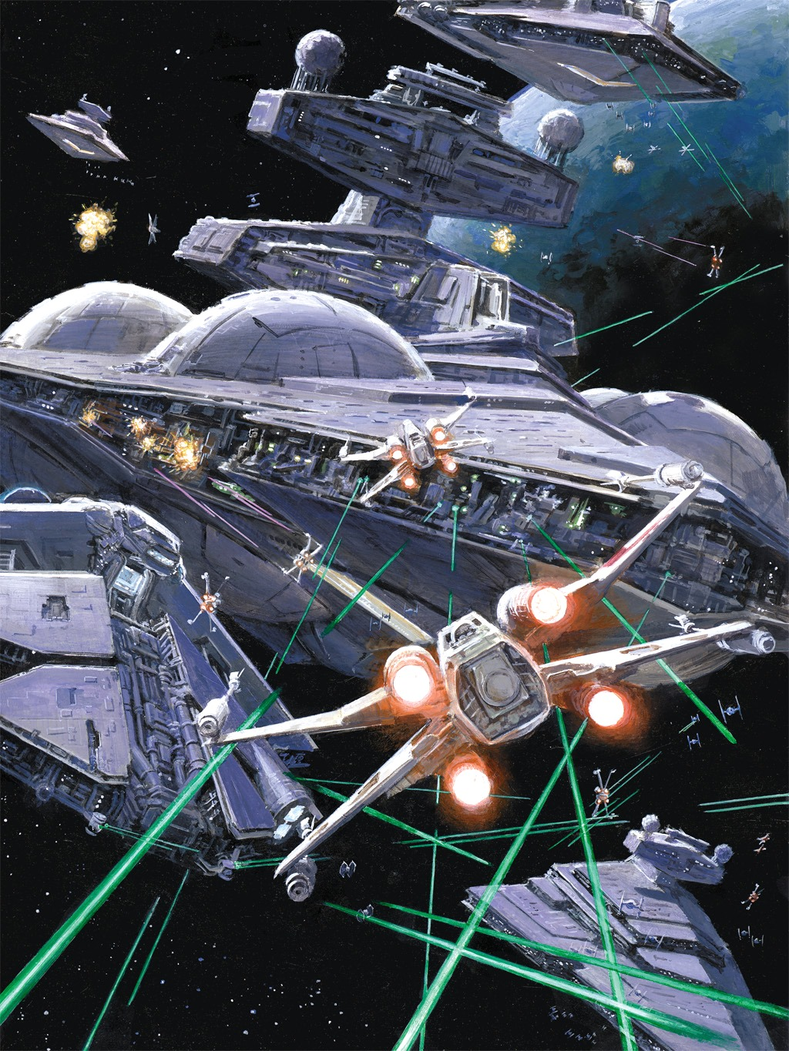

Nadrin will be in command of a team of specially selected Arconan Army Corps men. These men have been selected for this mission due to proven skill in performing boarding operations. Nadrin and his team will attempt to board and take control of one of the enemy capital ships, most likely a Majestic class Heavy Cruiser as they are familiar with the layout of this class of vessel. Their primary goal will be to take control of the ship’s weaponry systems. Nadrin will be assisted in this by Andrelious’ slicing expert ally and member of the Fade initiative, Swil Phift Erinos. Once the ship’s weaponry has been taken over, it will target the nearest O’reenian ship, aiding our cause with further damage to their fleet as well as a large helping of chaos.

Meanwhile, Sa Ool will head to the Sanctuary, where he will lead the defence against any attempted O’reenian boarding actions. If it is clear that he and the Odan-Urr forces onboard will not be enough, Nadrin will provide backup along with his squad.

Contingency Plans

If it becomes clear that our strategy will not work, we will use our ships, starting with the weakest (the Corvettes), to ram the enemy Interdictors, whilst also concentrating our fire on these vessels. Once the Intererdictors are destroyed, whatever is left of our forces will then be authorised to withdraw.

The above plan is to be used only if we start to take losses to the point that the battle will be lost. As it will leave Odan-Urr high and dry, it is highly undesirable to do so.

Also, if Sanctuary becomes overrun, despite the best efforts of Sa and Nadrin, the Arconan fleet is authorised to fire upon the station to prevent the O’reenian forces from taking control.

This strategy is also not authorised by Odan-Urr command. In fact, our intelligence suggests such an action will be considered hostile and will result in the Jedi cancelling the alliance and treating us as a hostile entity.

