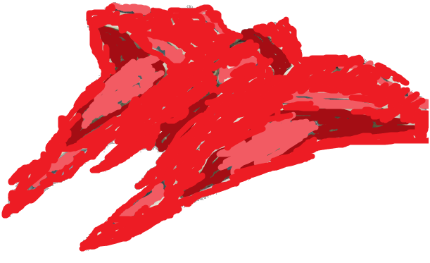
The Lobsters Battle

The Red Kom’kr class transport flew above New Tython majestically. At least that is what its pilot, the Jedi Scheat would have though. Scheat however was not aboard the ship. As the Ship carried people to safety from the wreckage of Sanctuary. The Lobster was in a hurry to get the people as far away from the battle as possible, and headed straight for New Tython. It nearly crashed into the mountainside on landing, and had to be sent in for repairs and a new paint job.

These are some stories of people on board:

Darius the Co-pilot:
“I knew right away that we had to help as many people as we could. I mean Scheat, our captain, would have been upset if we hadn’t. Sure we are smugglers. But we are not fools. It was the right thing to do. Unfortunately I’m not as good a pilot as Scheat is… and my rocky flying caused the near collision.”

Sally, a woman who was saved from Sanctuary:
“It was a miracle. We didn’t have enough ships and then this red ship came flying in to save more of us and get us to New Tython. I thought we were doomed for sure until the ship came. And when it was hit several times from enemy fire. That Darius is a Hero… I wonder if he is single.”

Crasis, a Zabrak smuggler and one of the Lobsters Crew:
“Scheat told us to make sure the ship was in one piece. and that is what we did. Darius got a bit heavy handed with the controls. But it went well. I suppose it could have been better. Maybe no damage to the ship, but hey we did our best under the conditions we were in. I wish we had saved more people. Scheat will be mad we didn’t make a return trip for more.”

And well those areall the people who would volunteer information. Apperently people want to find their families more than answer a reporter. DON’T THEY KNOW THEY COULD BE FAMOUS FOR THIS!!! I mean. Hey its that Scheat figure. I wonder what he has to say about all of this.

Scheat:
“Ummm I wasn’t around. I was boarding an enemy ship with some allies. You know the usual. What tell you about it? WHY?! I don’t want to be famous. I already have a big enough bounty on my head! Get out of here you stupid reporter!”

Well that is all for this week I suppose. Why doesn’t anyone talk to me :’(.

