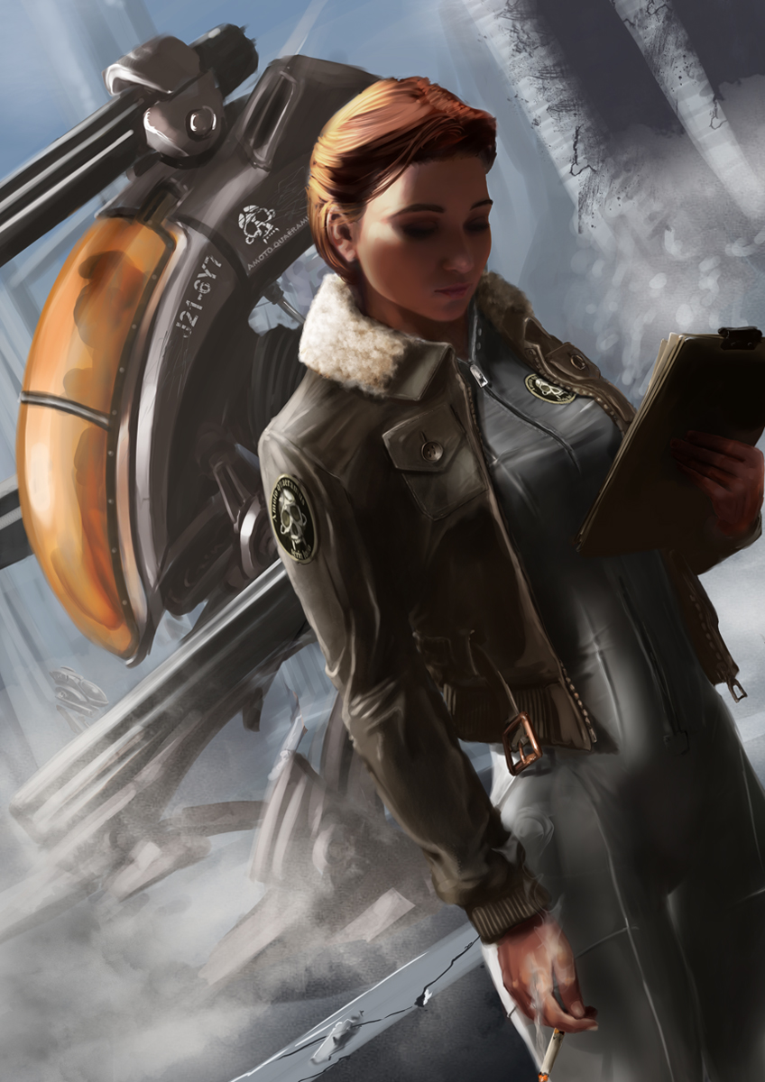
Name: Andrian Kiles
Age: 39 (Born June 4, 0 BBY)
Species: Human
Gender: Female
Height: 1.62 m
Hair: Reddish-Brown
Eyes: Green

Andrian was born to impoverished parents Ferul and Jenia Kiles in the slums of Stonia, the capital city of Almania. Not long after her birth, Ferul and Jenia was captured by pirates and sold into slavery, leaving Andrian an orphan. Homeless, Andrian would spend most of her childhood stealing what she could to survive and hiding from the pirates and slavers that often raided the planet. Around the year 3 ABY she became acutely aware of the fact that staying on the planet was only delaying her inevitable death. So she decided to leave, stowing away on a freighter barge Andrian made her way to Almania’s third moon, Drewwa. Not long after she arrived she joined the Almanian military where she discovered she had a calling as a military commander. She quickly rose through the ranks, reaching the station of Commodore at the age of 16 and was given command of the Almanian Navy’s 2nd Brigade, codenamed “The Reapers”. Her new station required her to return to Almania, stationed within the capital city, Andrian fell into a comfortable routine and the months pasted quickly.

In 17 ABY, the man known as Kueller arrived on Almania. After he over through the Je’har, Kueller seized control of the Almanian military. After his reorganization many of the manned units were phased out, however the Reapers remained. Only now they were used as a mobile execution squad, sent to eliminate any threats to Kueller’s plans. Following Kueller’s fall, the Reapers were to be brought to justice for what they had done. During a raid of The Reapers headquarters more that two-thirds of the unit was captured and arrested on war crimes. Commodore Kiles and the remaining 3600 of the Reapers escaped capture and seized control of Almanian Capital Dreadnaught “Maelstrom” and fled the system.
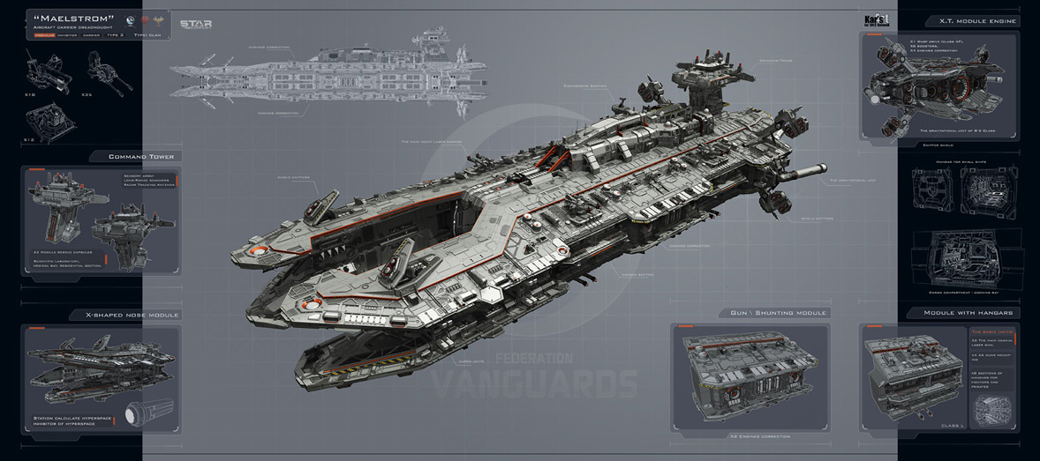
The Maelstrom is a massive dreadnaught built during the last years of the Je’har regime. Measuring just shy of 4,900 meters. Armed with ten HT class Laser turrets, 35 AA autonomous Cannons, and 12 batteries of Kar Systems Missile turrets. Shielded by roughly 3,200 SBD of impact reactive shielding allowing it to shift between ray and particle shielding.

Over the next 17 years Kiles and her crew would follow the Outer Rim hyperlanes. In that time, the Reapers would loose close to 200 members and eventually ceased using the name. Late in the year 34 ABY the Maelstrom would encounter a contingent of Clan Tarentum’s Task Force Piranha, lead by the MJHC Corsair. Outgunned and exhausted, Kiles and her crew surrendered without a fight and were escorted back to the Yridia System. There, Kiles met Ronovi Tavisaen, Quaestor of then House Tarentum. Explaining to Kiles that Tarentum would seize the Maelstrom, Tavisaen would convince Kiles to stay on board as the Maelstrom’s commanding officer. The bulk of the remaining 3400 members of the original crew would stay on, bolstered by an influx of 1700 members of the Tarentum Navy; the Maelstrom now had a full crew of 5100.

Kiles is a callus military tactician, believing that no price is too high to pay for victory. Her style of combat is best described as brutal and in-your-face. Despite these facts, no one can dispute her success; her high casualty numbers are only overshadowed by the significance of the targets the Maelstrom has taken. Kiles success can greatly be attributed to the Maelstrom’s speed and maneuverability, despite its length; the ship is capable of out maneuvering smaller vessels. This is thanks to its X.T. Module Engine Array, consisting of a central Class 4F Warpdrive, six secondary drive engines, and an extensive tertiary drive setup.

Kiles is wary of force users and will often fight having any on-board the Maelstrom. Her argument is that true pilots rely on their minds and the machine they are in control of, not an invisible energy that they can “feel”.

Where other commanders try to out maneuver their opponents, Kiles just bashes them with everything she has until they submit. While effective this style of combat does not lend itself to group engagements. As such the Maelstrom is most often sent ahead of the primary attack force in order to soften a target.

