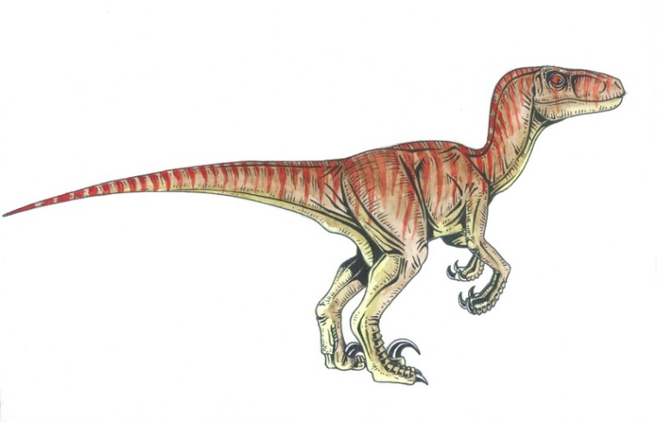
A sleek and fast hunter the Ha'una is a bipedal reptilian predator native to the continent of Kamuekiko. Standing just over a meter tall and weighing in at approximately 40 kilograms they average about two meters in length from nose to tail. They are extremely swift animals capable of reaching speeds in excess of 50 kilometers an hour however they can only maintain such speeds for brief spurts and generally save these spurts for running down prey in packs of six or seven animals. Once a prey animal is found they will attempt to surround and disorient the animal, ejecting a highly corrosive acid like substance from a pair of venom glands situated under the tongue.
They have smooth orange skin that lightens to an almost yellow colour on their throat, stomach and lower legs and they have a series of red bands across their backs that run from the tip of their nose to the tip of their tails. They have large red eyes with a black vertical pupil and they have excellent night vision. They have three fingered ends with each finger tapering down to a long hooked claw which the Ha’una uses to grip onto prey items and climbs trees. They also have three toed feet each ending in a sharp claw however the inner claw of each foot is disproportionately larger than the other two and is used to latch onto prey when the Ha’una leap atop them when making a kill.
During mating the male stakes out a small territory in will attempt to woo females through a mixture of elaborate “dances” and calls ranging from whistles to hoots. The males become fiercely territorial during the mating season and will kill any male who enters their territory or die themselves in the attempt. Once mating has occurred the female will retreat deep into the jungle and construct a large nest high in the canopy where she will lay between 2 and 5 small eggs. Incubation takes between 50 and 60 days at which time the young are born fully formed and ready for hunting at which point the mother leaves them to fend for themselves. They survive by sticking to the tree hunting small birds, lizards and insects until they are large enough to come down from the trees and hunt larger animals.

