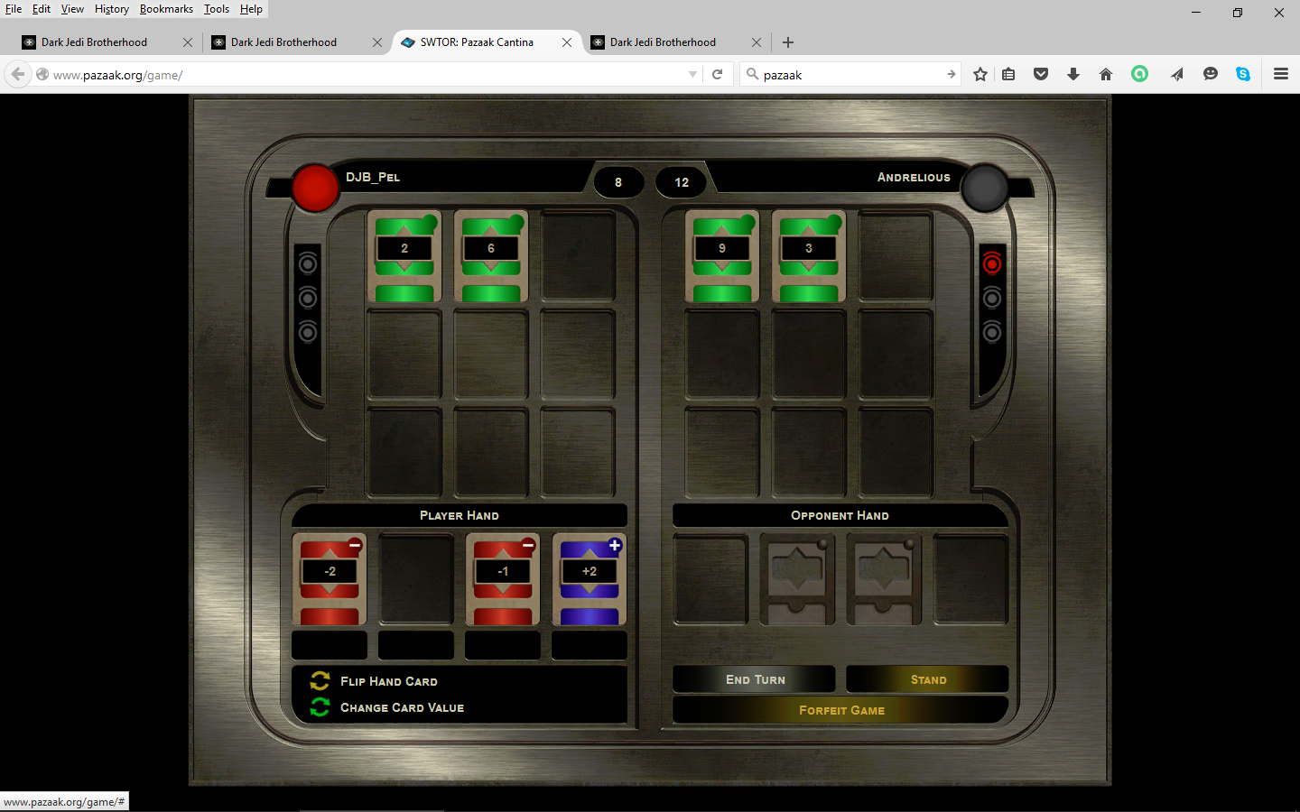
What do you want for nothing? Fun? HAH!

