Kr'tallian Nexu

The Kr'tallian Nexu is an evolutionary offshot of the Nexu species.

Characteristics (Biology and Appearances)

A compact and well-muscled feline creature, it is the largest cat native to the chilly forests of the Karusthar continent on the planet of Karufr.
They vary considerably in size and weight, with male Nexu typically being 10-20% bigger than females. Just like their cousins native to the forests of Cholganna the Kr'tallian Nexu had an additional set of eyes able to view in infrared wavelength.

Like their cousins the Kr'tallian Nexu appear to be feline in nature, with claws which could slice a Human in half. They had quills along their back, and a long tail that in the wild allowed the Nexu to swing from tree branch to tree branch. The tail also split into two equal sections for a better grip on the tree branch they were swinging from. They had extremely sharp instincts and reflexes, although they were known to tire easily, and often used swift movements to finish an enemy quickly, biting down and strangling the windpipes of their victim's neck. They also have more slender heads and shorter, stockier limbs compared to other Nexu offshots.
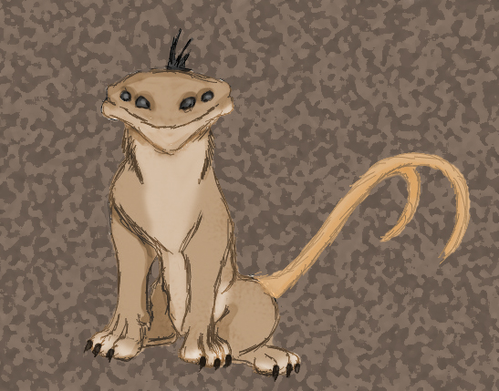
While the Kr'tallian Nexu closely resembles their cousins, they grew sturdier and heavier, and the two animals can be distinguished by color patterns on their fur: While the Nexu of Cholganna sport a striped fur, the Kr'tallian Nexu show dark speckles dotting their fur. Unlike the Cholgannan Nexu, cubs were born with a light beige fur from which only the color pattern on their body will darken while they age.

Color morphism

Color morphism occurs regularly in this evolutionary offshot, with a near-blackmelanistic form happening more often than in the common Nexu. Nexu with melanism appear entirely black, although their speckles are still visible on close examination. Though the color morphism is common within their species melanistic Nexu are informally not known as a separate sub-species the ancient Quahl society named them "were-nexu".

Behavior and Intelligence

Knowledge about their art of living and behavior in their natural habitat were mostly incomplete, based mainly on a rare animals caught and equipped with transmitting collars and a few live sightings. Reason for this is the extreme difficulty in capturing one of the Nexu to equip them with a collar as they, despite their size, tend to withdraw from human beings.
They usually live as loners with defined territories that randomly overlap between males and femals with territories of males overlapping sometimes as well, though in general males would avoid fighting each other except during mating seasons.

Despite their sturdy built, the Kr'tallian Nexu are, like their Cholganna cousins, skilled climbers, though it has been proven that cubs climb more often than grown up animals. They also tend to be good swimmers due to their prey spectrum, something uncommon to other nexu. Explorations also showed that the Kr'tallian Nexu is somewhat used to hunt during day time. However more commonly they spend about half off the day resting.

However stone statues and figures spread across the jungles of southern Karusthar and the remains of ancient villages suggest that at least some of the Nexu might have been re-domesticated by the Quahl, an ancient and extinct culture of Zeltrons within the population of Karufr, as for them the Nexu was the deity they worshipped. Latest archeological excavations have further revealed that the Quahl have used these domesticated Nexu for hunting and guarding their villages from outside attacks, though due to the density of the jungles the common believe for their extinction was the lack of different genetic material due to their isolated lifes instead of an outside influence.

Habitat

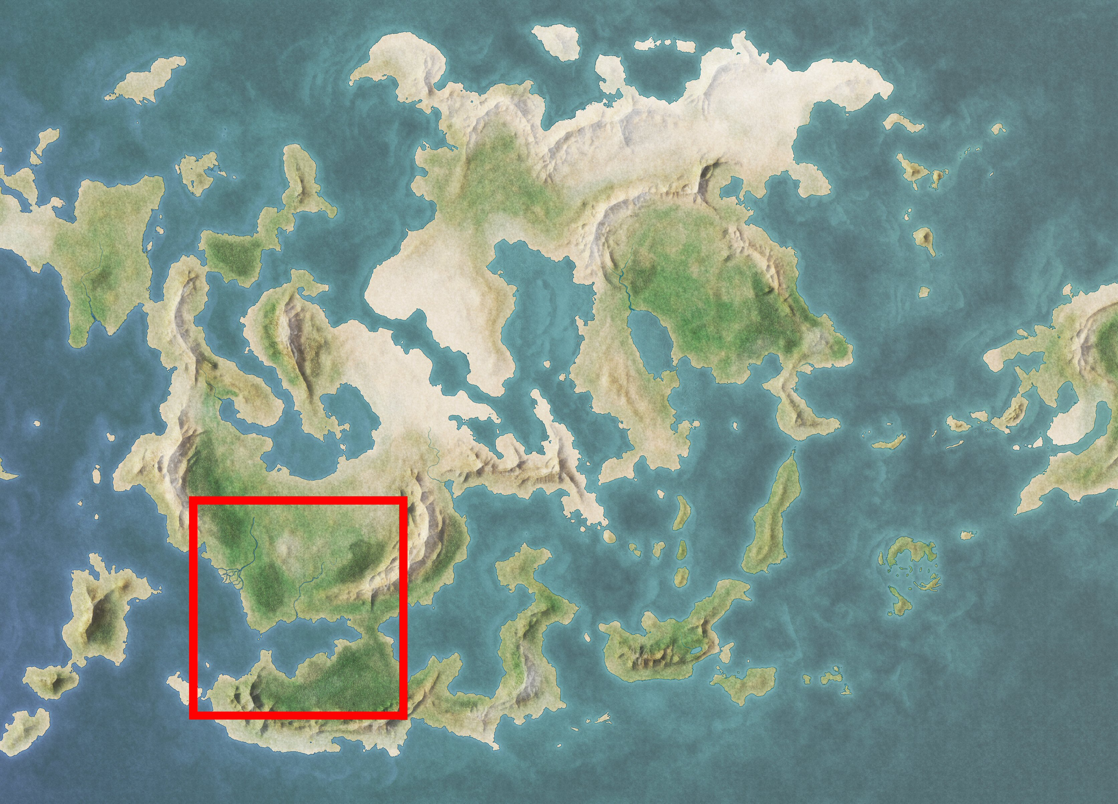
The habitat of the cat includes the rain forests of South and Central Karusthar, open, seasonally flooded wetlands, and dry grassland terrain. Of these habitats, the Kr'tallian Nexu much prefers dense forest; the cat has lost range most rapidly in regions of drier habitat, such as the arid grasslands of Zabac, and the central Adeal plateau. The cat will range across tropical, subtropical, and dry deciduous forests. The Nexu is strongly associated with water, and it often prefers to live by rivers, swamps, and in dense rainforest with thick cover for stalking prey. They have been found at elevations as high as 3.900 m, but they typically avoid montane forest and are not found in the high plateau of eastern Hylin mountain range.

Ecological role

The adult Nexu is an apex predator, meaning it exists at the top of its food chain and is not preyed on in the wild. The nexu has also been termed a keystone species, as current observations suggest, through controlling the population levels of prey such as herbivorous and granivorous mammals, apex felids maintain the structural integrity of forest systems. However, accurately determining what effect species like the nexu have on ecosystems is difficult, because data must be compared from regions where the species is absent as well as its current habitats, while controlling for the effects of outside interactions from non sentinent secies which is difficult as Karusthar is the only natural habitat of the Nexu on Karufr. It is accepted that mid-sized prey species undergo population increases in the absence of the keystone predators, and this has been hypothesized to have cascading negative effects. However, similar field work on other worlds has shown this may be natural variability and the population increases may not be sustained. Thus, the keystone predator hypothesis is not accepted by all scientists.

History (Interactions with local populations)

When the first Zeltrons established settlements on Karufr in terms of creating a permanent colony on the planet, they brought nexu with them as part of the extened investment of military personnel. These Nexu were meant to protect the civilians from the local gundark population. However the general assumption is that some of these Nexu eventually escaped their Zeltron masters into the wilderness and transversed the Krystan land bridge into the rain forest jungles of the southern Karusthar continent where they evolved into their current form when the first attempts at settlements failed.

Huttese Invasion

During the time the Hutts wrestled control over Karufr, the Kr'tallian Nexu became a symbol of power and strength by the oppressed Zeltron population having survived during the time the Zeltrons recovered from the failed settlement attempts. Among the Zeltron culture of that time, a secret societ disseminated making the Nexu their heraldic animal, during their fight against the huttese Invaders. The society would later become a religious cult among the Zeltron population.

When the Republic finally managed to oust the Hutt Corporations two hundred years later – the Nexu cult would see a split within their members with the most radical of them separating from the rest of the cult to follow their heraldic animal and live a simpler life just like the Nexu they worship.

Within the next centuries the Quahl – as they named themselves, developed distinct culture with several settlements in the dense jungles of southern Karusthar excluding themselves successfully from the rest of the Karufrian population.

Imperial Era

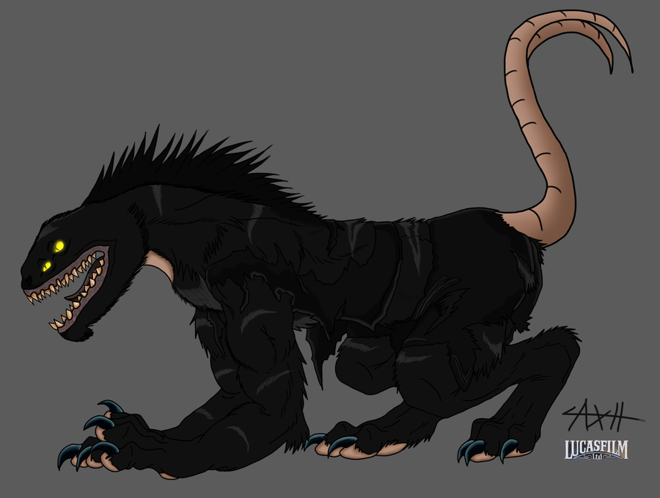
By the time the newly formated Empire took over control over Karufr, the Quahl – had created a wholy independent economy with the "were-nexu" the motif of sculptures and figures showing stylized Nexu of an entirely black color. While the common beige colored Nexu still had a significant meaning within their religion, the "were-nexu" had become the image of their protectors, making them forming an elite warrior cast named after the deity behind the image of the "were-nexu", the powerful Lunarin.

Sources

- http://axelhonoo.deviantart.com/art/Appo-were-nexu-form-300029867 (black nexu)
- http://jedi-cowgirl.deviantart.com/art/Young-Nexu-273630621 (nexu cub)
- http://www.deviantart.com/art/Fantasy-World-Map-01-170505416 (worldmap)

Obelisk Exarch Rian Taldrya (Obelisk) / Clan Taldryan [GMRG: IV] [SA: V] [ACC: Q]

AK / SB / GCx2 / SCx3 / AC / DCx5 / GNx3 / SNx5 / BNx2 / Cr:4R-12A-11S-10E-19T-7Q / PoBx3 / CFx71 / CIx57 / CEx113 / LSx2 / SoLx2 / S:10B-7De-3Ret-18Dec-13Aff-7Rn-35Cr-8Rv

{SA: MVC - MVF - MVL - DPE}

Son of Taldryan

