Vingobi

(“The Lost City”)

“A place where the lost can be found” – a common perspective of this ‘lost city’.
Vingobi (“The Lost City”) is a relatively spacious city on the oceanic planet of Karufr, yet it does not harbour many typically urban settlements. Akin to all other cities one of the planets in the Kr’Tal System, Vingobi is under the governmental hand of Taldryan.

History
“In finding this modern place, I found myself and a long-lost history.” – Senari, the initial discoverer of the city.

Past
Vingobi was a semi-recent discovery in 160 BBY by Senari, a bittersweet Zeltron who had fled her hometown. She had been told to ‘go and find herself.’ The red-skinned and gullible female had taken the metaphoric statement literally and had embarked on this mountainous settlement accidently.
(1) Senari, a bittersweet Zeltron who was the first person to discover Vingobi in many years
Senari never quite knew exactly how she found this place, but she began unearthing many secrets. Strangely in her time here, other Zeltrons and Humans alike began arriving with little knowledge of how they had come. It was all very unusual.
The Old Republic Era loomed over this bespoke place on its discovery, yet there was no prominent way of pinpointing the exact year it was formed. Ancient civilisations were mostly ruins and did not hold any obvious clues.
In recent years, there were a few scattered findings in varying locations. Unexplainable occurrences happened around the bases of the mountains in a large lake. The vast expanse of water would crash against the feet of the mountains adjacent to it, as if it has its own tide similar to an ocean. No one could rationally explain the unusual ebb and flow of what should have been a relatively motionless landform.

Present
Presently, Vingobi still tends to have a rather spooky aura surrounding it that many species and experienced brains are beginning to rationalise the meaning behind its unusualness. Civilisations are more advanced and have been assembled bringing modern technology into an ancient and impaired society. Those inhabiting this place tend to be those who disappear from more well-known and recognised settlements and seem to lose touch of their roots from whence they came. Even more extraordinarily, the relics that have been unearthed here in recent years, have been those people believe to be lost beyond ever finding.

Future
Research is fully underway by the current inhabitants into the stories and rumours behind ‘The Lost City’. However, some feel that thy will never be found, others believe only those who want to be found, will be.

Geography & Demographics
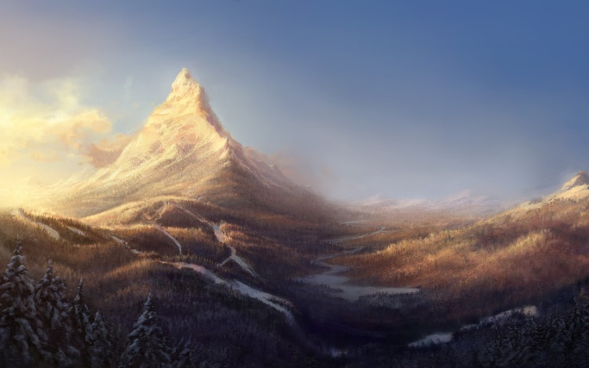
Vingobi is quite unique in that despite being a city, it is quite rural. Yet, similarly to Karufr, the landscape is mainly mountainous and has meandering streams which flow into a large lake. There are a few forested areas of grassland nearby. This city is very aesthetically pleasing upon first glance, however it harbours many dark secrets and vibes surrounding it.
The mountain areas look rather wintery, yet only at the apex are they cooler than the remainder of the city. The climate in Vingobi tends to be temperate all year round. Both in the winter and summer months, the weather is rarely extreme.
(2) Picturesque mountainous landscapes of Vingobi, with meandering streams and lakes
This unique city is quite sparsely populated. In total, there are roughly 200,000 inhabitants spread over 2000 square miles, resulting in a population density of 100 people per square mile of land. The population is comprised of a majority of Zeltron (55%), 30% Human and a mere 15% of miscellaneous species. The large proportion of all species is those of adults, however there are a few children who have gone missing from their previous settlements and have wound up in this exclusive location. Regardless of the varying species living here, they all spoke Galactic Basic Standard, so could therefore communicate freely and understand one another. Even though there are a lot of unanswered questions and many conspiracies circulating Vingobi, it is still under the powerful dictatorship of Taldryan.
Vegetation in the forested areas in this city are fruitful and provide a safe habitat haven for those who have evolved to occupy the area. Those who first arrived here after Senari, with her help managed to help calm the wild creatures and manage to create a balance between man and creature. Unusually any water or amphibious creatures failed to thrive, due to the darkness around the lake that the streams all flowed into.

Points of Interest
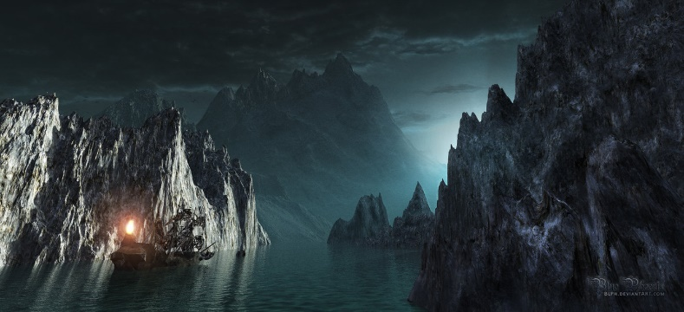
“Where do all the blue waters go? Into the lake with the ebb and the flow. Where does it feel so eerie and cold? Into the Lake of Lost Souls.” A verse comprised by early inhabitants of Vingobi.
(3) The 'Lake of Lost Souls'- an eerie place where bodies of several Dark Jedi lie beneath its waters

Lake of Lost Souls
All the meandering streams on Vingobi flow into a mysterious lake. This lake is like no other. Like the oceans of Karufr, it has flowing tides. The ‘Lake of Lost Souls’ has had its secrets revealed, to being an ancient site where several Jedi died. Their deceased corpses lie beneath the spooky waters and continue to haunt the area. This is the logical explanation behind the surreptitious tides on the water’s surface.
The Jedi are rumoured to have been Dark Jedi, since the paranormal and unnerving chills around this area of this city have given many who have visited the area negative vibes. However, this area is becoming less secular and more spiritual.

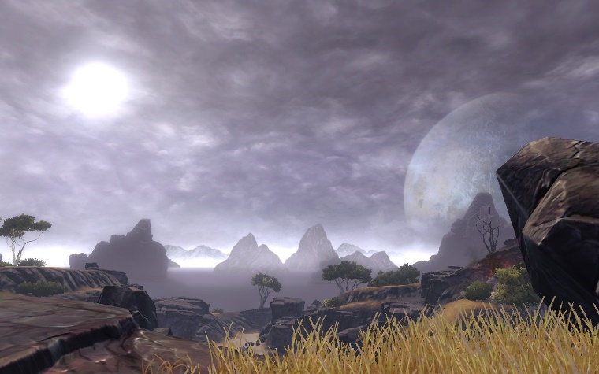
Old Republic Base
(4) Scattered remains of what is assumed to have been an Old Republic Base at the beginning of that era
There are a few rocky areas around a grasslands clearing away from the mountains. Bones of deceased Jedi have been discovered in this area. It has been home to unearthed Jedi relics, such as blasters and lightsaber hilts. These clues shed some light as to the Old Republic who had been here prior many years before Senari. Exacting details as to who exactly was here and pinpointing the precise time frame is yet to be fully deciphered.
This old location attracts a lot of fascination with those who wind up here. There are also concrete remains of an old Jedi conclave in this area. It is assumed to lure lost Jedi to Vingobi. Back in the peak of the Old Republic era it is believed that this site was where the lost Jedi would train and duel with one another and release their anger at being stuck in this place. These duels often resulted in death, due to lots of aggression combined with fear at their fate of being stranded far from their homelands. Hence the remains of deceased of those who once waked the landscapes of Vingobi.

Culture
“The Lost City” was once perceived as the place where the lost found themselves. However, as time progressed, the species inhabiting there evolved and procreated with those around them. ‘Finding themselves’ was considered to be a paramount rite of passage in any one person’s life. As a result of this new life was then highly regarded as seen as very precious. Upon the birth of any species, miniature carnivals are held and the new life is highly celebrated. Bountiful buffets full of lavish food and drink is spread for many guests to partake in. Zeltrons tend to often live up to their stereotype and savour the rich food and devour copious amounts of alcoholic beverages.
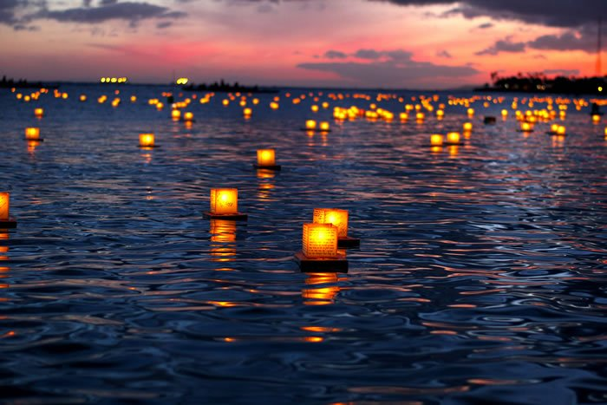
Equally as important as the beginning of life, is the end of life. Death is similarly seen as a celebration of the person’s life. When people die in Vingobi, a ceremony and death ritual is carried out at the foot of the mountains to celebrate the person’s life. An ancient verse (as mentioned in the previous section) is chorused by those who attend and the deceased body is concealed and sailed out on a boat and thrown overboard by hooded people to join the remaining ‘Lost Souls.’ It is believed they ‘find themselves’ once on the bed of the lake, yet their ghostly presence is forever felt by visitors to the area. Small messages of condolence and memories of the deceased ‘lost soul’ are written in ink on naturally made papyrus lanterns and encases a candle, which is illuminated and sent along the unusual tides of the ‘Lake of Lost Souls’. The wax melts down and the flames extinguish themselves. The spiritual area is very metaphoric and every detail is significant, akin to the rest of the city. Everything and everyone has deeper meanings than what’s on the outer surface.
(5) Candles and Lanterns during the scared death ritual on Vingobi

Image (1) Source: http://orig09.deviantart.net/70ec/f/2008/300/0/7/tami_jolo__zeltron_jedi_knigh_by_vectorattila.jpg
Image (2) Source: http://www.1280x800.net/large/201204/6209.jpg
Image (3) Source: http://pre07.deviantart.net/91fa/th/pre/f/2010/235/1/3/lake_of_the_lost_souls_by_blph.jpg
Image (4) Source: http://images.mmorpg.com/images/galleries/full/492011/b00086bd-7daa-4882-9255-7543d266a78f.jpg
Image (5) Source: https://justmyphoto.files.wordpress.com/2012/05/lantern1.jpg

