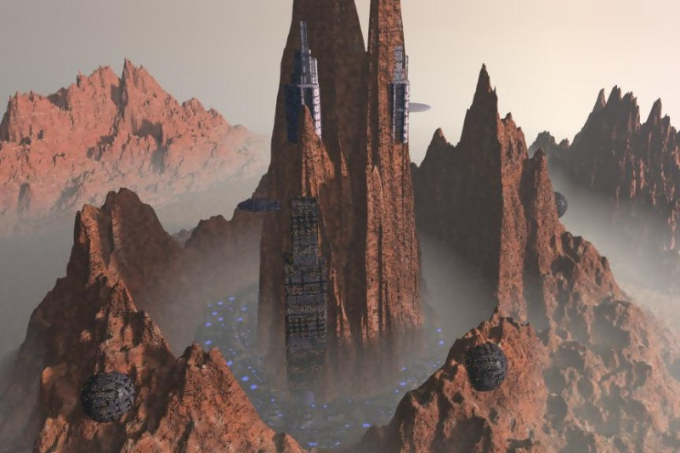  The Imperial Palace overlooking the City of Ohmen, Judecca  The City of Ohmen  Capitol city of Judecca, Ohmen is built into one of the planet’s mountain ranges. At its center, a lone mountain stands above the rest; home of the Imperial Palace and the Monarchy of the Cocytus System.  Notably, the town held out against the Yuuzhan Vong Incursion due to its militant design. This fortification creates a foreboding, dangerous atmosphere as you explore the nooks and crannies of the privileged, upper-class manors, museums, and restaurants.  Notable Attractions in Ohmen:  - The Black Road  - The Imperial Palace  - The Twin Towers |  |  | Who We Are  About Us  The Judecca National Tourist Organization (JNTO) is a subsidiary of the Scholae Palatinae Organization. JNTO aims to provide the highest level of customer care through great vacation pricing and customized vacation packages for travelers from all parts of the galaxy.  The JNTO was established in 30 ABY shortly after the Yuuzhan Vong incursion of Brotherhood space. The JNTO was responsible for re-establishing Judecca as a prime location for tourism, culture, and relaxation.  The current Director, Xen Mordin, loves long walks on the beaches of Judecca. He also is known for his lustrous short, brown hair.  Contact Us  Com-Link: 55-5-5555-01  Email: XenMordin@gmail.com  Web: https://www.darkjedibrotherhood.com/units/scholae-palatinae  Judecca National Tourist Organization  Clan Scholae Palatinae |  |  | Judecca National Tourist Organization  - Judecca. Infinite Possibilities.

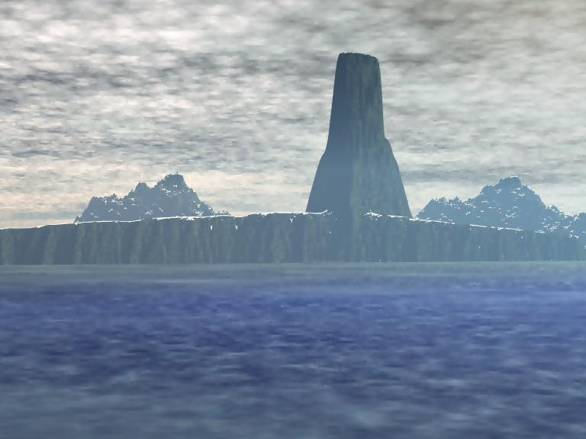  Dragon’s Point on the coast of Dragan  Culture and Attractions  What makes Judecca stand out  The planet is filled with unique, breath-taking landmarks dotted across its entirety. Adventurous individuals are encouraged to take shuttles (guided tours provided at your local JNTO stations) to peruse local landmarks surrounding Ohmen: The Black Road, Twin Towers, and The Imperial Palace.  Special tours can be arranged in advance by registering with the JNTO and obtaining a Class-III permit; these permits allow for access to rarely seen, but remarkable sites: Ghostly Citadel, Lake of Shadows, Black Jungles, and the Lonely Moors.  Only licensed officials are allowed to travel to the former city of Cardas; now known as the Missing City. In an effort to respect the sacrifices of soldiers and citizens to defend against the Yuuzhan Vong, the land is to be left untouched by man or alien. |  |  | How you fit into Judecca society  With the appointment of Cuchulain Darkblade as the first Emperor of Cocytus; the denizen were brought into the age of space-travel and advanced technology. Visitors are often seen as exotic; revered for their wealth and experiences collected on distant planets.  “Hidden in the Outer Rim, Judecca is a gem lost in time. A land of abundance with no discrimination; all proudly claim Judecca as their planet and nation – eager to share with others.”  Etiquette on Judecca  All citizens are equals on Judecca; however, the ruling clan – the Royal Clan – of Scholae Palatinae are given a wide berth. As the delivers of prosperity and the saviors against the Yuuzhan Vong, they are afforded every right of the ruling class.  Only one clan can rule Cocytus at a time, but Scholae Palatinae – through military might – has served as the current and foreseeable leaders of the system. |  |  | 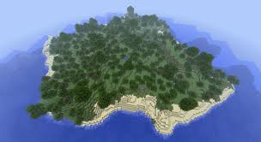  The remote, unpopulated island of Dleacht  Our Products and Services  The JNTO provides general information at more than one hundred (100) unique tourist centers across Judecca.  Tourist Centers can assist visitors with directions, customs, and societal questions. Local centers are also willing to make recommendations for lodging, restaurants, and local attractions.  In addition, JNTO will help you book vacation packages ranging from time-shares, secondary residences, and first-time lodging.  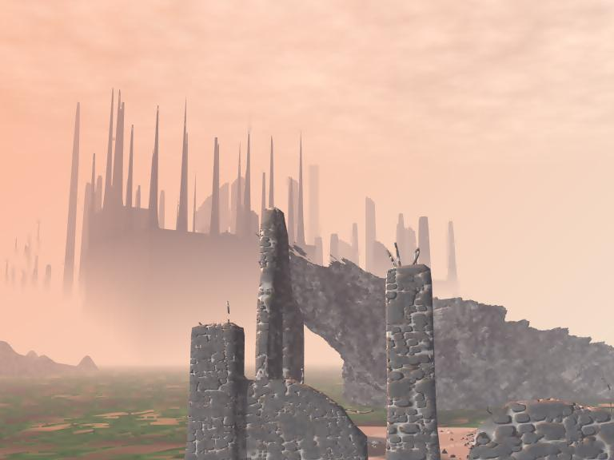  The ruins of the Jade Fortress; now known as the Ghostly Citadel

