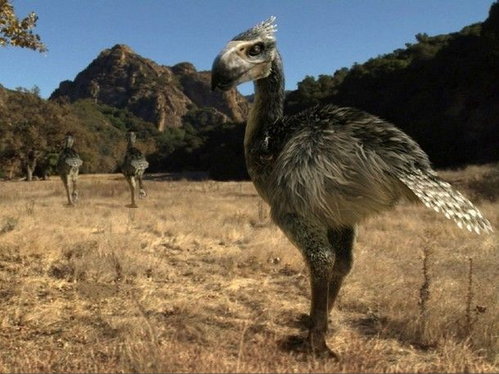
The Karakel is a species of flightless bird native to the continent of Kamuekiko. Swift hunters they are capable of running at great speeds for extended periods and possess the ability to regurgitate a highly acidic form of stomach acid to blind their prey enabling them to take down animals many times their size.
Evolution and History
The Karakel is believed to have evolved within the jungles of Kamuekiko where they hunted small reptiles, mammals and amphibians on the jungle floor. It is theorised that as they hunted primarily on the ground their wings began to decrease in size until they all but disappeared. The few examples of fossils that have been found have all been quite small, less than fifty centimetres tall in most cases, leading biologists to believe that the Karakel has increased in size over time possibly in response to an increase in prey size.
First encountered by shepherds who fought off a pack of the birds attempting to prey on their flock the birds showed no fear of the humans or their weapons and it wasn’t until more than half had been killed that they retreated. Seen as little more than pests the colonists began to hunt the bird’s almost driving them into extinction. They are now a protected species which has seen their numbers rise steadily over the last few years.
Biology and Description
The average Karakel stands between ninety and one hundred and thirty centimetres tall and can weigh between fifteen and thirty kilograms and tend to live for about twenty years. Both males and females are covered in brown feathers to better blend in with their environs however during the mating season the females moult and develop a coat of dark blue, almost black feathers in order to signal that they are ready to mate. They also have a series of extremely stiff tail feathers that act as stabilizes when the bird is running with while their legs are devoid of feathers below the knee. Their feet have three toes each ending in a large sharp claw the Karakel uses during a hunt or combat.
Unlike other avian species that swallow stones to aid digestion the Karakel evolved a primary and secondary stomach. After ingestion the food, which is swallowed either whole or in large chunks, travels down the bird’s oesophagus and into the first stomach which contains a highly acidic form of stomach acid that begins to immediately break down the food into a thick soup like substance which is then moved into the second stomach where the “soup” is further broken down before passing into the intestinal tract. It is the stomach acid from the first stomach that the Karakel is able to regurgitate and eject up to six feet from their beak with surprising accuracy.
Unlike birds that are capable of flight the Karakel’s bones are not hollow instead they are extremely thick and strong enabling them to take a beating from larger prey animals and not get injured. Their beaks are also incredibly dense and constitute more than sixty percent of the heads. Their eyes are protected by a set of nictitating membranes that move horizontally from the inside edge of the eye to the outside edge and protect the eye from damage.
Behaviors
Social and territorial behaviors
The Karakel is a social animal, whose basic social unit consists of a mated pair, accompanied by the pair's adult offspring. The average pack consists of a family of 5–11 animals although exceptionally large packs consisting of up to 30 birds have been known to exist. In ideal conditions, the mated pair produces between two and five eggs every year, with such offspring typically staying in the pack for 10–54 months before dispersing. Triggers for dispersal include the onset of sexual maturity and competition within the pack for food.
Karakel are highly territorial animals, and generally establish territories far larger than they require to survive in order to assure a steady supply of prey. Territory size depends largely on the amount of prey available and the age of the pack's chicks, tending to increase in size in areas with low prey populations or when the chicks reach the age of 6 months when their nutritional needs become the same as adults. The core of their territory is on average thirty to forty square kilometres and they will cover roughly 9% of their territory per day in search of food.
The Karakel is generally monogamous, with mated pairs usually remaining together for life, unless one of the pair dies. Upon the death of one mated Karakel, pairs are quickly re-established. Since males often predominate in any given Karakel population, unpaired females are a rarity. During the breeding season female Karakel that are not sexually active construct a large nest for the dominant female who, after conception, will lay between two and five large green eggs that are incubated by one of the packs male members. Incubation usually takes about sixty days at which time the chicks hatch and are taken care of by every member of the pack.
Hunting and feeding behaviors
The Karakels travel in search of prey through their power of scent, chance encounter, and tracking. Karakels typically locate their prey by scent, though they must usually be directly downwind of it. When a breeze carrying the prey's scent is located, the Karakels stand alert using scent receptors on the tip of their tongues to zero in on the prey animals location.
The Karakels attempt to conceal themselves as they approach. As the gap between the Karakels and their prey closes, the Karakels quicken their pace, open their beaks wide, and peer intently, getting as close to their quarry as possible without making it flee. Once within range the Karakels will attempt to “tag” their prey with bile to disorient it before moving in to perform the kill with beak or claws usually by leaping atop the prey animals back and biting down hard at the base of the skull severing the spinal column to prevent the animal from fleeing.
Once prey is brought down the pack begins to feed excitedly, ripping and tugging at the carcass in all directions, wolfing down large chunks of it. The Karakels typically commence feeding by consuming the larger internal organs of their prey, such as the heart, liver, lungs and stomach lining. The kidneys and spleen are eaten once they are exposed, followed by the muscles.

