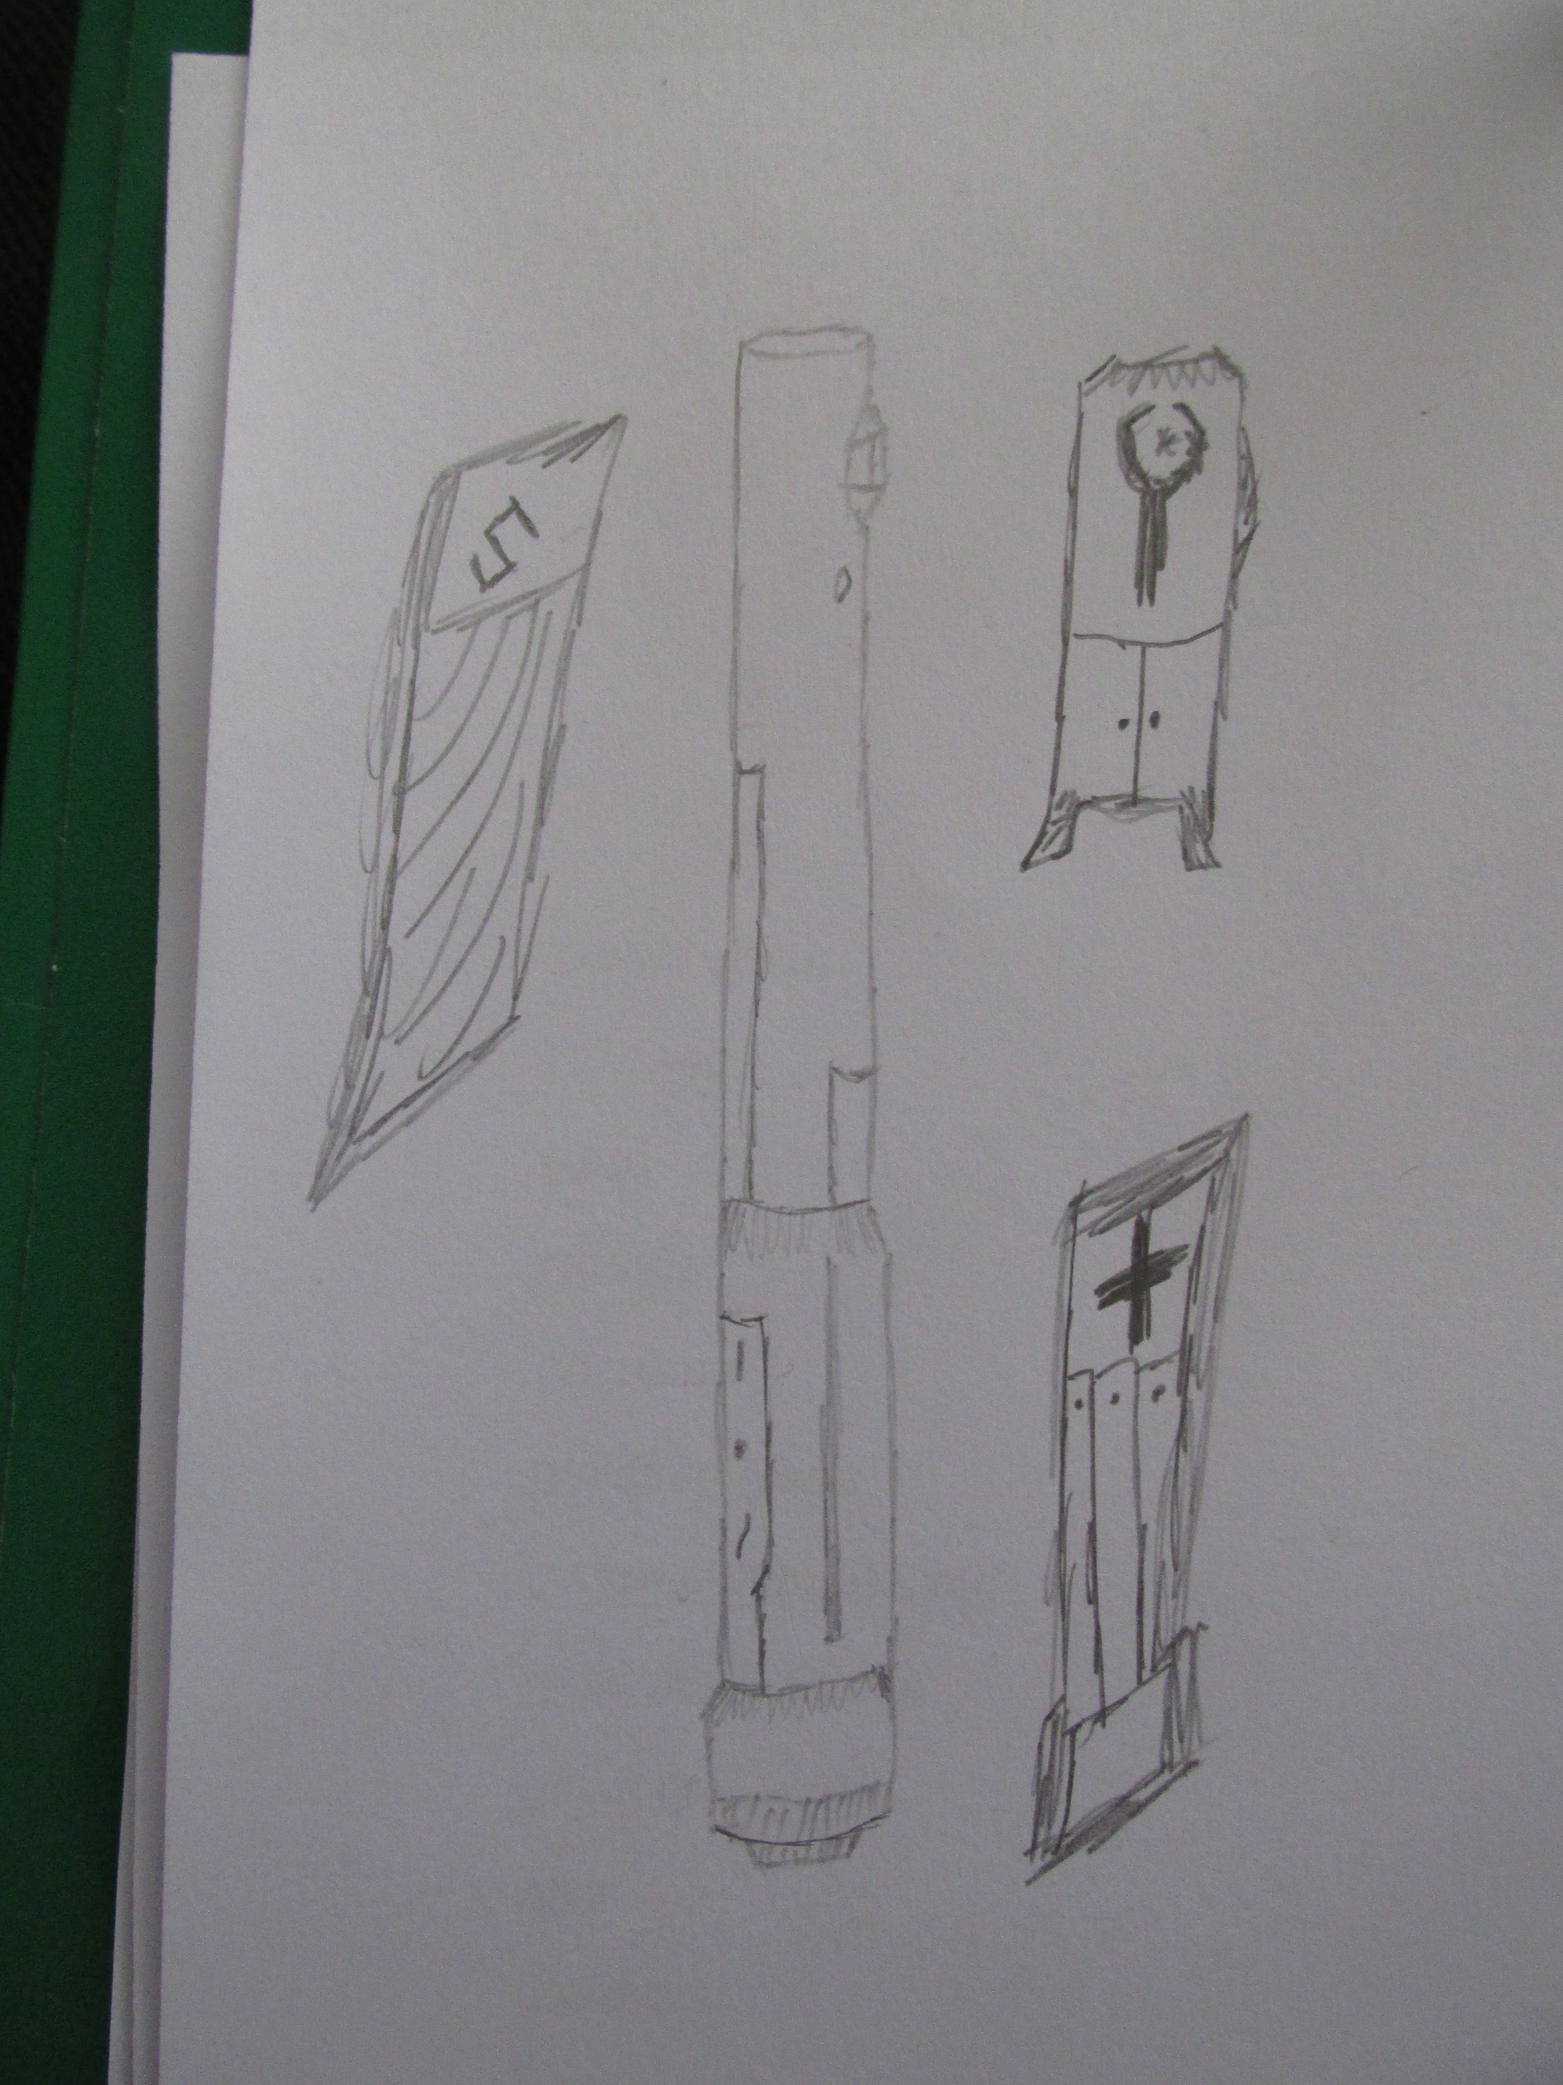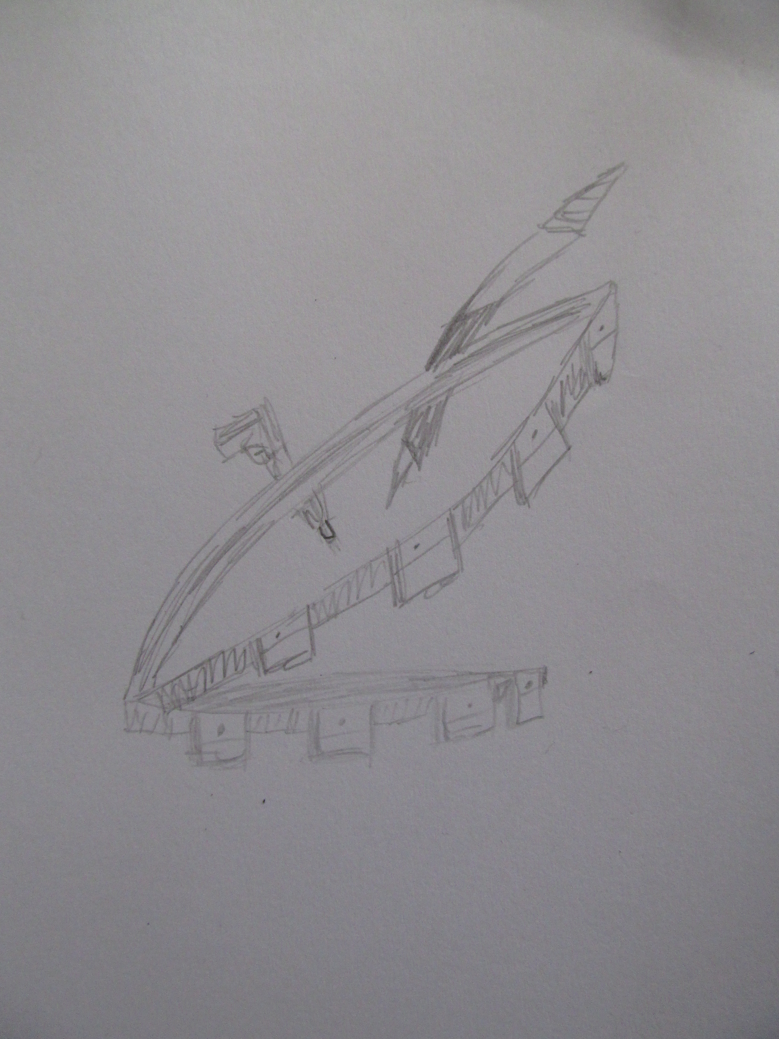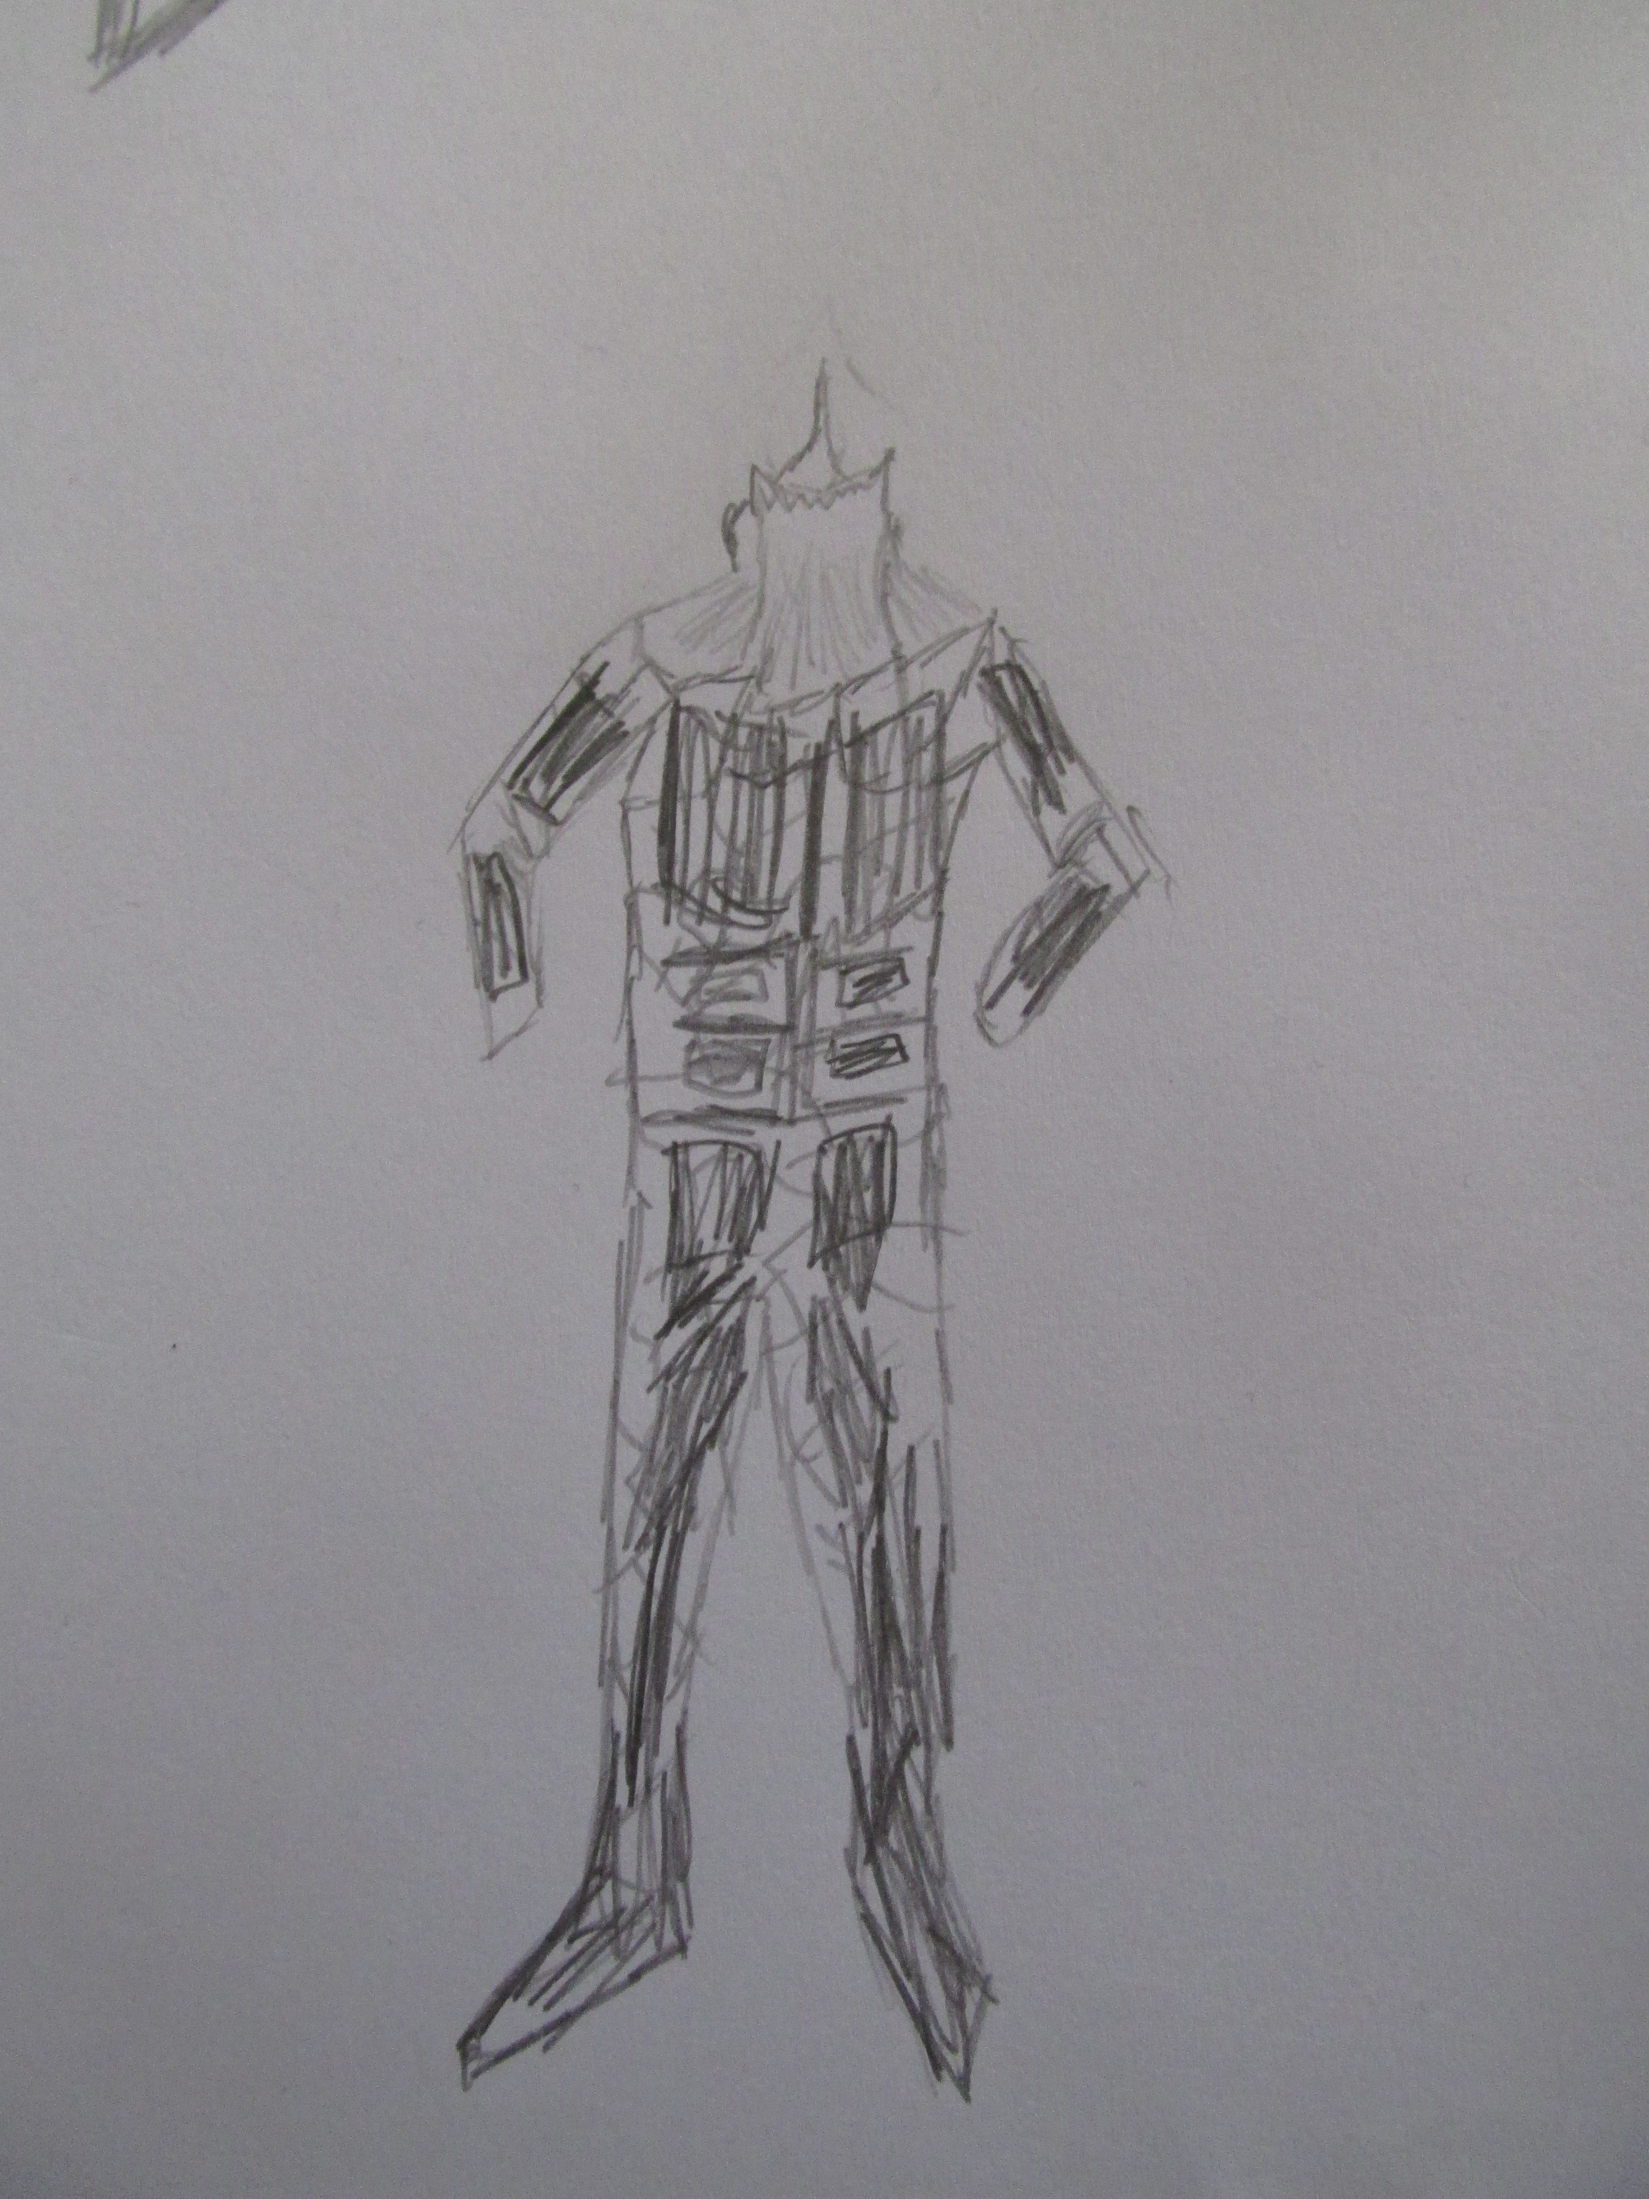Dek Rott's Herald Ideas
Lightsaber idea:
May I present, the Utility Saber. It is a slightly elongated saber with a multi-tool at the end of it. The multi-tool is not one of the favored father/son camping variety that most colonizers use. It is one meant for a Force-User that has a slightly more skill focused character. At the very back end of the saber is a computer plug in, where a storage device holds a few gigabytes of information useful to the user. Good for the spy or the slicer in you. The saber itself has three alternate different styles that can be changed out at the end. One meant for the healer within you, one for the mechanic within you, and one for the spy within you.
The medical interchange includes a slot for small medications and injection tools for the purpose of quick heals on the battle field. The medical slot also includes a bacta reserve meant for partially sustained intake until one can get to a real bacta tank itself. Lastly, it contains a DNA extractor, for those on the fly medical technological needs.
The mechanic interchange includes a small hydrospanner for tightening bolts on a droid or fighter, a plasma beam and cutting uses, and a small metal pound that doubles as a hammer and a nail or screw remover. It comes with a side plate which could be used for small measurements.
The spy interchange has a liquid cable reel that allows you to travel up side walls and levels without much trouble. It also doubles as a voice changer, which allows for easier communication between specific hidden peoples, and lastly has a functioning ion grenade at the end, used for disabling droids or computer/security systems in a jiffy.
The Utility Saber is a complex saber, but it allows a person to exist as a character outside the normal functions of being. A wide arrange of sabers exist for artistic or combat purposes, but completely ignore the duelist or force user who uses a saber as a last resort. The Utility Saber does not.
Accessory idea:
Over the years both Dark and Light Jedi have fought enemies who were slightly more well prepared than the usual array of soldiers. These Mercs, Bounty Hunters, or Loyal Soldiers were a tough nut to crack. They had tons of combat experience and rarely came to a fight or situation ill prepared. So why leave our brothers and sisters in the Merc and Loyalist fields ill prepared? What they need is what Chewbacca, Boba Fett, and Canderous Ordo all had in common: a bandolier.
A bandolier would be a single strap across the chest with a belt of pouches laying upon the waist. The bandolier can hold ammo, stimpacks, bacta, tools, explosives, or even credits and lightsaber crystals of hunted force users. So why hasn't such a simple concept made it into the accessory department? No one knows, except it would be an invaluable asset for most of our soldiers and mercs to have. Why fight the enemy ill prepared? Why fight outsiders without he ammo or bacta one needs to survive? They don't and they shouldn't. Bandoliers for everyone!
Robes idea:
Combat is mostly done through the use of a weapon. Fighting with sabers and blasters has been the norm for thousands of years. The soldiers go into battle and hopefully don't get shot with a blaster wound. A force user could use a lightsaber to fight face to face, and even deflect blaster bolts. But then we bring an unknown into the mix; the slugthrower. A weapon that is very difficult if not almost impossible for the average force user to deflect, and one that could very easily cause insane amounts of damage if shot with. Where a blaster or lightsaber leave a smoldered wound, a slugthrower leaves a dying entity with shards of pain streaking through their insides.
Let's throw out the idea that robes are needed. Why not something that could resist this pain and death inducing fragment. That is where slug-proof armor comes in. This armor does something different though. The armor itself is plated with both ceramic and metal parts that guard key open areas with an inner mesh conducive to quick body movement. The neck area though has a guard that raises up from out of the chest area. The guard itself is metallic, and guards everything from the mouth down, leaving breathing room for the nose and clear sight for the eyes. A similar guard comes up the back to protect behind the head and the upper spinal column. This design prevents both easy frontal and back attacks from melee users while also guarding key slugthrower hit spots.

