Chaos in Cocytus

Trouble in the air
The Planet Judecca has come under brutal attack before but nothing like what is currently happening. The reports of an outbreak of some weird strain of flu are incorrect. This reporter has found the deadly truth, we have been lied to. The Emperor in all his wisdom decided to lie to the people so that panic would not break out. The sad truth is that panic has broken out and that we are all going to die if something doesn’t happen soon.
This new disease turns the bitten people into an undead creature who thirst for living flesh. If you see one of these creatures run as fast as you can in another direction. Repeat run the other direction unless you are part of the military who can help destroy these beasts. A head shot seems to work the best, whether it’s a blunt instrument or a blaster to the brain. The creatures look a little like this.
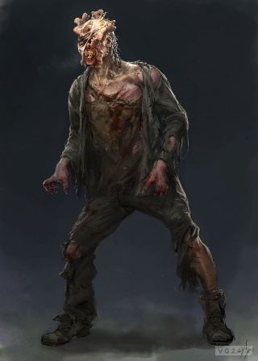
This is the closest artist rendition of the beasts that we could obtain. Their appearance will vary from this image but be careful just the same.
The Imperial Army protecting the city has withdrawn to the Palace in Ohmen and they aren’t letting many people in because of the fear of the virus spreading to their ranks. They are just trying to save themselves and that just won’t do for this reporter. We must all question what we have been told in the past. We must question the Emperor and all of his wisdom. Wisdom? Ha! He wants for himself and that’s it. That’s why the general populace is being made to suffer through this outbreak. This is why he leaves us to fend for ourselves. The Empire has always been good to us but only when it serves their purpose. When things get rough the military takes care of its own and we are left to the wayside under someone else’s control or hiding for our lives while they try to sort out whatever business they have. We have dealt with pirates, and murderous wretches, and now a zombie like creature.
When will we stand up for ourselves? When will we be able to fight for the freedom we so rightly deserve? The Empire is cruel to us and we go along with our little lives. We are in a state of panic all the time and we get little for ourselves. The time has come for the citizens of the Empire to rise up and take arms for themselves. Protect your families from these monsters. Protect yourselves from the Empire. Once this terror has abated we will get the peace that we deserve. When we leave this system and forget about the evil of the Empire and the Emperor. The Dark Jedi can go fwek themselves because we the people of the Cocytus system will no longer be controlled by the likes of them. We will be free from them soon! Mark my words.

