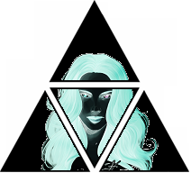

The Unknown

*by*

*Prophet Darth Vexatus (Sith) / Naga Sadow*

*In the darkness, waits no one else,* Audio:

*Quiet, alone, I open my sight,*



*Staring back, I see myself.*

*This great void, this hole, this empty shelf,*

*From high I gaze, from such a height,*

*In the darkness, waits no one else.*

*Soft, a voice, they sound upset,*

*In the dark, there flickers a light,*

*But alas, staring back, I see myself…*

*A cold reflection, not ourself,*

*Bark the light may, but there comes no bite.*

*In the darkness there waits no one else.*

*Tricks and illusions; they try and pretend,*

*To fool me, to convince me, with their dark rites,*

*That staring back I see only myself.*

*But no—*

*Blood of my blood, I see your face, my Elf,*

*Fight back if you will, it is trite, my sprite.*

*In the darkness there waits no one else…*

*Yet staring back, I still see only myself…*