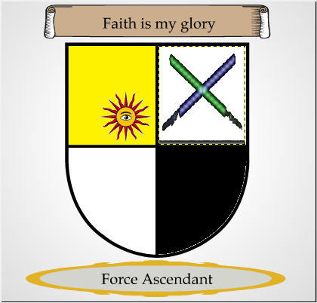

The Order of the Force Ascendant is a group dedicated to ensuring that the practitioners of the Light Side do so free of the taint of the Dark Side. Their Heraldry shows this in several ways. First their faith is solely in the Light Side of the Force, hence the motto “Faith is my glory”. While others seek glory through accolades, knowledge, martial prowess, etc. they focus on their faith in the Light.
The main portion of their Heraldry is in the shape of an old shield. This signifies their status as defenders of the purity of the Light. Within the shield you will notice a yellow square with a watching sun symbol. This signifies the Light side and their ever watching eye on those within their Order to ensure its purity. To the right of it is two sabers crossed. This signifies their willingness to fight over their beliefs and to keep their order clear of heretics and those that would taint their view.
The bottom two images on the shield represent the Light (in white), and the Dark (in black). This shows that the Order does not follow the idea that the Force is in shades. You are either an adherent of the Light or that of the Dark, nothing else.
The values of the Force Ascendant are the following:
Assertive in their nature to ensure the purity of the Light.
Devoted to the Light and only the Light.
Disciplined to avoid the lure of the Dark Side.
Righteous in their beliefs and nature.

((Note: This was made in part through the website: https://www.makeyourcoatofarms.com/app.asp Also the image of the sabers was found through google image search for “crossed sabers”.))

