The Speculation Awakens - Who is Snoke?

Knight Ranarr Kul (Sith) / Battle Team Order of the Trident of Clan Tarentum [GMRG: VI] [SA: VII] [INQ: VIII]
SC / DC / Cr:5R-8A-11S-6E-7T / PoBx3 / CFx403 / CIx13 / CEx21 / SI / SotM / SoL
{SA: MVC - MVH - MVL - MVLD - MVLO - DMPH - MVWD - DPE - DPV - SVHL}

!!!Supreme Leader Snoke is really Freddy Krueger!!!

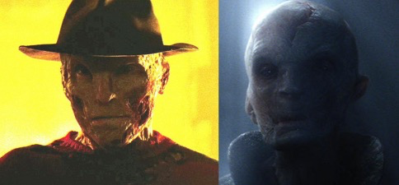
Let us first look at these images:

Can you see it?... You can!... Can’t you?... You Can!

In 2011 in ‘The Nightmare ends on Haloween II’ it was already revealed that Freddy would be given a new opportunity for doing evil. Take a look at this conversation out of the movie:
Pinhead: ‘Hello Freddy, you look surprised.’
Freddy Krueger: ‘What’s going on? What have you done to me?’
Pinhead: ‘I have taken back what you’ve abused.’
Freddy Krueger: ‘No, you can’t! My Powers...!’ (yeah... He did have Force Powers!)
Pinhead: ‘Nothing belongs to you. But we’ll give you another chance...’
(And nobody really knew it was at that point he was send to Disney!)

Freddy Krueger always prefered the Dark Side:
‘How sweet, Dark meat.’ – Freddy vs Jason 2003

Now... Looking at the image again, you could ask: ‘What happened to the hat?’ Let me explain real simple. Freddy met Han Solo... Freddy met Han’s ‘other self’ Indiana Jones... You can see where I’m going.

