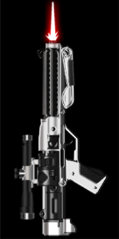
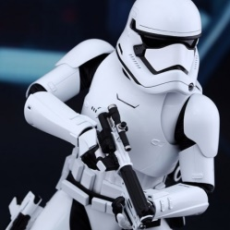
JB-007
Private, First Order Stormtrooper Corps
Dark Path, Order of the Loyalist
Weapons Specialist, Human Male, Right Handed
Height: 1.78m – Weight: 78kg – Age: 27 Years
Physical Description  JB-007 is the Stormtrooper’s Stormtrooper. Of average height, weight and build, his body might as well have been the design template for the newest generation of Stormtrooper body armor. With a strong, but lean musculature, JB-007 is clearly devoted to his physical exercise routine, but not to the point of excess. It is obvious from his casual gait that he spends as much time in aerobic and acrobatic exercises as he does weight training.  On the rare opportunity JB-007 is not in his Stormtrooper uniform, he is possessed of piercing blue eyes and hair the color of a Tatooine sunrise. His strongly defined features are handsome, if rugged, and his precise Imperial accent denotes one of the earlier indoctrination regimes of the First Order. In every aspect, JB-007 clearly represents the best ideals of the First Order’s troops. | Weapon Loadout  - F-11D blaster rifle [Link]  - SE-44C blaster pistol [Link]

General Aspects
Bounty Hunters. We don't need their scum. (Custom)  JB-007 was one of the first candidates to receive the First Order's modified childhood indoctrination regimen, and as such, much of his personal viewpoints still embody many the old values of the Empire. Along with pathological mistrust of non-human species, and a misogynistic bent worthy of Palpatine himself, JB-007 has also been trained since birth to absolutely hate fringe types. Whether it is bounty hunters, smugglers, pirates or scavengers, JB-007 would be happiest if they were safely dead, and unable to cause any mischief. | Prideful  Despite whatever all his other characteristics may convey, JB-007 retains the air of a person that is confident, if not arrogant. Minor (and often, major) things in his body language - his walk, his stance, his expressions - reveal these feelings. At times, it seems he borders upon narcissism, especially judging from how much he enjoys his own company.
Personality Aspects
Heavy Handed  JB-007 is not afraid to exploit any advantage or position of power he has when dealing with others, and relies on a combination of fear, intimidation, manipulation and shows of strength to convince others to compromise and lose. JB-007 can be quite callous in his dealings with others, and never gives up his power. This has earned JB-007 with the reputation of a “bully” and can often make negotiations difficult before they even begin. | Universal Soldier  JB-007 has a military background, and draws upon his experience to tackle the obstacles in his life. This makes him decisive, efficient, and fearless; provides him with a strong sense of duty and strength; which tends to influence his ability to fight and lead. However, a rigid mind is less compassionate towards individuals and less imaginative, and JB-007 sometimes risks appearing callous, relatable, or capable of compromising.
Combat Aspects
It is the hits that count. (Custom)  "My rifle and I know that what counts in war is not the rounds we fire, the noise of our burst, nor the smoke we make. We know that it is the hits that count." JB-007 has developed an almost sacrosanct relationship with his blaster rifle. Though he has training with other weapons, he constantly works to ensure his marksmanship with his rifle is beyond the pale. Morning, noon or night, JB-007 can be witnessed obsessively caring for his rifle to ensure that it is in proper working order, and never far from his side. | Minister of War  JB-007 is utterly devoted to success in combat, no matter the mission, no matter the cost. he has spent his life building himself in the image of war, utilizing a dogmatic regiment that has lead him to a single-minded obsession with military success and requires intense physical and mental training. This training, however, has come at the cost of anything resembling empathy or concern for others - even his superiors and subordinates.

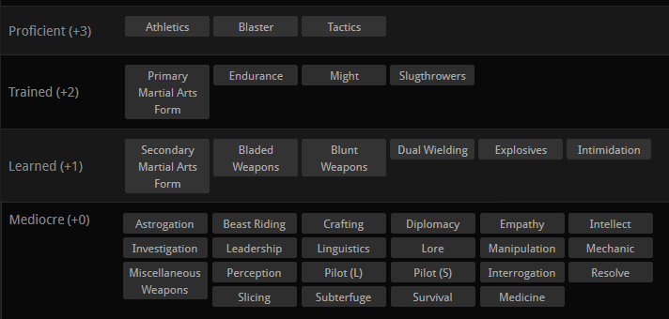

Skill Feats  Active Reload  JB-007 is familiar enough with their ranged weapon that they can reload instinctively without losing focus or skipping a beat. This allows for significantly faster reloading, even when in motion.  There Are Many Like It, But This One Is Mine  JB-007 has trained vigorously with his specific weapon of choice, and suffers no penalty when using this favored weapon in his offhand. This allows JB-007 to use his Dual Wielding skill at the same level as his Weapon Skill when brandishing this weapon. (This weapon should be noted in ‘Weapons Loadout”)  No Scope  JB-007 has a knack for pulling off accurate shots when firing off the hip or not using a scope to aim.  Medley I  The Weapons Specialist is able to temporarily use any weapon as if they had +1 skill in that weapon type during combat. This Feat does not grant increased knowledge or experience with that weapon type, just the ability to effectively utilize the weapon.  Proficiency I  JB-007 has spent years training and honing his skills with his favourite weapons. This allows him to use his chosen Primary Weapon’s associated Skill at one Skill Point higher (+1), to a maximum of +4. | General Feats  Human: Just Another Face  Humans are the most common species in most of the known galaxy, and can thus blend into crowds of other Humans seamlessly. While their own distinctive individual qualities such as hair color and height can set them apart, JB-007 is otherwise just another mug in a sea of faces.  Human: Eye of the Tiger  As a Human, JB-007 can conform to new environments with relative ease. Not possessing traits such as scales, gills or fur, JB-007 is nonetheless adaptable to either cold or warm climates with minimal preparation. This makes most members of the Human species best-suited for the life of a colonist or traveller.  Order Feat: Loyalist (First Order Variant)  JB-007 is counted among the Loyalist Order. Those that wish to serve the First Order, but lack no ability with the Force, are called to serve in the First Order’s armed forces. Whether they serve the Supreme Leader or the Knights of Ren, members of the Loyalist Order make up a variety of callings, from pilot to soldier to mechanic. Despite their lack of Force sensitivity, Loyalists receive considerable training in combating Force users; as such, they are well versed in identifying Force-based attacks, and conditioned to not balk in the face of a Jedi or Sith’s powers.

Specialization  Primary Martial Art: Jakelian  Secondary Martial Art: Teräs Käsi  Primary Weapon Specialization: Blasters | Knowledge  Languages: Basic  Lore: Lore and History of the Empire, and First Order

OOC: This is the Stormtrooper that is voiced by Daniel Craig, who fell prey to Rey’s Jedi Mind Trick in Starkiller Base. Also, ID line for the lulz.

Prophet Keirdagh Taldrya Cantor (Sith) / CON-DOC-T:R / Clan Taldryan [SA: XII] [GMRG: X] [ACC: Q] [INQ: X]
GLS / DS / ED / RS / AK / SB / GCx3 / SCx8 / ACx6 / DCx24 / GNx13 / SNx11 / BNx25 / Cr:8D-20R-42A-36S-34E-12T-10Q / PoBx16 / CFx1451 / CIx54 / CEx1563 / DSSx7 / SIx18 / SoFx9 / SotM / LSx27 / SoLx9 / S:4M-2D-2Dk-6P-14U-33Dec-5Aff-38Cr-11Rv
{SA: MVC - MVF - MVH - MVL - MVLD - MVLO - MVS - MVW - DPE - DPV - SGL - SGWV - SVHL - SVLC - SVT - SVWV - SVWP}

Dossier #83

