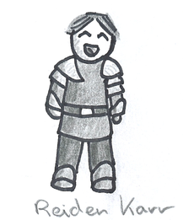

I should do some competitions today…

**A Day in the Life: Reiden**



But…I just don’t know what my character would do…



To Telegram I go!