Fang and Fury
By Shadow Nighthunter

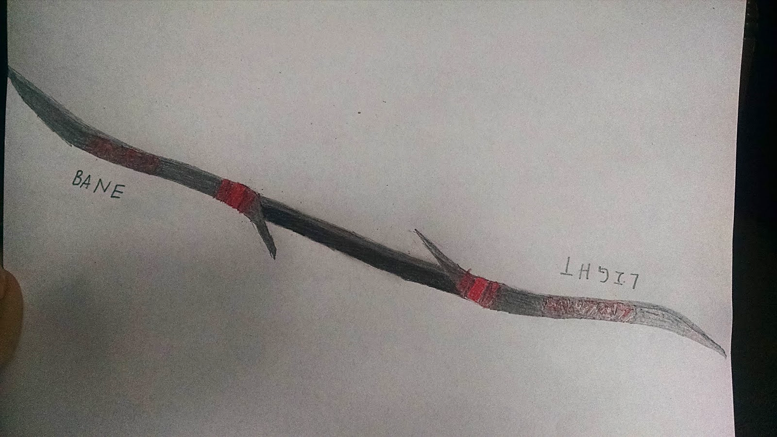

Mygeeto
34 ABY
---------------------------------------------------------------------------------------------------------------------
Frigid winds wailed in the night as flashes of light in the distance was the only evidence of a fight going on. The night was yielded no light for the crystalline environment, but that was simply not a problem for Shadow Nighthunter as she trudged through the snow towards a wall of both ice and crystal. Retrieving an artifact didn’t bother her in the least just as the icy tempest barely troubled her. If all went well, it would be a good night. However, the Sith knew better than to expect an easy retrieval with all the Sadowan pests making a mess of things.

Shadow shook her head and pushed away her annoyance towards the Sadowans as she grabbed her dagger and dragged it across the icy wall while putting some pressure on the hilt. She did this until she felt her dagger slip deeper into what must’ve been softened ice. She let the dagger slip in all the way to the hilt, and placed her ear against it as she closed her eyes. She filtered out the howls of the blizzard winds until only the vibrations and sound of the cracking of the ice had her full attention. Along with that, she could hear and feel a warm draft seeping through the growing cracks snaking along the wall. A slight grin of satisfaction appeared on her pale and ghostly face as her golden eyes glowed.

Without hesitation, she quickly withdrew the dagger from its icy sheathe before plunging it in again followed by a kick to the hilt. The thin ice shattered as snow and loosened crystal fell to the ground. With a newly established entry way, Shadow entered the chamber where there were pirates already on their feet with their weapons aimed right for her.

“Frak! It’s one of the magic ones!” a Togruta exclaimed as he fired recklessly, the bolt from his pistol sailing over Shadow’s shoulder.

“Oi! Terran, you bastard!” cried out the human group leader as he held back from firing. “Fraking idiot! I told you not to shoot at them! They’ll kill you in a second!”

Shadow chuckled in amusement, her face hidden underneath the hood and its shadow. Only the pirates’ fire managed to reveal her soft smile. “Death is the least of your concerns, gentleman,” she said as she lifted her head and gazed upon the men with her golden eyes.

“Let’s just kill her, Ga- AGH!” The Togruta didn’t have a chance to finish his sentence as he suddenly screamed in fear. “No! Stay away! Stay away! Someone help me! Mother!”

“Terran, what’s the matter with you? Terran…”

The human was cut off by another pirate screaming in fear as he fell and writhed on the floor. “Please, stop! Don’t kill me! Don’t kill me!”

The human scowled and looked up from his indisposed companions to find Shadow right in front of him with her dagger at the ready by his throat. “You bitch! What have you done to them!?”

The half-Sephi looked into his eyes, the Sith completely enjoying the taste of fear that emanated from the pirates. “It doesn’t matter. I can make it stop if, and only if, you give me the artifact within your possession. Make this easy, and I’ll end my reign of terror over your men and let you all go.”

“You think I’d believe you? I’ve seen what your kind can do!” The man glared at her, his finger still on the trigger. “You can forget the artifact!”

Shadow studied him as she pressed the dagger harder against his skin. “Well, I guess then you’re no longer of use to me,” she said as she quickly slit his throat. She then went to the other two, and slowly slit their throats as they screamed out in pain and fear. The Sith was captivated by the sight of their blood spilling onto the icy floor, but didn’t allow herself to be distracted for long as she looked to the shadows that flickered from the light of the fire.

“Quite sly of you to take it for yourself, Sadowan. However, you should’ve left instead of staying to enjoy the show.”

A tall figure came out from the shadows, and revealed itself as a humanoid male with black hair and green eyes. His face held a serious expression with no sense of hostility. In his hand was a double-bladed sword with red Sith runes inscribed on both black blades. The cold and dark aura within called out to Shadow, and the Sith let the weapon’s whispers fill her.

“I wouldn’t say I enjoyed it,” the Epicanthix said as he gripped the weapon tightly. “What you did to those pirates wasn’t exactly entertaining.”

“Well, I’m sorry to have disappoint,” the Sith said as she managed a smile. “Yet again, I’m not here to entertain you, Sadowan. Give me the artifact. I can’t keep my Emperor waiting, now can I?”

“You just may have to make him wait, Sith,” the man known as Marcus Kiriyu said firmly. “This artifact is going back with me.”

“Is that so?” Suddenly, the fire died as the cave darkened. “I’m not leaving here without it. Be a good fellow, and give it to me.”

The Dark Jedi kept his wits about him, trying to sense the Sith assassin in the darkness. However, Shadow had hidden herself well with the Force, using the darkness to her advantage. She quickly and silently made her way to his flank, and softly spoke as her voice echoed within the chamber. “Clever of you, really. Using an illusion to trick them for a few seconds that you were one of them with the help of the old fashioned mind trick to get the weapon…that is very clever. Thought you could sneak away without me paying close attention? Nice try, Sadowen, but I couldn’t help but notice out of the four of them one was missing.”

Marcus scowled as he whirled around and ignited his blade. “Won’t matter once I kill you, Palatinaean!”

Shadow had quickly moved in time to avoid being revealed by the blade’s light. That’s when she saw her chance, and she leaped at him with both of her red blades coming to life. She whirled around in mid-flight as her blades rhythmically followed her twisting body and made contact with his. The full force of the blow along with the suddenness forced Marcus to drop the artifact much to his disdain as he defended himself. The Sith quickly kicked him back against the wall and charged at him again, only for the Savant to parry her offensive blade. She struck for her gut, but she managed to bring her left blade to her defense while taking the chance to send the other blade into his shoulder. With the man screaming in pain and preparing to make a strike of his own, Shadow’s quick reflexes came to play and she unleashed lightning from her fingers into his head. His screams only fueled her resolves as she continued with the crackling and lightning barrage. She then quickly jumped away, not allowing the Sadowan a chance to grab hold of her.

“I don’t think so,” she said as she Force pulled her saber to her hand from the man’s shoulder. “I am the wolf in the shadows, Sadowan…I am fear and death. My enemies only know death from my fangs. Your suffering only fuels my fury.”

Knowing it was time to take her leave; Shadow grabbed the artifact and quickly made her way for the exit. She could hear Marcus attempting to get up, the man still alive and determined to destroy her for the artifact. Not wanting to take any chances, she grabbed a thermal detonator from one of the fallen pirates, and threw it towards the ceiling of the cave before running out. She had only gotten a few feet when she heard the explosion, and she looked back to see the section of wall cave in.

“It’s done,” she said to herself before she looked at the artifact in her hand. Inscribed on the blades in Sith was “Light Bane,” which brought about a certain temptation to the Sith. Indeed the pulsing runes and the darkness from the weapon tempted her to fulfill the bloodlust she kept at pay, but she refused to let it consume her. Getting the weapon to the clan was of greater importance. With her heart and mind made up, she embarked into the tempest and into the night.

