S H A T T E R E D T I E S
Wolves at the Door
Battleplan

Wolves at the Door
by Darth Vexatus

Legend Darth Vexatus (Mercenary) / Clan Naga Sadow (#188)

Area Layout
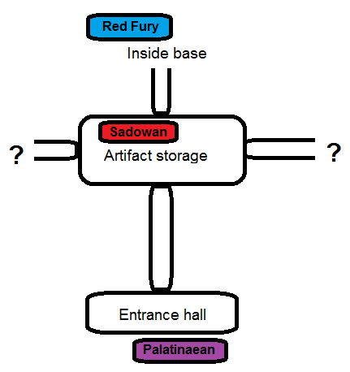

Breakdown of forces

Known knowns:

- Sadowan: 6 Foxtrot Uniforms, 300 Warhost marines

Known unknowns:

- Red Fury: Exact numbers are unknown, speculated to be several dozen, possible droid support.

- Palatinaeans: Exact numbers are unknown, speculated to be several hundred troops, with the potential for air support outside the base.

Unknown unknowns:

- Red Fury are suspected to have contacted the Kasador City Authorities, but whether they respond and/or arrive in time is unknown.

Plan

Preparations

- The Sadowan forces will partially withdraw to one of the neighbouring sections of the Red Fury base before any hostile forces can arrive. 100 of the 300 Warhost marines will remain behind to delay—but not halt—whichever of the two opposing enemy forces should arrive first.

- The 6 Foxtrot Uniforms and 200 Warhost marines will collapse the passageways behind them to further stall any pursuit by either the Red Fury or Palatinaean forces.

Initial distractions

- It is expected that the combination of the firefight and the demolish charges being set off will ensure that both the Red Fury and Palatinaean forces will hurry to the central chamber where the artifacts were previously held, the Red Fury to defend them, the Palatinaeans to secure them before they lose their chance. This will therefore ensure that both the Red Fury and Palatinaean forces will converge on the same location.

- The 100 Warhost marines left behind will not survive, but provided they have delayed the Red Fury and Palatinaeans long enough for both enemy forces to arrive, it will lead to a direct battle between the two hostile forces, with the Palatinaeans bringing in more reinforces from outside while the Red Fury pirates call more from further inside the base.

- The firefight in the main chamber between the two enemy forces will provide the main Sadowan force with time to reinforce the area they have headed to in the side chamber.

Main encounter

- Irrespective of which hostile force comes out on top, the force that eventually pursues the main Sadowan force into the side chambers will have been greatly weakened. It will therefore then fall to the main Sadowan force of 200 marines and 6 Foxtrot Uniforms to take down the surviving Red Fury or Palatinaean force, whichever should be the case.

- It is also hoped that the delay in the enemy forces reaching the main Sadowan force will have provided Sadowan reinforcement with sufficient time to call in an extraction team who in addition to providing the Sadowan Foxtrot Uniforms with a means of extraction will also be able to follow up the rear of the enemy forces so that the Sadowan forces can perform a pincer manoeuvre and put an end to the enemy forces in order to safely extract the Sith artifacts from the Red Fury base without further delays.

