OPERATION CLOSE THE “DOR”

- Support group
- Support: The Warhost Navy has provided us with 300 soldiers for support.
II. Enemy
- There are several Red Fury Pirates looking for a way out or a chance to strike us down. Also there is a team from Scholae Palatinae looking to take our artifacts. They are about the same in number as we are and probably equal in power.

- Introduction:

- The Mygeeto System is where we have landed to take on the remaining Red Fury Pirates and we have recovered several of the artifacts. From our current knowledge, there are still several Red Fury pirates looking to break away or take us out completely at the Kasador Base. Also on top of this, we have a team from Scholae Palatinae looking to steal the artifacts from our group by any means necessary. They are both dangerous, well equipped and are intent on taking our artifacts, striking out, and obliterating our entire group.There is a plan that we have developed that will help us to defend, attack, and escape if we must. With our careful planning, we should be able to take out their equally matched forces, however failure to complete the objectives we have set will result in failure and capture or killing of our entire group. We do not know exactly where all of the enemy forces are hiding, but we have spread our forces out according to our plan. The plan itself will be set up into three stages aimed at defense, attack, and escape. The entire operation will be lead by Tasha’Vel Versea, Muz Ashen, and Aul Celsus.

- Our Units
A. The Units will be divided up into three groups.
1. Group One: Led by Tasha’Vel Versea consists of 35 Heavy Infantry, 35 Clone Troopers, 10 B2 Super Battle Droids, and 20 Medics.
2. Group Two: Led by Aul Celsus consists of 35 Heavy Infantry, 35 Clone Troopers, 20 B2 Super Battle Droids, and 10 Medics.
3. Group Three: Led by Muz Ashen: 35 Heavy Infantry, 35 Clone Troopers, 15 B2 Super Battle Droids, and 15 Medics.

II. Objectives and Goals:

From what we previously mentioned there are three stages. Each stage has a primary objective.

- Defend our current position from the enemy forces nearby

- We must keep in mind that should we fail at defending the initial forces in front of us, we will have to face either being captured or killed in the event. Should we fail, we must have a plan of escape.

II. Attack the remaining forces and CSP team

- Once we successfully defend against the forces approaching, we must attack the last of the Red Fury members and the CSP team members. To do this goal we will have a plan of attack.

III. Retreat and Escape from the Red Fury and CSP

- If we fail to successfully destroy the CSP team and Red Fury Pirates, we will try to escape from the enemy forces.

- Assumptions:

- The enemy forces are armed and powerful.
1. We are expecting heavy losses with a 70% chance of success.
B. Due to the nature of our landing, they are ready to destroy us without mercy.
1. We must have a contingency plan if we fail to repel them.
C. They will be hindering our escape.
1. There is a 80% chance that all of our escape routes will be covered.

Strategy:

- Tasha Group One:
- This first group will approach the enemy front lines first and start to break up the forces.
- Their goal will be to scatter them a bit and remove them from the escape route.

II. Aul Celsus Group Two:
- The second group will approach from the left and drive out the remaining scattered forces and provide a clear way for the third group.
- Their goal will be to clear the way for group three to escape with the artifacts.

III. Muz Ashen Group Three:
- The last group will be holding the artifacts and running away.
- Their goal will be to reach the exit while the enemy forces are occupied.

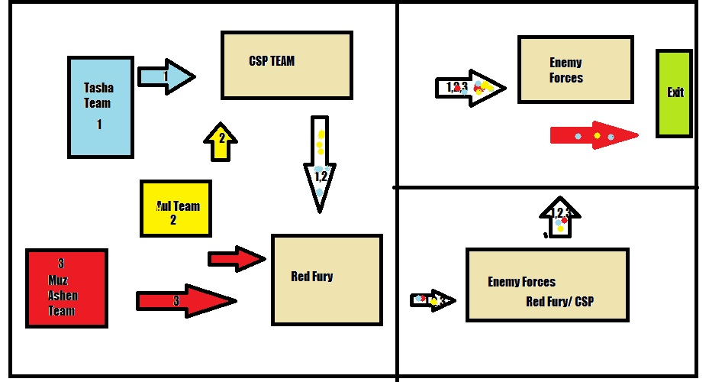

IV. Attack Formations
- Tasha and Aul Group will attack Red Fury and the CSP team to the right.
- They will go in distract/weaken the forces.
B. Muz Ashen Group will fight off the remaining Red fury and move onto the next room to proceed for the exit.
- Tasha and Aul will join the third group once it has broken through towards the exit and work on weakening the other forces till the exit is clear.

V. Proceeding to the exit
- Tasha and Aul will continue to help provide back up and assistance while Muz gets the artifacts out.
- It is vital to make sure Muz’s group gets out at all cost.
- Do what is necessary to ensure they make it to the exit.

Conclusion: As you have seen with our goals and how we will proceed, Groups one and two will be there to weaken, remove and stay behind in order to ensure that at least group three gets away with the artifacts. They will defend to the end.

Credit:
#14192 Tasha’Vel Versea: Introduction, Formatting, Units, Goals, strategy and Assumptions

#14565 Aul Celsus: Proofing, Formatting and Discussion
#3714 Muz Ashen: Discussion

