Temple of the Rains

The Temple of the Rains is an ancient ruined stone temple structure on the planet Kiast. It has no direct ties to the Force, but it is steeped in history and rumors. While the temple has been abandoned by any local groups for centuries, the structure is still a critical piece of lore for the system. When Clan Odan-Urr arrived to make Kiast their new home, this temple would catch their eye as a key to their training and focus in the Force.

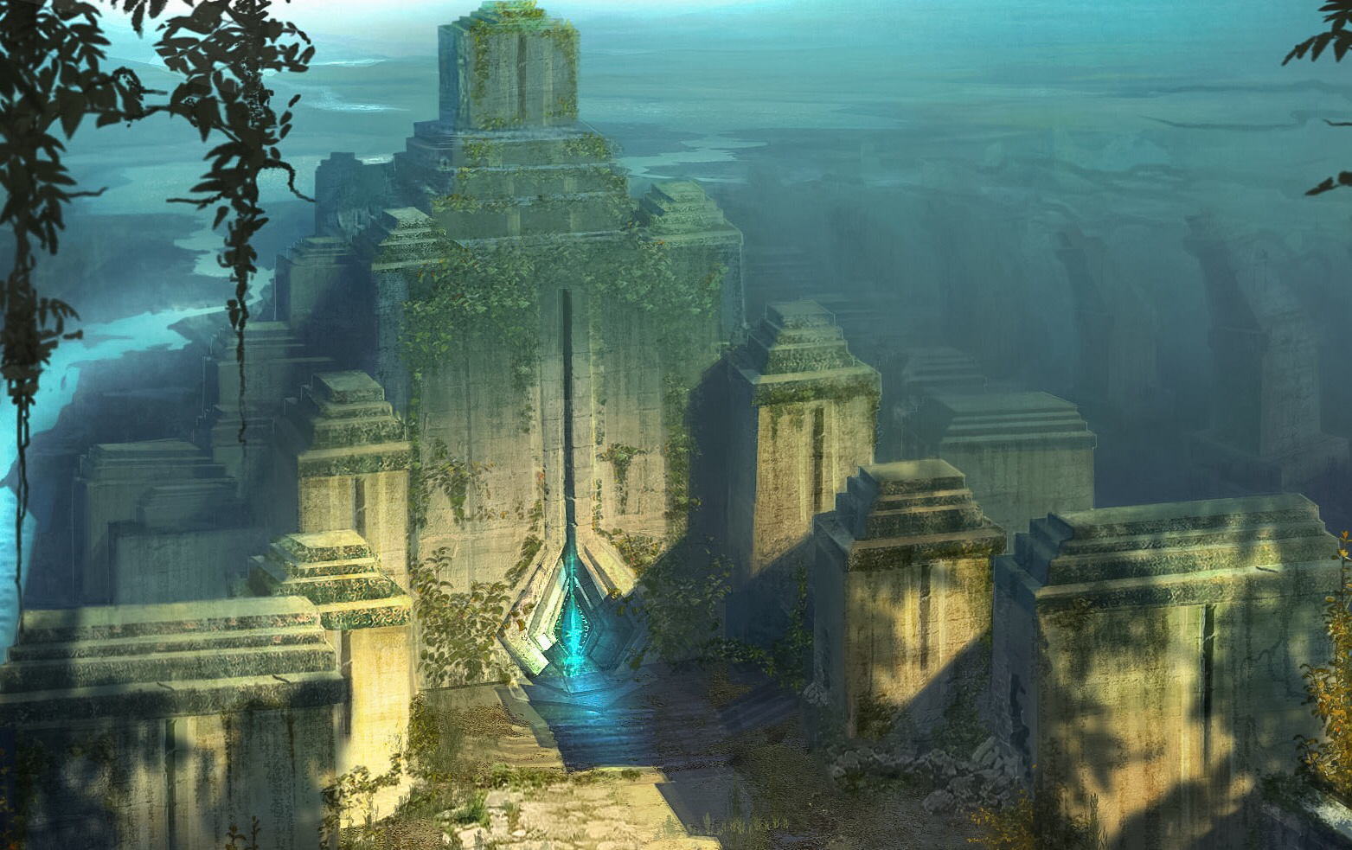
Temple of the Rains
General Information
Constructed: | Unknown, est. 540 BBY
Location: | Kiast
Builder: | Unknown
Usage
Era: | Old Republic Era, Rise of the Brotherhood Era
Affiliation: | Clan Odan-Urr, Dark Jedi Brotherhood

History

Early History

The general origins of the temple are unknown, although simple research scans and dating procedures provide an age of almost 600 years. The builders would have been inhabitants of the planet Kiast and may still live there in the present. However, it is clear that the temple has been abandoned for almost half of its age.

The building techniques used basic stone blocks of a local granite-like material, but have obvious traces of mechanized assistance for construction. But as with the builders or original inhabitants, the construction methods and mechanisms remain very much unknown as of yet.

Clan Odan-Urr Scouting Report

The initial scouting reports of the Kiast system by the Clan were very positive but excluded the temple. It was not until secondary ground scans and topography crews passed through the area that the structure was found. And given its proximity to the primary base locations it would serve as an ideal location for many facets of the Clan.

The plan would be to use the exterior and deep interior of the temple as training grounds, and some of the areas inside and out as meditation and group meeting spaces. Given the ancient nature of the structure and its unknown ownership, it would not be used as a headquarters in an official capacity and the temple would be left structurally in tact at the onset of the Clan’s settling of Kiast.

Description

Exterior

The outside of the temple was very much like a throne in a way, but becomes obvious as a cascading step setup in the stone blocks that makeup its structure. After some simple deduction of the symbols on the entrance, it was found to be called the Temple of the Rains, with the cascading blocks designed to bring rain down from the top all the way to a pool at the entry patio.

As one enters the entry-way, several outbuildings – mostly just watch-tower-like structures – line the passage. This makes for a more grandiose entrance for visitors and inhabitants alike.

Interior Layout

The interior has a few unique features that make this an ideal location for all members of the Clan. First, the grand foyer at the entrance has a waterfall feature that stretches from the top-most blocks of the temple all the way down to a cavernous basement level. This provides a soothing sound and a glorious view, with a few random beams of natural light shining through the roof and water as well.

Second, the main level is wide open to reveal stairs up on both sides as well as a small stairwell down. Going down, one would see the caverns below, fed by the waterfall – the rains cascade from outside to in, and into the caverns. There are no detectable secrets in the caverns and they are apparently there as mostly filters and outlets for the water. But wild fish, birds, and bats fill the caverns with the sounds and aura of life. No kind of Force crystals or other mysterious objects have yet to be found.

Third, going upstairs leads members to a few small chambers for meditation, meetings, or teaching. But the most impressive feature of the inside of the temple is what has been dubbed the grand hall at the top of the structure. Inside, reaching from mid-level all the way to the top, behind the waterfall feature, is a rough and thick glass window array in the form of not-quite-clear stained glass. Some of the glass has been broken over the years, which the Clan would repair upon arrival, but most remains in tact.

For the Clan, this could be used for ceremonies, awards, meditation, meetings, diplomatic calls, and any other manner of grand event. It allows just enough light in to add to the central waterfall and to the surrounding spaces.

When Clan Odan-Urr arrived, they began outfitting basic power into the temple, providing basic heating and cooling as needed, although they are rarely needed, as well as lighting for night events and some of the darker spaces. Flame-lit torches are used as much as possible to keep the natural tone of the temple.

