Crucesignatis Bracer
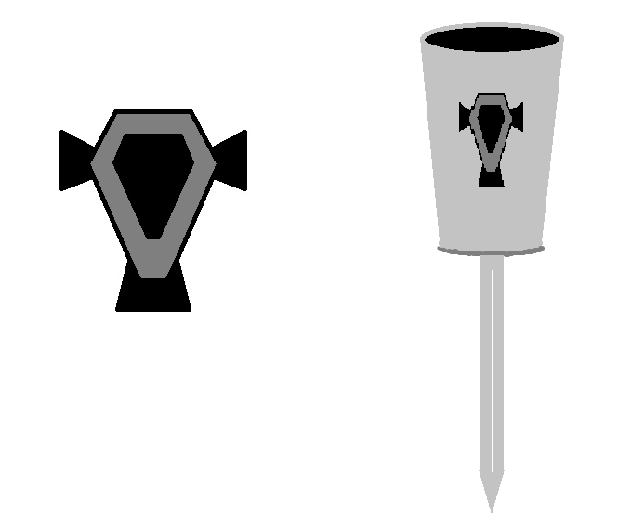
Awarded to members of the battleteam upon their induction, this hidden blade bracer bears the Imperial shield symbol of Crucesignatis Imperialis prominently on its chromium surface, and is intended to be worn proudly over clothing and in place of any other armour. The bracer itself is made of much more durable materials than those commonly found within the galaxy, allowing it to be used for limited defensive as well as offensive functions and, primarily, executions. This symbolic idea runs parallel with the function of Crucesignatis Imperialis, who serve as both a shield to defend the ideals of the Empire and a sword to strike at its enemies.

A hidden blade bracer was chosen as it is a pre-existing item in the DB possessions system which is both relatively inexpensive and useful to a wide variety of character builds. It can easily incorporated fictionally by selecting the ‘Dense alloy blade’ weapon modification and a custom cosmetic aspect.

