The Severian Principate

Ka Tarvitz, #14751 - Writer, Proofreader, Researcher
Alethia Archenksova, #14287 - Editor, Proofreader, Character Sheet Creator
Aurora “Aura” Ta’var, #10388 - Writer, Character Sheet Creator

“Palpatine is a fool. The Emperor believes that he can rule through the threat of violence, and the galaxy burns because of his arrogance. If any part of the Empire is to endure we must rid ourselves of his insanity.”

- Lucian Niatinus, founder of the Severian Principate

General Information
Governmental:
Organization Type: Republican Oligarchy
Head of State: Triumvirate
Commander-in-Chief: Master of Legions
Executive Branch: Senate
Legislative Branch: Parliament

Societal Information:
Capital: Cilurnum, Severnis
Official language: Basic
Population: 18.4 Billion
- 27% Twi’lek
- 24% Talz
- 17% Human
- 12% Wookiee
- 11% Mugaari
- 9% Other
Location: Javin Sector

History
The Severian Principate is a rare Imperial Warlord state which not only endured but thrived following the Empire’s collapse. Originally a network of slave mining worlds and orbital facilities in the Javin Sector, it existed to fuel the Empire’s war machine. This changed with the governorship of Lucian Niatinus, a commander disillusioned with the Empire’s self-destructive policies. Devoting portions of the yearly budget to improving the lives of slaves and secretly allying with the Mugaari Pirates, he sought to create an ordered state free of the tyranny which inspired the Rebellion.

Niatinus was one of the first Warlords to declare independence following Palpatine’s death. Culling the ranks of those hidebound by COMPNOR dogma, he took the first steps to abolish slavery within his territories and gave former serfs a voice in his new government. Through the promise of protection and trade deals, the Principate was able to quickly encompass nearby systems.

Despite its early successes, the Severian Principate was soon forced to merge with the New Republic when threatened by rival Warlords. Their acceptance required Niatinus to step down, but allowed the Principate to retain much of its autonomy. Under New Republic rule, the Principate instead opted to expand through trade. As worlds recovered from the war, it was able to use its facilities to establish itself as a commercial empire in the southern Mid-Rim. Nevertheless, the Principate was far from trusted by its allies thanks to its authoritarian policies and ability to control others through trade. The matter was only made worse by its willingness to circumvent the Military Disarmament Act through various means.

Of late, the Principate has found itself dealing with more enemies than friends. A recent brief but bloody conflict with the Dark Jedi Brotherhood ended with an uneasy peace, while an attempt by the Collective to usurp their government has led to multiple skirmishes between the two powers.

As a new age dawns upon the galaxy, the Severian Principate girds itself for war.

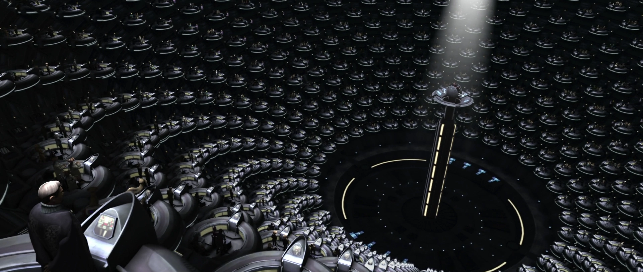
Governmental Systems and Structure
The Severian Principate is governed by a small elite, selected from the highest ranking members of their respective fields: International Diplomacy, Industry and Social Administration. These form the Triumvirate, which serves as a head of state and oversees the development of the Principate on a grand scale. While successors can be elected, the role was ultimately seen as a natural final step in a successful career. The origins of this system are found in the ad-hoc government formed between representatives of Imperials, former slaves and Mugaari Pirates.

Day-to-day decisions are handled by the Senate, formed from elected representatives of each planet within Principate space. Issues of policy and judicial alterations are handled by a smaller Parliament, the members of who are selected from a second group of system representatives. Protectorate states are not permitted seats on either council until they accept full integration into the Principate.

Culture and Territories:
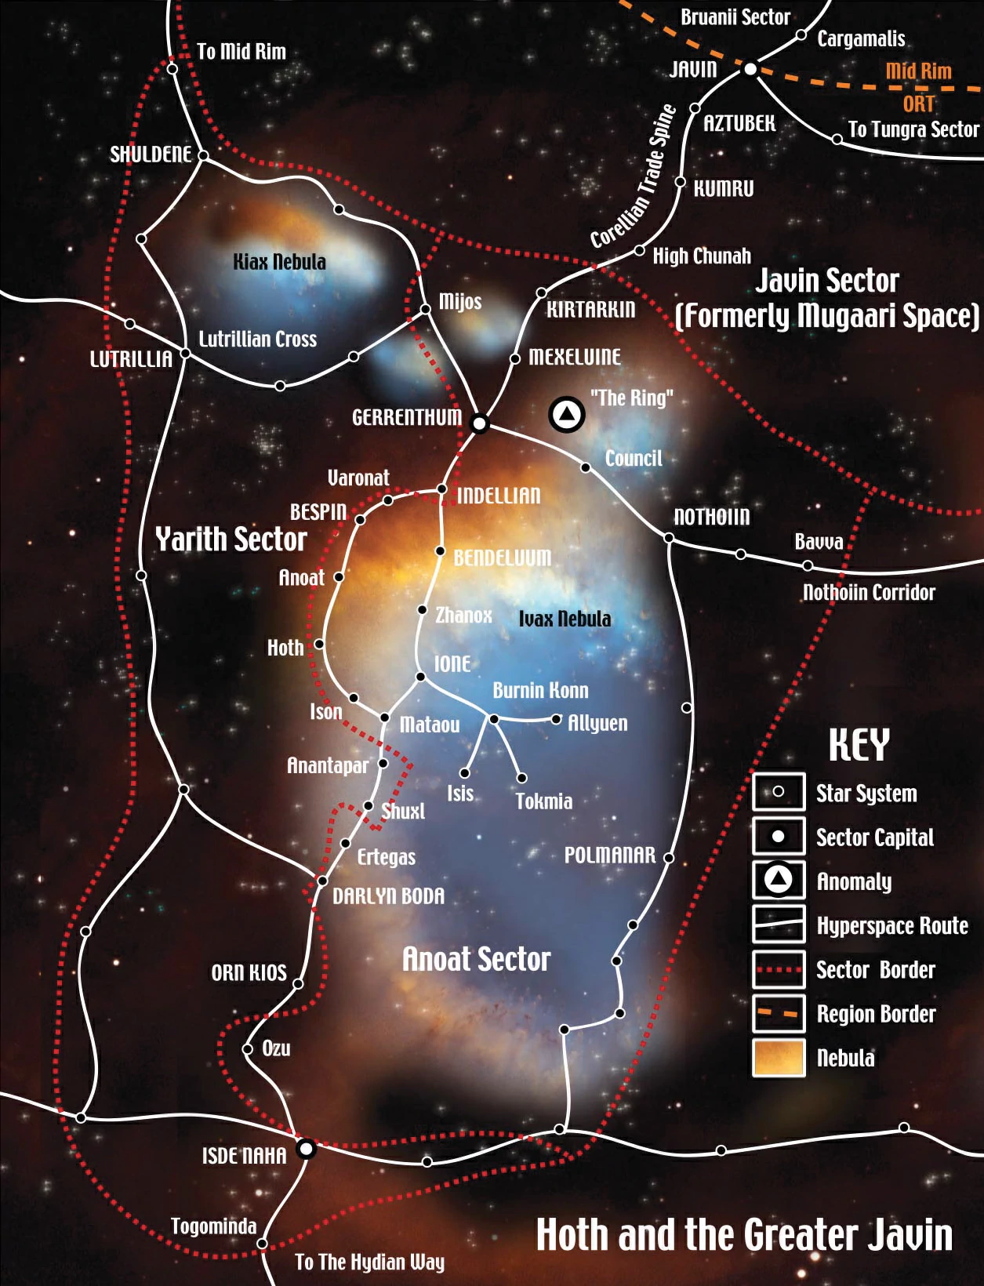
The Severian Principate’s territories cover seven populated systems and four protectorates. Situated close to both the Corellian Trade Spine and Hydian Way, it can rapidly transport ships to and from its worlds. This has been further assisted by the alliance with Mugaari Pirate factions, some of which have settled within the Principate’s borders. Most core worlds are barren mining planets of extreme temperatures, with the more temperate worlds residing in its outlying systems.

Due to its disparate populations, the Principate is a melting pot of varied cultures. Most emulate the traditions of their homeworlds, albeit with an emphasis on order and productivity encouraged by propagandists. The collectivist ideal of everyone working their part has helped unite the varied species, focusing them upon strengthening their holdings. Yet this emphasis on work is tempered by a common hatred of slavery, as diligence in work is rewarded but abusive employers can quickly become social pariahs.

Along with the abolition of slavery and opposition to species discrimination, the Principate promotes religious freedom among its worlds. The only exceptions are those which directly relate to the Force, as resentment of the Sith dominated Empire and Brotherhood led to a deeply ingrained distrust of Force-sensitive individuals.

Foreign Association and Affairs:

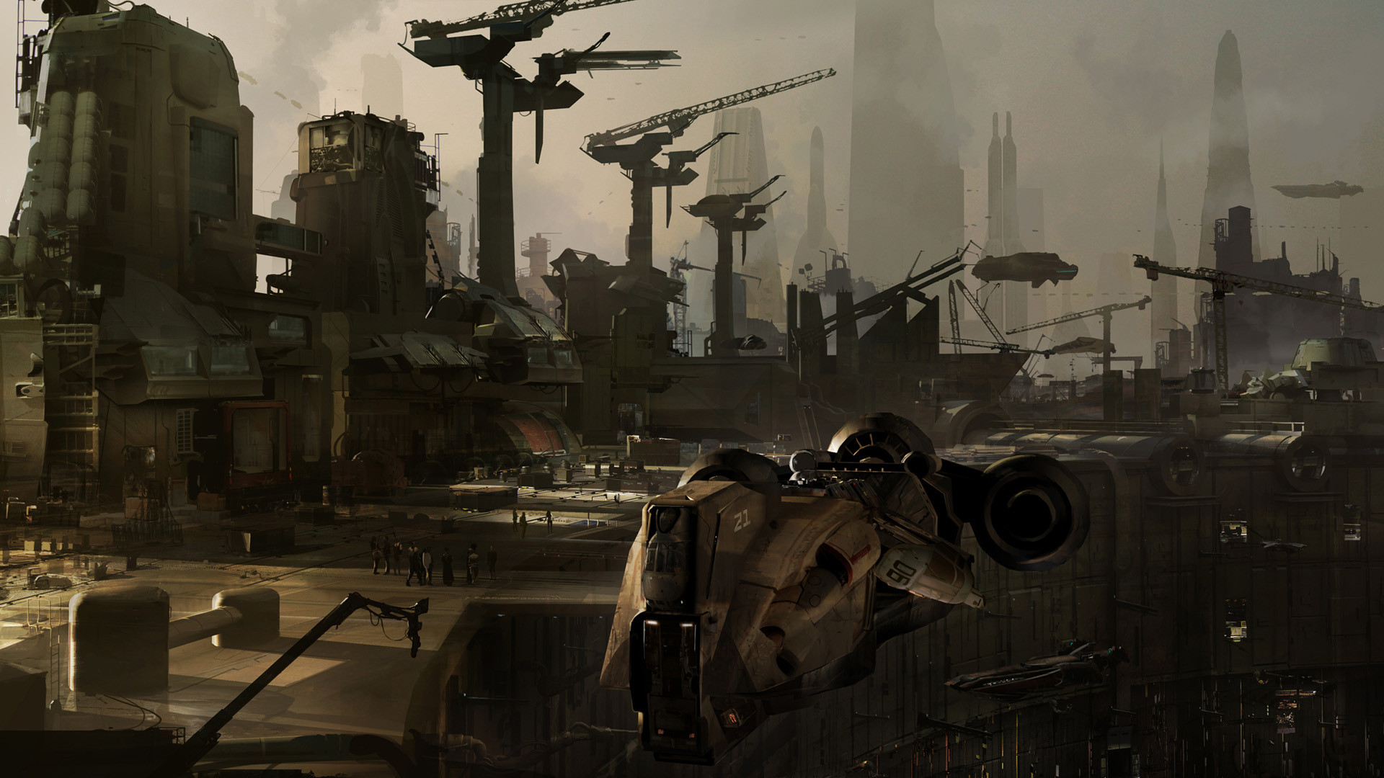

New Republic:
While a nominally a member of the New Republic, diplomatic relations between it and the Principate were often strained. The use of Imperial ideologies was decried by planets which had openly supported the Rebellion, a matter which was not helped by its expansionist policies.
Nevertheless, the Principate’s efforts to eradicate nearby slavery operations earned it allies, and likes of Kashyyyk and Alzoc III remain on positive terms as many families originated from those worlds. Equally, the Principate’s strong industry was essential in allowing multiple worlds to recover from Imperial occupation, which permitted it a more positive reputation among minor Mid-Rim powers.

Galactic Empire & First Order:
At best, the Principate’s citizens view the Empire as a grand concept poisoned by the megalomania of its rulers. While the Principate utilised its ideals of order and control as its foundations, the Empire is regarded as a blight that the galaxy is better without.

Yet while the Empire is viewed with bitter disdain, the First Order is regarded with absolute contempt. Deemed a collection of old monsters who escaped justice and young fools that fetishized tyranny, the Principate saw the First Order as its dark mirror: a government which did not learn from the Empire’s atrocities but instead came to venerate them.

The Dark Brotherhood
The short history between the Severian Principate and Dark Jedi Brotherhood has been both bloody and tumultuous. Despite a promising first contact between the two powers during 34 ABY, the Brotherhood was quick to invade the Principate’s worlds. With no regard for collateral damage or civilian casualties, the Brotherhood's superior numbers took their toll as it sought to claim the Principate's resources and remove a possible rival.

The tide only turned with the Battle of Tanith. Amassing its battle groups into a single armada, the Principate annihilated the core of the Brotherhood task force and its flagship. Forced into a stalemate and with threats gaining strength at home, the Brotherhood sued for peace. Paying heavy reparations and arranging new trading deals, an uneasy truce settled between the two powers.

The Principate still regards the Brotherhood with distrust despite their agreements. The dominance of Sith over their government and willingness to resort to violence draws easy comparisons with the late Emperor Palpatine's rule. At the moment they are at least an ally of convenience, but the Principate's leaders maintain a careful watch over their actions.

The Collective
Despite the mutual distrust between the Severian Principate and Dark Jedi Brotherhood, it regards the Collective as the more pressing threat. This stems from an attempted coup by the Collective, to turn the Principate into a source of new recruits to use against the Brotherhood.

Following the war with the Brotherhood, a new political entity known as the AFC (Anti-Force User Coalition) emerged within the Senate, promoting a program to oppose the Sith. Leading an initiative known as Severian 2.0, they sought to create combat cyborgs capable of equalling the seemingly unstoppable Force users. While it was swiftly approved and there was no shortage of volunteers, disturbing rumours soon emerged around the project. This culminated in the Slaughter of Danuvrun, where the cyborgs were revealed as mind-wiped creatures willing to butcher anyone in the pursuit of their own agendas.

Principate spies soon uncovered proof of Collective funding backing the AFC, and the defection of the Severian 2.0 units into the Technocratic Guild. In a fury at being turned into another's slaves once more, the Triumvirate unanimously agreed to violently purge all elements of the AFC and their allies. Three days after this, the heads of every AFC Senator and Collective spy in Principate space were delivered to Rath Oligard himself. Attached was a single message: Never again.

The Principate has since maintained a kill-on-sight policy against all Collective members.

Industry & Economy:
Having served as a large cluster of mining worlds and spacedocks at the time of its independence, the Severian Principate has long benefitted from a strong industry. A multitude of its key worlds are rich in the likes of Nova Crystals, Tibanna gas, and Lommite.

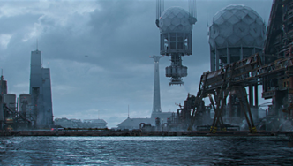
The turmoil following the Empire’s collapse allowed the Principate to quickly establish itself as a major power within the region. Many facilities previously devoted to weapons production were repurposed for manufacturing various items for civilian use, such as agricultural machinery and communications technology. This has only expanded over time, with the Principate buying out previously domineering companies and utilising its protectorate states to bypass laws preventing industry monopolies. Controversially, the Principate has even used elements of its military as mercenary companies.

Many vessels of the Principate’s trading fleet are refitted warships purchased cheaply from deconstruction yards, with the likes of Carracks serving as sprint traders. Larger ships such as Star Destroyers operate as mobile harbours, allowing the Principate to establish stronger ties with trading partners. While each was disarmed, most were left in a state where they could be refitted with weapons in times of war.

Military Doctrine & Formations:
Formed out of whatever resources it had on hand, the military arm of the Severian Principate is the diametric opposite to that of the Empire. The tactics of the Grand Army of the Republic have far more influence than anything listed within the Tarkin Doctrine, as its military relies on being able to adapt basic units to most forms of warfare while launching rapid strikes on enemy targets.

Command Structure:

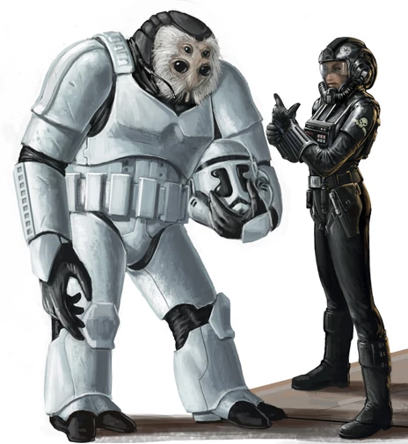
Unusually for a military spawned from the Empire, the Principate favors a decentralized command structure over a rigid hierarchy. As competence is prized above blind obedience, commanders are given leeway in how to achieve their goals. Officers will outline necessary objectives and risks, allowing for subordinates to take initiative within wider plans. This also allows the Principate’s forces to maintain a coherent leadership in the face of heavy casualties.

The most experienced of the Principate’s soldiers are drafted into the Lantic Council. This organisation discusses worst case scenarios and simulates conflicts with any power from the Hapes Consortium to the Dark Jedi Brotherhood. This is then be used to form new contingency plans, while also examining how new technological developments might impact battles.

Fleet & Army Elements:

The fleet and army elements are divided into the Principate Defense Fleet and Evocati Legions, each of which is commonly combined into Phalanx battle groups.
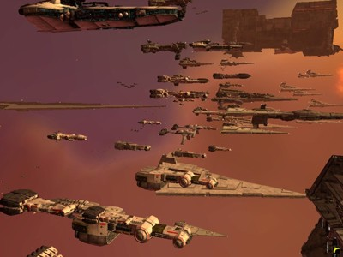
The Phalanx groups place a great deal of value in rapidly delivering substantial firepower. As such the fleet places an emphasis on carriers and frigate wolf packs over battleships. These fleets are a mix of older generation models and mothballed vessels rescued from deconstruction yards. This makes for the bizarre sight of Venator-class Star Destroyers being escorted by MC30c frigates and Fang Fighters.

By comparison, the Evocati Legions are structured about the use of heavy infantry tactics and airborne assaults. At its most fundamental level, the Legions are organized by the principle of equipping individual soldiers to combat any foe. Individual squads carry a far more varied number of weapons than those found in rival militaries and utilise of blast shields, which form an essential part of assault tactics.

Every citizen of the Severian Principate undergoes several years of mandatory service within the military. This allows the Principate to rapidly expand its armies during times of war.

References:

N/A, (2018), Reduced Military Spending [ONLINE]. Available at: https://vignette.wikia.nocookie.net/starwars/images/a/a6/Reduced_Military_Spending_Bill.png/revision/latest?cb=20150816153212&path-prefix=ja [Accessed 6 November 2018].

Galactic Gazetteer: Hoth and the Greater Javin, (2018), Anoat Sector Map [ONLINE]. Available at: https://vignette.wikia.nocookie.net/starwars/images/3/31/AnoatSectorMap.jpg/revision/latest?cb=20080309023308 [Accessed 6 November 2018].

N/A, (2018), ZZ39BA5EC8 [ONLINE]. Available at: https://www.slashfilm.com/wp/wp-content/images/ZZ39BA5EC8.jpg [Accessed 6 November 2018].

N/A, (2018), Corellia Main [ONLINE]. Available at: https://lumiere-a.akamaihd.net/v1/images/corellia-main_b70b23a7.jpeg?region=7%2C0%2C1266%2C712&width=960 [Accessed 6 November 2018].

Ben Wootten, (2018), Fel Empire Troops [ONLINE]. Available at: https://vignette.wikia.nocookie.net/starwars/images/e/ed/Fel_Empire_Troops.jpg/revision/latest?cb=20130222171536 [Accessed 6 November 2018].

Chris Barylick, (2018), 20051202warlords [ONLINE]. Available at: https://www.macobserver.com/images/columns/slackersguide/2005/20051202warlords/1.jpg [Accessed 6 November 2018].

Faction Page Text:

Motto - “Conquered by none.”

Leadership -

Triumvir of Oaths

Triumvir of Steel

Triumvir of Words

Master of Legions

About the Severian Principate -
Generous in peace and ruthless in war, the Severian Principate was founded by idealists, survivors, and former slaves. Seeking to retain the Empire’s best qualities while shedding itself of its self-destructive policies, it maintains an expansionist dominion based upon commerce.

Example Faction Members:

 | Lofurra  General, Elder 1, Severian Principate  Grey Path, Loyalist, Ace  Wookiee Female, Right Handed  Height: 2.2 m Weight: 100 kg Age: 200 |  |  | 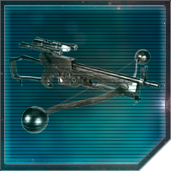
Physical Description |  |  | Loadout:
Lofurra has predominantly white fur with light brown accents on her thighs, shoulders, upper arms, chest, and head. With the exception of blue eyes, her facial features are very similar in color to her white fur. For visibility as well as professional appearance, she keeps her hair brushed back and out of her eyes. She also adorns her head with decorative beads and usually maintains a well-shined hair appearance. If one were to look under the fur they would see scars but the white fur covers any lasting marks. |  |  | Cynet: N/A  Tech: Shepherd Chip  Droid: TC-series Protocol Droid  Armor: Political Attire  Back: N/A  Weapon: Bowcaster  Equipment: Holoprojector, Performance Datapad, IM-40 Three-Slot Ammunition and Tool Pouch, C1 Personal Comlink, Stim Kit  Accessory: ID Tag  Land: N/A  Space: Lambda-class T-4a Shuttle
General Aspects
Former Slave  Lofurra grew up never knowing her family. She was sold into slavery very young, and was put to work almost immediately. However, due to her age, Lofurra bounced from owner to owner until she became a teenager. Having to endure horrible treatment during this time in her life, Lofurra has lingering trust issues while carrying an absolute hatred toward slavers. If confronted with acts of slavery, she will most likely lash out in some way, regardless of it compromises her objective. |  |  | If I Fits I Sits  Lofurra loves to fly but most ships, particularly starfighters, are not made with a Wookiee in mind and must be modified after the fact. Despite these changes, Lofurra has come to accept that she will never be given ample space in a cockpit. As a result, Lofurra has learned to be comfortable in tight spaces and is able to operate machinery with less room than most sentients would prefer. Unfortunately, this also means that her definition of personal space is much different than others, which often results in her unnecessarily crowding others.
Personality Aspects
In Shining Armor?  Lofurra has a knack for making heroic entrances whenever possible. This is actually something she works at, and one of these days, she might just be a little too late. |  |  | We Must Protect This House!  Lofurra is devoutly loyal, no matter her standing as a Senator or a War Hero, to the Severian Principate and will follow orders unquestionably. She would sacrifice her own life to protect the Severian Principate from harm. This attitude, however, often clouds his ability to see things from an arbitrary or objective point of view and he can come off as extremely narrow-minded.
Combat Aspects
It’s A Trap  Lofurra has an uncanny knack for identifying traps and alerting others to them. Now, if only she could consistently do it BEFORE the trap goes off... |  |  | Always Prepared  Sometimes the only way to prepare for the worst is to always expect it. Lofurra takes this philosophy one step further by never leaving home without accounting for every possible scenario she might expect to encounter. Lofurra tends to always have the right tool or item for a situation and has a habit of quietly and almost smugly presenting solutions before anyone even recognizes there is a problem. This foresight is far from infallible, however, and she often finds himself at a loss in situations that go beyond what she could have imagined. While incredibly practical and often a life-saver in a pinch, her perpetually pessimistic outlook on daily life can be a bit draining on more optimistic-inclined companions.

Skills |  |  | Force Powers
Sovereign (+6) | N/A |  | Grand Master (+6) | N/A
Master (+5) | Perception |  | Master (+5) | N/A
Adept (+4) | Pilot(S), Resolve |  | Adept (+4) | N/A
Proficient (+3) | Leadership, Empathy, Tactics, Intellect, Stamina |  | Disciple (+3) | N/A
Trained (+2) | Might, Blasters, Diplomacy, Subterfuge, Survival, Linguistics |  | Studied (+2) | N/A
Learned (+1) | Athletics, Medicine, Intimidation, Mechanic, Primary Martial Arts, Astrogration, Pilot(L) |  | Initiate (+1) | N/A

Feats |  | Specializations
War Hero  Your Reputation Precedes You  Cry No More  Disarming Smile  You Got a Bogey On Your Tail  Do A Barrel Roll!  Jury-rig  You Killed My Father, Prepare To Die  I See What You Did There  I've Got A Bad Feeling About This |  | Primary Weapon Specialization | Blasters
 |  | Secondary Weapon Specialization | N/A
Smooth Operator III  I Can Fix That III |  | Primary Martial Art | Wrruushi
 |  | Secondary Martial Art | N/A
Order Feat: Loyalist |  | Languages | Basic  Shyriiwook  Twi’leki  Talzzi
Wookiee: Let The Wookiee Win  Wookiee: Laugh It Up, Furball |  | Lore | - Lore and History of the Brotherhood  - The history of the Galactic Civil War including the Alliance to Restore the Republic and the Galactic Empire  - The history of the modern era including the New Republic and post-Galactic Concordance conflicts

Full Feats Listings:
War Hero: Lofurra is a veteran of well known wars or conflicts and can leverage her name, alias, or title alone to convince doubters to follow her vision or strategy. Lofurra can use her Leadership skill at one Skill Point higher when motivating new or doubtful troops to follow orders.
Your Reputation Precedes You: Before entering into negotiations with a new person or party, Lofurra’s name, alias, or title alone is enough to sway opinions in her favor. To this end, Lofurra can use her Diplomacy Skill at one skill point higher.
Cry No More: Lofurra has an innate ability to understand how individuals react in different situations. When attempting to elicit an emotional response, Lofurra may replace her Manipulation Skill Level with her Empathy Skill Level.
Disarming Smile: Lofurra is capable of flashing a disarming smile while appearing completely at ease and nonthreatening. She can use their Subterfuge skill at one Skill Point higher prior to engaging in combat.

You Got a Bogey On Your Tail: Lofurra has a knack for instinctively detecting, without the Force, when an enemy starfighter is trying to target or draw a bead on her from behind.
Do A Barrel Roll!: Lofurra has a knack for instinctively (without the Force) dodging their starfighter away from incoming fire by executing acrobatic maneuvers right before an otherwise lethal strike would blow her aforementioned starfighter to pieces.
Jury-rig: Lofurra is such an able Mechanic she can make use of some very unusual materials to get systems up and running again, often using parts of completely different machines or simple objects to replace typically complicated parts. These jury riggs don't last long, but come in handy in a pinch.
You Killed My Father, Prepare To Die: Lofurra is able to overcome a crippling injury through sheer willpower and toughness to complete her fight or mission. When focused on the task, her will is locked into finishing the conflict, ignoring her pain from injury conditions without any aid from the Force until success or failure. Even if Lofurra is successful, she will collapse from exhaustion and need medical attention.

I See What You Did There: Lofurra is accustomed to relying on their Perception to catch the little tells that reveal what's real and what isn't. When appraising an Illusion, Lofurra can reject the fabrication by focusing on these giveaways.

I've Got A Bad Feeling About This: Lofurra has an uncanny ability to avoid danger, able to almost sense it coming. Once per combat, she may replace her Athletics skill with her Perception skill expressly for the purpose of dodging an incoming attack.

General Feat Listings:

Smooth Operator III: Lofurra has an inherent gift for picking up new or unfamiliar vehicular/ship technology on the fly. She can operate any land or space vehicle, regardless of her skill in Pilot (S) or (L). Lofurra’s worldly experience also grants them a +1 Skill Point bonus to Piloting (S) or (L) when operating any kind of vehicle or ship.

I Can Fix That III: Lofurra’s knowledge of ship and vehicular technology is veteran enough that she gains a +2 Skill Point bonus to her Mechanic Skill when fixing anything from swoops and speeders to starfighters and capital ships — but only at a +1 Skill bonus when the vessel is alien or unfamiliar (to a maximum of +6).

Let The Wookiee Win: Wookiees are known for their ferocious strength when pushed into action. Lofurra can, in situations of struggle, perform temporary feats of preternatural strength, without the need of the Force for the duration of the instant. This can range from holding open a blast door or ripping a limb out of a socket to lifting a heavy object.

Laugh It Up, Furball: Wookiees are hard to miss with their thick fur and large stature. Lofurra has a difficult time blending in with other species of the galaxy, and trying to fit into tight or compressed spaces.

Order: Loyalist: Lofurra is counted among the Loyalist Order. Those that wish to serve the Brotherhood, but lack no ability with the Force, are called to serve in the Brotherhood’s armed forces. Whether they serve the Iron Throne or the military of their Clan, members of the Loyalist Order make up a variety of callings, from pilot to soldier to mechanic. Despite their lack of Force sensitivity, Loyalists receive considerable training in combating Force users; as such, they are well versed in identifying Force-based attacks, and conditioned to not balk in the face of a Jedi or Sith’s powers.
 | Ramtak  Commander, Equite 2, Severian Principate  Light Path, Order of the Loyalist, Director  Talz Male, Right Handed  Height: 2.00m / 6'5" Weight: 90 kg / 198 lbs Age: 34 |  |  | 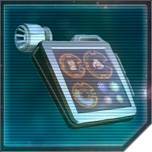
Physical Description |  |  | Loadout: Scout
Although he’s fairly small by Talz standards, Ramtak still towers over most sentients. His four eyes gleam with curiosity, and he is covered head to toe in the thick white fur typical of his species. |  |  | Cynet:  Tech:  Droid: TC-series Protocol Droid  Armor: Natural Armor  Back:  Weapon:  Equipment: H-series Performance Datapad, Holoprojector, C1 Personal Comlink  Accessory:  Land:  Space:
General Aspects
Diplomat  Ramtak has dedicated his life to the Principate’s diplomatic corps, and the investment certainly seems to be paying off. As fairy junior member of the foreign service, Ramtak was responsible for large portions of the negotiated peace with the Dark Brotherhood and currently serves as the Triumvirate’s ambassador to Arx. He is widely considered a future triumvir himself, and the eyes of the Senate are on the Talz’ every move. |  |  | Sympathizer  Empathy and compassion are critical job skills for a being in Ramtak’s position, and although he shares his fellow Severians’ disgust with the Brotherhood’s brutal Sith feudalism, he is well aware that not ever being on Arx is a mindless vessel of Darth Telaris’ will. In fact, he strongly—albeit quietly—breaks with his government’s stance on Force users. Ramtak finds them fascination, and believes that many are driven to dark deeds only because of the hostility they face from the galaxy at large. Although this opens up many opportunities for diplomacy, Ramtak’s sympathy may, in fact, border on naivety where Force users are concerned.
Personality Aspects
Always Look on the Bright Side of Life  Ramtak is very cheerful and happy, and always looks on the bright side of life. When chewing on life’s gristle, he doesn’t grumble, but gives a whistle. He always hopes for the best, and enjoys laughing, smiling, dancing or singing. This unending optimism often improves the morale and spirit of everyone around him, and Ramtak is always quick with a smile or a joke, even when drawing his terminal breath. This same exuberance can also be tiring to more jaded curmudgeons. |  |  | I Am Not A Committee!  Ramtak likes to engage in detailed discussions and think through situations carefully, often collaborating with others to seek their opinions before deciding on the best course of action. While this often ensures Ramtak is more fair and well-respected amongst his peers, sometimes others do not have time to discuss this in a committee.
Combat Aspects
Dead Sprint  When Ramtak gets in trouble, he finds no fault in bravely turning tail and getting the hell out of dodge. Obviously, this means that he tends to survive even the most deadly encounters... but the same can't always be said for his compatriots. This fact hasn't exactly made him the most popular among his peers, but hey, at least Ramtak isn't dead yet. |  |  | It’s a Trap  Ramtak has an uncanny knack for identifying traps and alerting others to them. Now, if only he could consistently do it BEFORE the trap goes off...

Skills |  |  | Force Powers
Sovereign (+6) |  |  | Grand Master (+6)
Master (+5) |  |  | Master (+5)
Adept (+4) | Perception, Diplomacy, Empathy |  | Adept (+4)
Proficient (+3) | Intellect, Resolve, Subterfuge |  | Disciple (+3)
Trained (+2) | Investigation, Leadership, Linguistics, Lore, Manipulation |  | Studied (+2)
Learned (+1) | Athletics, Might, Stamina, Astrogation, Pilot (S), Survival |  | Initiate (+1)

Feats |  | Specializations
Ambidexterity, Beast of Burden, Down Scope, Elusive Prey, I've Got A Bad Feeling About This, Just A Flesh Wound, La Resistance |  | Primary Weapon Specialization | Blasters
 |  | Secondary Weapon Specialization | N/A
Checkmate II, Silver Tongue II |  | Primary Martial Art | N/A
 |  | Secondary Martial Art
Order Feat: Loyalist |  | Languages | Basic  Talzzi  Twi’leki  Shyriiwook
Talz:The Cold Never Bothered Me Anyway, Talz: Gentle Giants |  | Lore | - Races and Species of the Known  - Galaxy, History and Cultural Traditions of the Javin Sector  - Lore and History of the Brotherhood  - The history of the Galactic Civil War including the Alliance to Restore the Republic and the Galactic Empire  - The history of the modern era including the New Republic and post-Galactic Concordance conflicts

Full Feats Listings:

Cry No More: Ramtak has an innate ability to understand how individuals react in different situations. When attempting to elicit an emotional response, Ramtak may replace his Manipulation Skill Level with her Empathy Skill Level.

Droid Whisperer: Ramtak can communicate with Droids through having a learned understanding of the Binary language without the need of a corresponding additional Linguistics skill.

Go Ahead, Make My Day: Ramtak is talented in the subtle nuances of acting or putting up a front to bluff or intimidate a target. In these instances, The character can use their Subterfuge skill in place of their Intimidation skill to gain leverage in a compromising situation.

Friend of Rancors: Ramtak has always felt more attuned to the creatures and animals of the Galaxy at large. Ramtak can communicate with animals and creatures they encounters in a conversational manner by translating their feelings into understanding with their Empathy skill.

Ivory Tower: Ramtak can delve into their own thoughts so deeply, that they can resist the pressures of everyday life through sheer effort of intellectual rhetoric. When stressed, The character can use their Intellect Skill Level in place of their Resolve for a short time.

Your Reputation Precedes You: Before entering into negotiations with a new person or party, Ramtak’s name, alias, or title alone is enough to sway opinions in her favor. To this end, Ramtak can use her Diplomacy Skill at one skill point higher.

I’ve Got a Bad Feeling About This: Ramtak has an uncanny ability to avoid danger, able to almost sense it coming. Once per combat, they may replace their Athletics skill with their Perception skill expressly for the purpose of dodging an incoming attack.

Assess the Situation: Ramtak is extremely skilled at scanning an area for information. The character can replace their Perception Skill Level with their Investigation Skill Level for the purposes of quickly gathering information on a situation.

General Feat Listings:

Checkmate II: The character has become clever at thinking through more complex scenarios when matching wits against an opposing leader’s strategies. This grants them a +2 Skill Point bonus to Intellect when formulating a plan or strategy against a familiar adversary, but only a +1 Skill Point bonus against an unfamiliar one (to a maximum of +5).

Silver Tongue II: The character is comfortable when speaking in front of others, and can deftly maneuver and adjust their speeches to the subtle shifts in a crowd to suit their desire. This allows them the ability to use any combination of two of their Leadership, Manipulation, or Diplomacy Skills at +1 Skill Point higher when addressing a large crowd or stadium.

The Cold Never Bothered Me Anyway: Talz possess a greater resilience to lower temperatures than Humans, allowing Ramtak to remain comfortable in extreme cold weather conditions, even in a light wardrobe.

Gentle Giants: Despite their gentle nature, most species find Talz inherently intimidating due to their large claws and towering stature. However, Ramtak’s bulk makes stealth a difficult. It can also make things difficult for Ramtak when trying to fit into compressed spaces or blend in with the other species of the galaxy.

Order Feat: Loyalist: The character is counted among the Loyalist Order. Those that wish to serve the Brotherhood, but lack no ability with the Force, are called to serve in the Brotherhood’s armed forces. Whether they serve the Iron Throne or the military of their Clan, members of the Loyalist Order make up a variety of callings, from pilot to soldier to mechanic. Despite their lack of Force sensitivity, Loyalists receive considerable training in combating Force users; as such, they are well versed in identifying Force-based attacks, and conditioned to not balk in the face of a Jedi or Sith’s powers.

 | Zeno Niatinus  Knight, Journeyman 4, Severian Principate  Grey Path, Order of the Force Disciple, Juggernaut  Human Male, Right Handed  Height: 1.75m / 5’74" Weight: 64kg / 141 lbs Age: 23 |  |  | 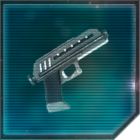
Physical Description |  |  | Loadout:
Appearance  Zeno is a well-groomed but otherwise nondescript Human male. He has an olive complexion and dark brown hair that he keeps short enough that its gentle curls are only just apparent. Zeno keeps his beard neatly trimmed and tends to maintain a fairly somber expression at all times. |  |  | Cynet:  Tech:  Droid: R4-series Astromech Droid  Armor: Casual Attire  Back:  Weapon: BlasTech DC-17 Blaster Pistol  Equipment: Performance Datapad, Corzo 2-MAL Comlink, Chronometer, Nerf-wool Towel  Accessory: Family Heirloom  Land:  Space: C-ROC Gozanti-class Cruiser
General Aspects
Legacy  “Zeno Niatinus? Like, the Niatinus?” Yes, invariably everyone Zeno meets in the Principate immediately makes the connection. Zeno is the grandson of Governor Lucian Niatinus, who ended slavery in the region and led a backwater sector through the troubled days of the Empire to become the glorious Severian Principate it is today. As a result, anyone who meets Zeno is at first impressed, then curious, and finally underwhelmed. As the unassuming captain of a simple merchant vessel, all Zeno wants is to escape his family’s grand shadow. |  |  | Something’s Inside of Me… And Now It’s Awake  It’s understandable that a man like Zeno would shun the spotlight and comparisons that come with his lineage; after all, who would want their every moment measured up against Palpatine or Skywalker? But few understand the true reason Niatinus tries so hard to fly beneath the radar. Over the past few years, something has changed in him. Awakened. Zeno has a strong, if unrefined, connection to the Force. Given the prominent anti-Force-user prejudice across the Principate, Zeno fears that if his secret ever got out, he’d be forced to become the face of all Force-users across the Principate.
Personality Aspects
All Work, No Play  Zeno Niatinus considers his work to be the most important aspect of his life. This borderline obsessions with the "job" leaves little room for any kind of personal or social life, making it difficult for Zeno to relax and enjoy spending time with others. he excels in activities that relate to their work, but the idea of work-life balance is an altogether abstract concept. |  |  | Glass Half Empty  Zeno manages to always see the down side to every silver-lining, joyous occasion, or victory. Where some may see a boon, Zeno will often see the curse accompanying it, just around the corner. Zeno's constant pessimism can often lead to conflict and the annoyance of those around him, not to mention the dampening of spirits. However, this mindset is not without its benefits, for a pessimist is far more likely to be prepared for the worst and be left unscathed by it - after all, none are more prepared for the worst case scenario than the ones expecting it all along.
Combat Aspects
Dead Sprint  When Zeno gets in trouble, he finds no fault in bravely turning tail and getting the hell out of dodge. Obviously, this means that he tends to survive even the most deadly encounters... but the same can't always be said for his compatriots. This fact hasn't exactly made him the most popular among his peers, but hey, at least Zeno isn't dead yet. |  |  | Keeping My Distance  Zeno Niatinus vastly prefers ranged combat, taking every opportunity to use skills and Force Powers to disengage from melee and instead fight at range, so much so that he has become competent at staying out of melee in the first place.

Skills |  |  | Force Powers
Sovereign (+6) |  |  | Grand Master (+6)
Master (+5) |  |  | Master (+5)
Adept (+4) |  |  | Adept (+4)
Proficient (+3) | Perception, Astrogation, Pilot (L) |  | Disciple (+3)
Trained (+2) | Intellect, Resolve, Linguistics, Pilot (S) |  | Studied (+2) | Precognition, Sense
Learned (+1) | Stamina, Blasters, Leadership, Mechanic, Subterfuge |  | Initiate (+1) | Beast Control, Farsight, Telepathy

Feats |  | Specializations
The Force is With Me  I Know That Feel, Bro  Beast of Burden  No Scope |  | Primary Lightsaber Form | N/A
 |  | Secondary Lightsaber Form | N/A
Surge I  Iron Skin I |  | Primary Martial Art | N/A
 |  | Secondary Martial Art
Order Feat: Grey Jedi |  | Languages | Basic  Sy Bisti  Talzzi
Human: Just Another Face  Human: Eye of the Tiger |  | Lore | - Lore and History of the Brotherhood  - The history of the Galactic Civil War including the Alliance to Restore the Republic and the Galactic Empire  - The history of the modern era including the New Republic and post-Galactic Concordance conflicts

Full Feats Listings:
The Force is With Me: Some might call it luck. Others would argue that there are higher powers at work. Zeno Niatinus has a knack for avoiding potentially lethal strikes by acts that blur the line between chance and skill.
I Know That Feel, Bro: Zeno Niatinus can use their Sense power to augment their Empathy skill. By reading their target's thoughts and aligning with their emotions, they can easily relate to anyone, regardless of stark conflict in personality or sense of justice.
Beast of Burden: Zeno Niatinus can perform strenuous activities while burdened by a heavy weight, such as swim, run, or perform combat maneuvers, even if they would normally have difficulty doing so given the weight they is carrying. Armor Encumbrance is negated by 1 point as a result.
No Scope: Zeno Niatinus has a knack for pulling off accurate shots when firing off the hip or not using a scope to aim.

General Feat Listings:

Surge I: Juggernauts are revered not just for their ferocity in combat, but their ability to fight longer and harder than others on the battlefield. As Zeno Niatinus’s adrenaline surges with every hit they lands or takes, they can begin to augment their Stamina to one Skill Point higher, as long as they are actively engaged in direct combat and focused solely on feats that utilize their Might or Athletics ability. When a lull in combat presents itself, Zeno Niatinus will immediately lose their stamina boost, but suffer no penalty.

Iron Skin I: Juggernauts know how to take a hit better than most. Zeno Niatinus can dig their heels into the ground and, with full concentration, momentarily steel their body against impact to prevent themself from being staggered, knocked back, or thrown off their feet otherwise.

Human: Just Another Face: Humans are the most common species in most of the known galaxy, and can thus blend into crowds of other Humans seamlessly. While their own distinctive individual qualities such as hair color and height can set them apart, Zeno Niatinus is otherwise just another mug in a sea of faces.

Human: Eye of the Tiger: As a Human, Zeno Niatinus can conform to new environments with relative ease. Not possessing traits such as scales, gills or fur, Zeno Niatinus is nonetheless adaptable to either cold or warm climates with minimal preparation. This makes most members of the Human species best-suited for the life of a colonist or traveler.

Order: Grey Jedi: Zeno Niatinus is a Gray Jedi of the Gray Path. Gray Jedi are Force users that do not ascribe to the rigid teachings of either the Jedi or the Sith. Whether they were never exposed to Sith or Jedi teachings prior to the Brotherhood, or simply because they do not agree with either Order’s philosophies or codes, Gray Jedi as an Order are not united by any single binding doctrine or philosophy. Gray Jedi of the Gray Path attempt to walk the balance between the light and dark sides of the Force. They may lean on one or the other side more, but their usage of both sides of the Force to some degree defines them as Gray Jedi.

