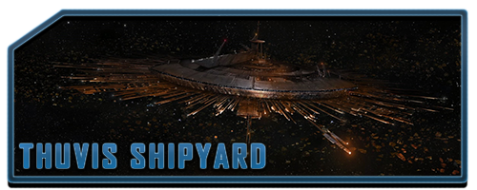

Once an Imperial Space station, Thuvis Shipyard is now on collision route with Eorillia. Inside, a labyrinth of corridors, some intact, some collapsed, and a myriad of rooms and labs in which the Empire would have conducted a lot of its research. Now, Thuvis is closely guarded by the Navy soldiers of the Severian Principate whom always shoot before asking.

The powerful gravitational pull from Eorillia makes the station a very dangerous place. With no maintenance having been done in an eternity, gravity has pulled pillars and ripped ceilings. You never know if the floor you’re walking is sturdy or about to fall and you know even less when a wall is going to give in to the pull and be dragged towards you.

Some remnants of the Empire can still be found since patrol droids still wander around the less explored areas of the Station. And most important, the pull from Eorillia is so strong that Blaster bullets will curve depending on the distance.

