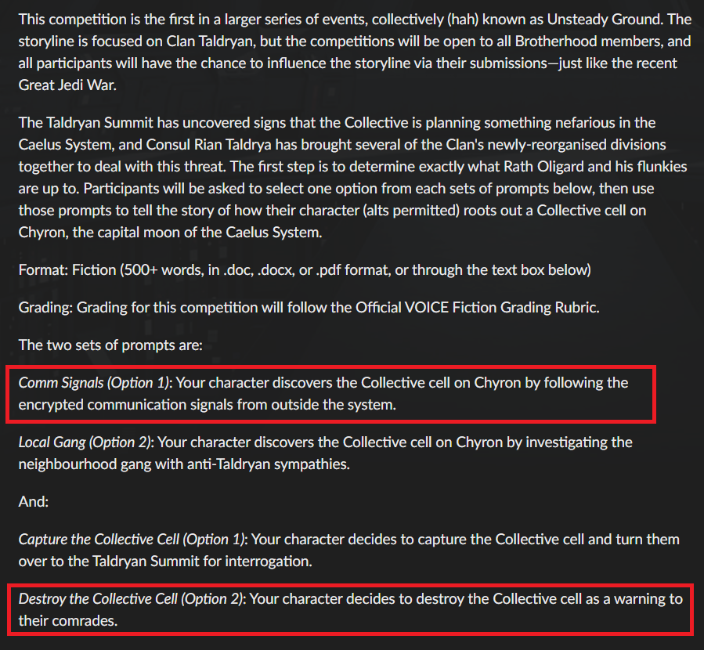

It was a morning… just another morning. Light from the nearby star shone through her small window as she lounged in her small living quarters… of which was probably a boiler room or something at one point in time judging by some large pipes on the walls and leading out of the room. She had scavenged materials to upgrade her door and fill the area with traps in case she were to be hunted. One would be amazed what traps were there… if they could find the entrance.

In her hands sat a Communication Scanner which she almost lazily watched, waiting for her teacher to get back to her on her next job or perhaps a pickup site. The device became like a radio station as she checked different conversations like forum posts. A particular conversation caught her attention:

Unknown #864321983: Next package is due to land in an hour with supplies. I’ve attached a list of supplies and coordinates.
Unknown #186432885: Covered convoy is heading out the door to do the pickup.

Jala had the scanner check for viruses or such before opening their list. Her eyes lit up as ideas formed in her head about upgrades she could make with some of those items that were hard to come by in these parts. Oh the ideas that came to her mind of what she could do to intruders… Within a few minutes the lean Sephi was out the door, stepping around and over her traps as she went to the coordinates.

---

A small collection of arm men with a convoy of vehicles were already unloading crates and boxes off a drop ship and loading them onto various cargo haulers. Their footsteps were heavy as were the discipline etched onto their faces. One of them whom seemed to be their leader snapped, “Hurry up, we need to make sure these supplies get back safely to secure our foothold here without the Taldryans noticing.”

Jala had arrived onto the scene, dashing behind crates just a bit further away and caught wind of the conversation. Her ears twitched as she listened and scanned the area… now which of those crates may have what she wants?

An Advanced Scanner popped out of its holder as she scanned as many of the workers as she could, recording their information via cable to her datapad; she’ll check if there’s a bounty on any of them in a bit… two birds with one stone would be a better prize after all. The problem now would be how she would follow them.

Jala started with gathering information on the vehicles in the convoy then saw holes in their surveillance… Perhaps a bit of sabotage would aid in tracking them down?

With what little tools and no mechanic skills she has, the Sephi ducked and weaved quietly under one of the vehicles and started to fiddle. A few loosened parts here, unplugged hose there… and off to the next vehicle to do the same to different parts. Meanwhile, her ears listened to each pair of footsteps to keep track of where they were; and in turn also conversations.

The organization ‘Collective’ was brought up and stopped her fingers from working as she realized that these people were part of the bastards whom she finished a contract for then decided to silence her… That just won’t do.

The first vehicle that doesn’t have cargo gets some ‘special’ treatment… a few extra treatments of course. Then, she scampered away undetected and watched as they finished loading up and wriggled into the transportation like rats when light is shone on them.

Jala ducked behind some crates to type out the notes and start formatting them to give to the Taldryans. After all, no need to get her hands dirty. The 6 transports made different sounds, though most seem fine, as they left the location as the dropship took off; in this time Jala started to make her way back around to get out of there and start heading to the Brotherhood to drop off the information and what she did… somehow. With the body signatures and vehicle information, any assassin or bounty hunter could easily find these people after all.

---

Just as she entered the well shaded alleyway, bo--BOOM reverberated through the air off to the other side of the building. Well, there was PROBABLY a bit TOO much fiddling, time to get out of there! Or at least enough around to see if some parts were salvageable.

Her feet flew as she dashed down a couple of blocks before going to the main road to take a look at what had happened, pretending to be some concerned passer-by.

Well, the passenger-only vehicle was engulfed in flames… still. No one was moving to save those inside. A couple of the haulers had stopped working it seems, and another was swerving… and swerving… and CRASH into the burning vehicle causing another large set of explosions that chained to one of the stopped vehicles.

This second chain caused massive panic and screaming as everyone started to run away. A few brave scavengers started dashing to what’s left to try to pick out some goodies before they get torched, so Jala went to join them.

A sack flew out of its dedicated holder as she filled her own of various things. All the scavengers ripped boxes apart, not caring too much about fragility as if it can’t handle the jostling then it might set off their goods.

Sirens were heard coming as the scavengers stopped and perked up like meerkats. They looked at each other and started to BOOK IT out of there in different directions. Jala took winding paths around before getting back to her hideout, breathing strained. She flicked on the light source and started checking out her loot one by one, categorizing and organizing on the rug-covered floor.
Well, she found most of what she wanted… and some of what she didn’t need. It was successful nonetheless. Time to give the Taldryans a heads up as 2 of the transports weren’t there.

---

The Taldryans’ facility had a large upgrade compared to last time and it seems the guards were intent on checking for identification. That’s when a waste disposal truck was coming towards the gate just by Jala. A grin appeared on her face as she noticed only 1 person in the truck itself. She waited for it to stop at the light a few feet down before walking quickly to it and grabbing ahold the backside, clinging casually as if she was supposed to be there.

The waste disposal truck stopped at the gate as she could hear snippets of the conversation between the driver and the guard before the bundle was let through. From there, it was simple to pull her hood and mask up as they made a turn inside the base.

Now the hard part was to figure out where to drop off the datadisk of information with black sharpie letters: “TO TADRIANS” on it.

---

She rounded and checked her corners, avoiding people in general whenever she could yet seeking to get into spaces where it looks more and more ‘luxurious’. There, she bumped into a female Zeltron in some spiffy uniform, forcing their datapad to clatter to the floor as the taller figure’s hand brushed past her face. Her ear twitched as it was touched and she leapt back to have her own personal bubble not be invaded.

Jala panicked and tried to shove the datadisk into the figure’s hand where a lovely voice chuckled, “Newbie too? Nice to meet you. What is this?” Oddly, Jala’s tensed muscles to escape softened and her nervousness to escape dissipating, guard dropping. It felt… wrong. She turned and ran as fast as she could to escape whatever it was with the voice calling behind her, “Wait!---” before anything else couldn’t be heard.

As she got further enough away, her sharpness returned and she found her way to some stacked boxes by a wall due to the upgrades in the in-progress stronghold to hop over and away.

---

Proconsul Erinyes called out, “Wait! You’re not in trouble! What is… uh… they’re gone...” She looked at the datadisk with the bold characters on it puzzled and walked back to her office. There, she took out a datapad and attached a datablocker device in case the datadisk had a kill program on it. Looking at the files, it was safe.

Her eyes lit up in interest as the news of malfunctioning vehicles had hit the news hard with no obvious information gleaned from the remains. The sabotage had fully burned away any signs of 4 of the vehicles.

Eyebrows narrowed, the Proconsul decided to try to search for an oddly quiet member finding none that matched the high of the hooded figure. No searches on preference to hood and cloaked figures either. She leaned back in her chair and thought for a moment about any clues. Her hand had brushed past a soft-skinned face, and an ear, a sensitive one that twitches; the figure had brown eyes but a covered face. The ears…

Fingers danced across her datapad as she plugged in various races that could have those ears, eye-color brown, and approximate height. 8 search results, not bad. Erinyes looked at each, none were a match. Was this person even a member? Should be impossible for them to get this far in then. Might as well do a full database search for anyone.

9 results.

She shook her head slightly in disbelief, did the number just go up slightly? A couple taps to remove the members leaving one slightly pixelated figure. Eyes were not captured well in the surveillance cam, but her Sephi ears stood out as she wore a Taldryan uniform with miniscule regulation errors. The information referenced one report, one written by Justinios Taldryan during the war with the Collective.

.

