Headshot/Image | Oslo  Grand Master, Defender  Male Human, Right-Handed  Height: 2.26m , Weight: 276kgs, ± 2000 CY
Physical Description |  |  | Loadout Weapons
Oslo is a tall, very muscled man. He is bald and sports a huge orangey mustache. He wears nothing but leather pants and boots, despite living in the Cold mountains of Selen.

His eyes are of a warm honey like brown.
General Aspects
When life gives you Curdled Milk, be patient. You get very good Cheese!  Oslo is the first to tell you never to give up on your dreams. Just as he has fought countless times against impossible odds, so can you, he’ll tell you.  And who doesn’t like good cheese? |  |  | The Hero of Gundaabar  Oslo isn’t seen by many these days. In the past, he was regarded as a hero to the people of Gundabaar. Now, he is but a legend, a bedtime story passed down from elders to younglings. But even if Oslo isn’t seen around anymore, his legacy and all he embodies live on as teachings to the young.
Personality Aspects
Take Heart!  Oslo always goes the extra mile. He makes sure whatever he does is achieved with complete success. He finds inventive ways of achieving solutions to his problems. “If I can’t open Door, I’ll go through Door.” Is a saying he usually tells people he meets that are facing any kind of problem. |  |  | Sometimes Icy soul just needs Warm smile!  Oslo is always smiling. Those who are weaker than him need it. He is always happy to help those in need. Even those who refuse his help are usually a warm smile away from melting to his friendliness.
Combat Aspects
Mother always said, Don’t Lose!  For the sake of those who cannot fend for themselves, Oslo is there. He does not allow himself the luxury of losing a conflict, as there’s usually a life on the line. If Oslo is knocked down, he gets right back up and stands strong between his foe and protégé. |  |  | Today we fight each other… Tomorrow, we may fight together!  Oslo will fight any who demonstrate evil intentions. Although, he is the first to fight besides them if they see the error of their ways. No enemy is true enemy.

Additional/Optional Information

Top Skills | Athletics +6|Might +6|Primary Martial Arts Form +6  Stamina +5| Leadership +5| Blunt Weapons +5  Empathy +4|Creature handling +4|Perception +4  Survival +3|Resolve +3|Intellect +3  Intimidation +2|Investigation +2|Medicine +2|Crafting +2  Diplomacy +1|Tactics +1|Miscellaneous Weapons +1|Mechanic +1
Force Powers
Feats | Beast of Burden|Cry No More|Creature Affinity|Just A Flesh Wound  Daredevil|Sleeping Rancor|This Is Where We Fight  Your Reputation Precedes You|The Force Is With Me
Martial Arts | Wruushi
Lore
Languages | Basic

Character Reference Art:
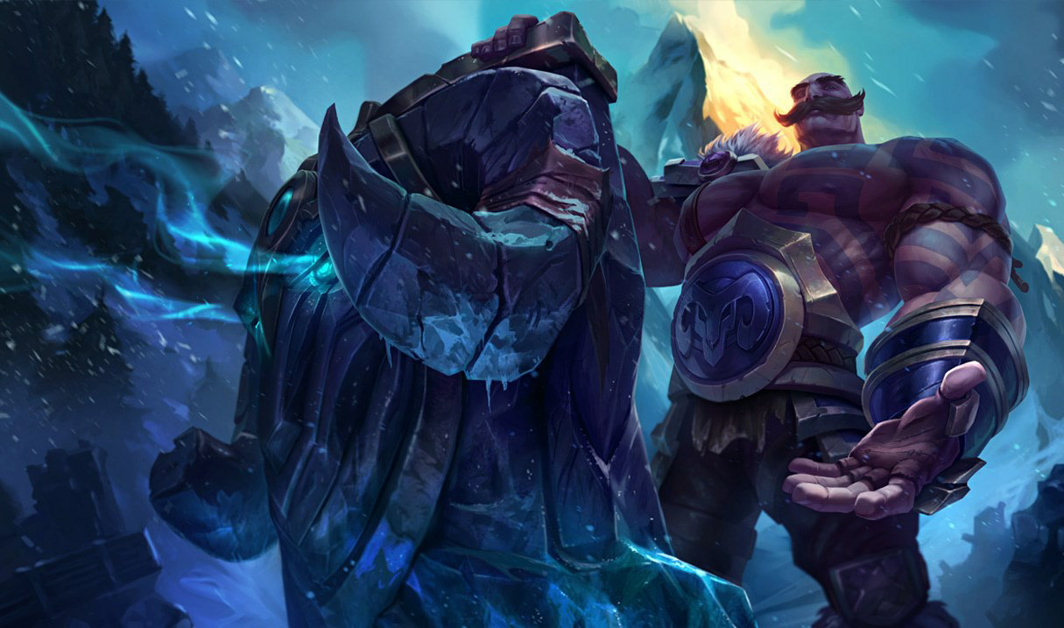

Notes/Extra
Oslo is a mysterious man. He is in fact alive and his lifespan is already over 2000 CY. This is due to the fact that Oslo has been blessed by the Force.

As one who embodies true Goodness, Oslo has been given a very long lifespan. Miracles like this one are rare but they’re not unheard of. One such example is Jedi Master Fay, a Human who lived more than 800 CY.

In Oslo’s case, despite him being Force sensitive, he does not control or manipulate the Force in any way. He is a simple man, always ready to jump in to help those in need.

His legend is all but real, though too mysterious and confusing for mortals to understand.

Who knows when the Force will set him free? Until then, Oslo will continue to help those in need.

