Dandoran: Casino Arena
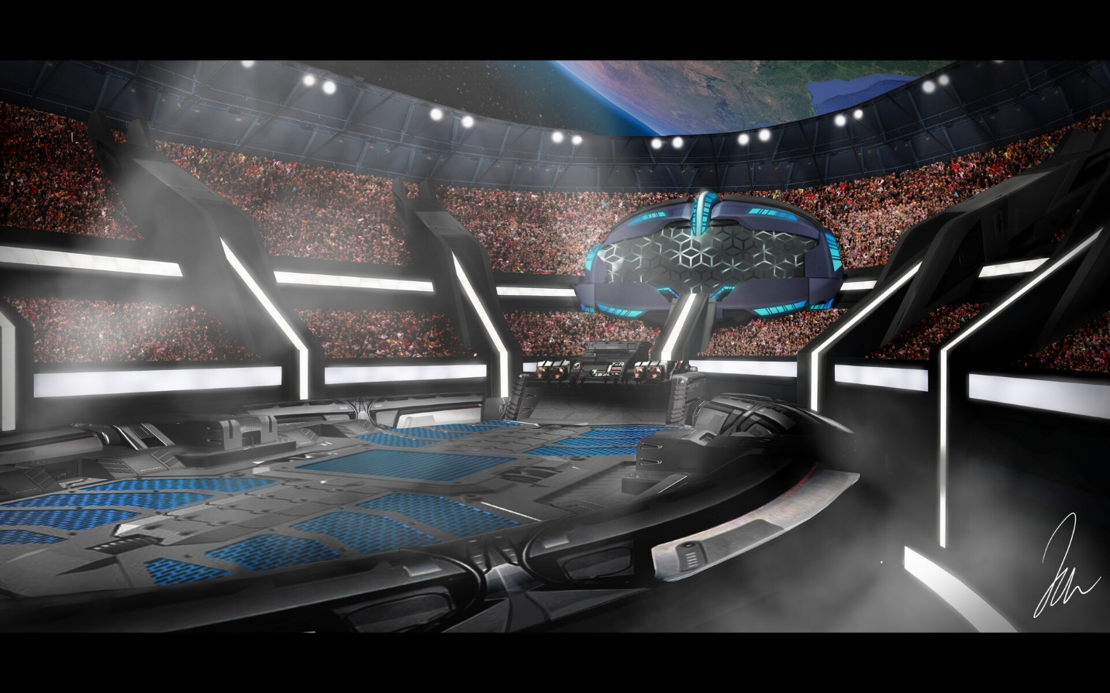
The Garganta Galleria Casino Hotel’s gilded dome complex holds all manners of spectacle. Ranging from golden statues of the Hutt Owner, to circuses, to all manner of high society masquerade balls, few spectacles match the grandeur of the Casino’s main event arena. The Golden Legacy Bowl presented by Py’zah the Hutt plays host to the largest events held on the casino grounds. With a seating capacity of ten-thousand, the cavernous arena feels empty without scores of shouting fans in attendance.
With stadium style seating, crowned by lavish viewing suites there is no bad seat in the house. At one end of the stadium a particularly large viewing gallery, complete with a Hutt sized dais is particularly noticeable. A large holo-projector hangs from the gantry ways and catwalks above, frequently displaying advertisements and information regarding the current event. In the gantries, spotlights and pyrotechnic projectors can be seen.
The current configuration of the arena is set for an upcoming bout between two famed prize fighters. In the center of the circular arena lies The Hexagon, a Six-sided cage ring complete with deadly laser fences. A transparisteel false floor reveals that The Hexagon sits above the one of the Hutt’s prized Rancor Pits. The controls for the trap door can be found next to the Hutt’s lounging place upon the dais. All entryways into and out of the arena floor have been closed, allowing for the final preparations to be made away from prying eyes.
Warlord Thran Occasus-Palpatine (Sith) / Clan Scholae Palatinae [SA: V] [INQ: VIII]
Image credit Jamie Warner: ‘https://www.artstation.com/artwork/0nao8Y

