Chapter 1: A Lost Hope

Exospheric Orbit
Mu-Rigil 186f
39 ABY
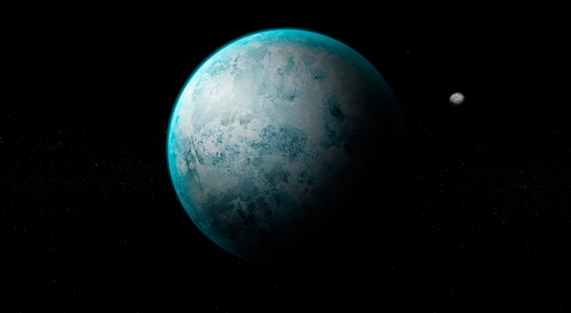
The world orbits a weak star locked in by the tide. The southern hemisphere is a tectonic desert with a sun that never sets, and the north is in perpetual frozen darkness. The historical records show very well-preserved settlements on both ends. To the north has a hidden large landmass that tells of a world with one ocean. It once hosted life and contains archeological remains. A severe glacial encased the remnants of a possible civilization under the ice. The snow around the equator glistened off the star's light like brilliant gems and gave color to the once orbiting meteorites. The rings were three layers thick of a once colorful array of precious medals. The archeological expedition turned into orbital mining after they failed to produce what their investors had hoped for.

This world's life wasn't completely extinct. Settlements in the southern desert report findings of a colossal skeletal carapace akin to stomatopods. Settlements have also turned up completely destroyed. During the search for civilization it wasn't enough to look for patterns but something that could be considered verifiable information. Reserve engineering the device left by the progenitor civilization showed computation with advanced algorithms, use of chemical fuel, and hydro-mechanical movements.

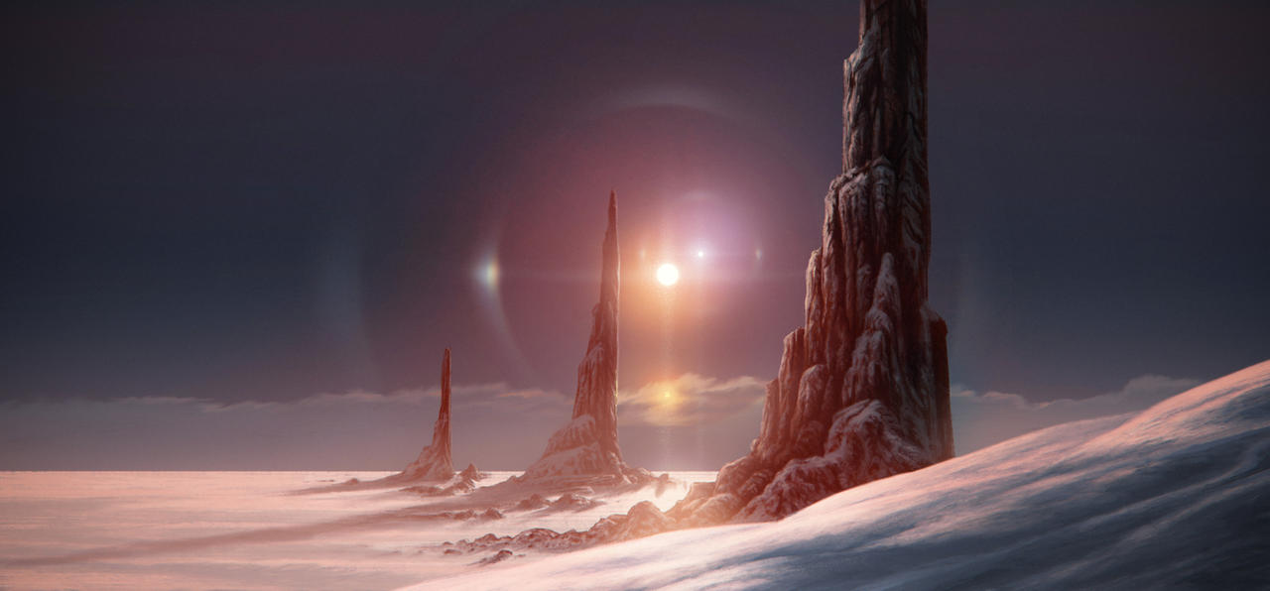
Creon turned off the hologram display screen and proceeded into the atmosphere towards the equator. He followed the given coordinates of the distress frequency caught by the Guardian Corps. The clouds were colored in copper, silver, and gold under the perpetual glow of the horizon sun. Underneath were large waves of sand pierced by the root of a manufactured rivers and vegetation. Creon avoided landing near the settlement buildings in favor of a more remote location. He followed the copper clouds until he found traces of stone in the sand. He then parked his starfighter under the shade of a large enough rock and waited for BD to begin its geo-mapping software and save the coordinates for where the ship had been parked. BD then locked itself onto the face of his jetpack as he took off towards the village.

About two kilometers outside the farthest building the Mandalorian landed and concealed his jetpack in foliage. BD took note of its location and rode on his shoulders as he walked. The appearance of his armor and weapons brought some attention by the locals. They were dressed in fibers of cotton, wool, and leather in buildings made of metal and wood. The metal ones were large but few, and were constructed after recycled ship parts and industrial mining facilities. The wooden homes were produced by dense wooden grass by the agriculture along the main river. A generation of farmers and construction craftsmen profited through housing; meaning the population had grown since its arrival. Creon found a place to stay and to rest.

The Next Day

"Not to seem rude, as you look capable. But I expected more, like a naval armada," the politician that petitioned the Corps remarked.

"I am the first, not always the only," Creon replied.

"Fair enough. I am plagued by the indigenous lifeforms as they have nested somewhere nearby underground and continually invade our territory and destroy our agriculture. They have taken many lives and have nearly cost us our economy. If we are to survive and continue our trade depot exports, we need these creatures off the area. Your Corps would be graciously offered trade agreements with us if you can clear a 50km distance from them and our farthest outpost."

Creon nodded and bowed, "I will get to work."

"Oh but please," the host insisted, "Dine and speak with us."

Creon met many of the villagers leadership. They were corporate owners of each industry involved in the processing of raw materials. Each owner was a diplomat, of whom each worked together in the distribution of wealth throughout the payment of employers and cost of goods and transportation. They asked Creon questions about engineering and technology, looking to expand their methods of trade for better wealth. Some also sought to employ Creon into their security forces with the offer of a sum that was more than the Consul and Proconsul's net worth combined. The economic impact of wealth from the resources from this world would be enough to cause a galactic scale inflation, leaving those who profited most the economic elite. This elite would then spend their wealth with the ideology of Enterprise Democracy to the Republic, just after it has suffered the consequences of a war from the First Order. The dish was from a greenhouse and wasn't of the same quality as to some places on Naboo Creon recommended. He was given room and board for the duration of his stay, but was pressed by questions as to how exactly he planned to destroy the bugs. Creon explained a daisy chain of explosives from surface to the queen would ensure an entire kingdom killed. This was explained before to them by some of the surviving miners, but none had the courage to delve into the center of a hive's nest.

A few hours later

Creon stood beside his starfighter parked in a hangar bay. He waited until he sensed no other presence nearby in the Force, and used the vessel's projector to give a life size hologram of Jedi Master Kah Manet. The projection was still the holographic opaque blue, but the quality of resolution was nearly lifelike.

Creon saluted in attention, "Sir, here to report." The Consul put him at ease. Creon explained that the protection plea was due to the insectoid lifeforms inhabiting the world. He went over the terms on the possible trade agreements also explained a lone demolition plan to collapse the hive nests.

"Yousa no do this alone. mesa sending reinforcements."

"I request a demo team with mines and a few dozen demo charges. The wealthy here have some stores of slugpowder from the orbital mines that we can use to make more if needed. I'm going to recon the ant hills we need to hit and their depth. My droid is sending you the coordinates to where my vessel is parked, as well as a direct comm channel to my helmet once they make planetfall."

"Yousa will be getting a big boom specialist. Councilor Tavar with some vatali merchants will arrive to speak about the trade agreements yousa mentioned. Yousa mate is coming too. She volunteered to join in the mission."

"Of course," Creon replied with a long drawn out sigh.

"Report yousa findings after survey of the area. Manet out," his holographic image faded from view.

After a warm meal and a peaceful moment of meditation Creon began his work. He received the coordinates to each of the outposts and a digital map of the layout of the land. He applied this data to BD who made an identical rendition of the map with its own software. In his ship he patrolled areas with the most recent disturbances until he was able to isolate a working alien bug working to find food. He easily killed it with a single shot of his laser cannon. What was left of the remains he scanned and studied. He named this particular species a "Worker Beetle" and scanned it to add into the Corps database. It measured 120cm in length, 82cm in height, and had a dead weight of 40kg. The head and legs were armored with a chitin-like armor composed primarily of long-chained polymers of keratan sulfate. Its eyes were small and ears even smaller, though it possessed two long antennae at the head. The digestive system looks to be able to use a derivative of glucose, and it was unclear with how she shot the specimen as to how they reproduce.

He searched for more in his vessel and found a few more workers carrying various sediments, foliage, and carcasses towards a large mound. The color patterns on their shells seem to vary based off the seasonal and geological influences. As he approached the mound he noticed two different species at the mouth of the mountain entrance. Unlike the worker beetles, these had eyes facing facing forward, chitinous mandibles, with a notable musculature and outer shell. Long range scan put one at 157cm high with a projected weight of 400kg. After it had been scanned, the creature jumped upward and from its pack produced two thin sheets of wings that allowed the bug to buzz into flight. It followed Creon until he was able to outrun it. He named the predator creatures "Arthraptors." After circling around for a place to land, Creon returned on foot and shrouded behind his Force Cloak. He followed closely a worker beetle as they lined up to the guarding arthraptors before being permitted into the colony. Creon's helmet and droid emitted waves that attracted the insect's attention through its antennae. Creon powered off his helmet and put BD on "offline mode". This allowed him to slip past into the tunneled colony hive underground.

Within was a sticky webbed series of tunnels with no real wrong way to go. Creon patiently crept deeper and found more and more dense populations of both species. The arthraptors were the authoritative species over the worker beetles. The worker beetles moved stone and supplies while the athraptros supervised and sometimes devoured a weakened worker beetle. Creon soon came to realize that there was no queen in the colony. The worker beetle had the potential to perform the functions of both genders in sexual reproduction. Their breeding pools produced offspring at a faster rate than the colony can maintain without population regulation. This meant that it is in their nature to grow together and will thus take up more of the planet's space and resources. The Dark Side was not present in the area, meaning these creatures were only acting out of survival. The worker beetles brought in objects that were either consumed for food, used as building material, or discarded. They were not above eating each other when supply could not meet the demand of the next generation. BD calculated the hive to be approx 1.6km deep and made a map after Creon spent time watching and walking in each of the tunnels. They returned to his ship and highlighted areas with weak integrity to the structure of the colony based off the map BD had made. These highlighted areas would serve as the points to place the denton charges that would cause a cave in impossible for the bugs to escape.

Two Days Later

The officials arrived on the back of the Kolonia in the same settlement spaceport. Creon was warmly greeted by his fiance Elyon De Neverse, and was introduced to the demolition specialist Damien Blackadder. "I hear your in charge of the Idiot’s Array now," Creon asked in reminiscence of the Wildcards.

"I mainly deal in trade on Palioxis, and use the array to carry cargo for large deals. I technically don't own her, as she's been labled as property of the OEF Navy."

"You mean they appropriated her after the group disbanded once Jael became Quastor."

Damien nodded, "Yes, and after that they saw no use for it and graciously allowed me the freighter."

That ship had been Creon's home and garrison during his early years in Odan-Urr. He was familiar with it and it had a sense of sentimental value to him. A mental note was made to request it be repurposed for the logistical transportation needs of the corps, but for now the focus was on extermination. BD displayed a holographic map made of the colony's interior.

"I found eight mounds total in the southern region. They choose their nest near sources of water along the equator. They reproduce more than what they can handle, and thus must go to war with other land-based species for survival. They're omnivorous; they prefer plant-based food but will eat their own kin if it means survival."

"It's so strange," Elyon interjected, "Most insect species only gather in populations like this when there is a sole reproductive monarch. You said that these beetles reproduce amongst themselves?"

"Yes, and they seem fine living their entire lives underground. Food is cultivated chemically inside the hives and scavenged above ground. I assume they drink from the moisture underground, though I'm not certain."

"Are they digging for something? They must have a goal to unify, else most just fend for themselves." Elyon asked.

"They might be, but I am uncertain. This planet has a long history of their indigenous life digging underground, deep in both in the arctic and desert hemispheres. Their carapace suggests came from the desert which is where most creatures dwell. If you ride along the sands in a ship you'll see their handiwork. They've spread throughout the entire hemisphere, though I am uncertain. They're able to breach the mantle as I was able to find some digging past the sediments into more metamorphic metals."

"Why do these creatures dig?" Elyon pondered.

Creon shrugged, "They communicate primarily through their antennae. It's no coincidence that this planet emanates an attractive magnetic pull that once surrounded the world with orbiting rings of different metals. It could be affecting them somehow."

"Well... I brought with me ten dozen denton charge kits. I have one with me now with the rest on the Kolonia. Aura mentioned staying for three days before having to address other business. We have that amount of time to make a clearing of the perimeter."

Creon nodded, "That's enough time. Lets get started.

A few hours later.
The first two colonies fell smoothly without mishaps. In the third targeted colony they had awakened something massive. After the explosion that left a collapsed crater in its wake, the sands rumbled at the emergence of a colossal titan. This was a creature of superlatives, with a armored exoskeleton that even the kyber cannons on the Phalanx couldn't pierce. It's rendering claws could form put enough pressure to make microscopic diamonds when it struck against any carbonaceous surface, and swift enough to almost crushed Creon in flight.

"It is angry, hungry, and very tired. It digs deeper than the smaller creatures could not," Elyon's voice said through Creon's ship comms.

"Can you calm it?!" Creon asked mid maneuver.

"I cannot. It is too old and too powerful in its will and instinct. I've never tried to a creature such as this."

"Do what you can and alert the Kalonia for backup. If this thing reaches the settlement they are done for."

Moments after keeping the creature distracted with Creon's ship, the consular cruiser came into orbit with a launch of turboasers and ion rounds. It's firepower was enough to aggravate the creature back underground, but not enough to leave any sort of notable damage. After things seemed to have settled, Aura called for a Corps meeting on the Kalonia.

"The situation has changed," Aura announced for we did not expect something of this magnitude when heeding the call. We've dealt with infestation missions before, such as with the Wyyyschokk. This 'Titan' as Creon called it is larger than any creature I've ever seen and is able to withstand our armaments. Going over these trade agreements as well, the amendments we discussed has left the village in poor taste in cooperation with us. They're wanting nothing less than planetary bombardment and are looking to seek other entities that could better help in their plight. I'm willing to bring in the Deliverance and Harakoa if anyone has a suggestion as to how we can help establish the Mu Federation's settlement."

"I'd like to report on something I've learned," Elyon sad after a brief period of silence. "I was able to domesticate some of the 'worker beetles' through the Force, and I learned something interesting. Between the three colonies we have been to each of the insects were driven with the same single purpose; to dig. Most insectoids aren't so unified unless their reproductive means is cultured by a queen unit or if they are compelled by resources. As we've come to witness, these creatures vary in size and strength, making them more able diggers. I believe they are all unified by something compelling them. I believe they are after something deep in the planet and will not stop until they reach it. They're antennae is they're primary sensory organ and is able to receive and transmit information through specific wavelengths. I've also tapped into their alpha neighbors, the 'arthraptors', who are the command structure of the mound. The worker units are to comply with the labor demands for both species and are devoured if they do not comply. They emit commands to dig or to find food, and consume workers that seem to weak to work."

"Their compulsion to dig is why they have stayed centralized and haven't spread throughout other areas of the planet. That titan could easily travel underneath the settlement and level it completely without knowing it," Creon said and nodded to BD. The small droid created a display on the ship's holoterminal table of the planet as a whole.
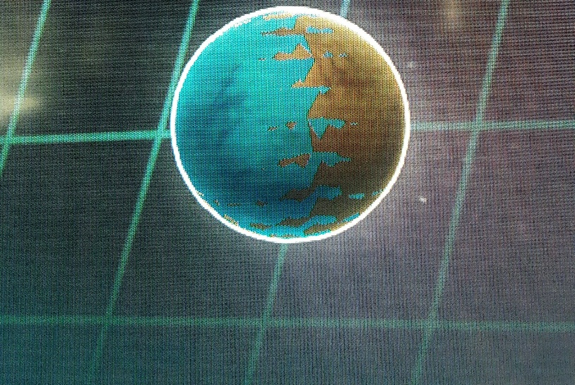

"This polar hemisphere," Creon points to the iced half, "Once held a civilization that built a technological signaling beacon. I think this beacon is what's drawing the insects. There is a hole in the northernmost pole that stretches for miles. It's preserved there and emits wavelengths to pull the asteroid metals. Even if most of it is covered in ice, if it’s still operational then the signal can still leak through planet wide. I think it’s a constant noise the bugs want to silence. The southern desert is their home. Their physiology won't allow them to survive in arctic conditions. In some areas are a dotted arrangement of water oasis. These are made from tunnels the creatures have made all the way to parts of the north where water can travel. Give or take a century or two and they may form a great lake."

"Theysa making the ocean again?" Master Manet asked.

Creon nodded, "I think so. The north was once all water with a few islands. The ancestors of these creatures lived in those depths."

"Do the locals know how it froze?" Kah asked.

Creon shook his head, "No one does."

To be continued in Chapter 2: The Hive Strikes Back and later concluded in Chapter 3: The Return of the Mu.

