- Sit Rep
  - Analysis – Enemy Fleet is comprised of various mercenary vessels. Enemy fleet is led by Light Cruiser MC40, designated, Mern Mern. The enemy fleet has blockaded planet Seraph. The enemy fleet is comprised of a mercenary group of unknown origin.
- Enemy Situation
  - Enemy fleet has taken up a staggered line formation, with target Mern Mern located at a central position. Frigates flank either side and corvettes run picket on the outer flanks.
  - Force Composition
    - 1 MC 40 Light Cruiser
      - Compliment: 1 squadron of E-Wing fighters.
    - 1 Neutron Star Bulk Carrier Conversion
      - Compliment: 1 squadron of Y-Wing Bombers, 1 Squadron R-41 Star Chasers, 1 Squadron Z-95 Headhunters
    - 1 Arquitens Light Cruiser
    - 1 Free Virgilia Bunkerbuster
      - Compliment: 1 Squadron G1-A Fighters
    - 1 Marauder Corvette
    - 1 Vakebeor Frigate
    - 1 Braha’tok Gunship
    - 2 GR-75 Support Transports
    - 1 Action VI support Transport
    - 4 Patrol Gunships
    - 4 AEG Vigo Assault Craft
  - Assumptions
    - Mercenary fighters will abandon post as soon as the odds are against them
    - Enemy fleet will have no reinforcements
    - Enemy Pilots are well trained through combat
- Sit Rep
  - Analysis – Friendly Fleet, comprised of the Imperial 3rd fleet, is inbound to Seraph from Ragnath. Friendly Fleet is flagged by Victory Class Star Destroyer ISN Subjugator. Mission objective is the break the blockade by destroying enemy flagship and fleet.

- Friendly Situation
  - Friendly fleet has taken up an chevron formation, with flagship ISN Subjugator on delayed arrival. Strike class Cruiser Typhoon takes point of formation, flanked by Frigates and Corvettes.
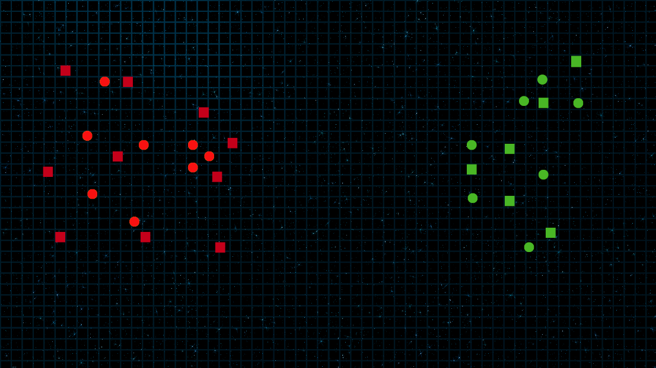

  - Force Composition
    - 1 – Victory Star Destroyer – Subjugator
      - Compliment 1 Squadron TIE Bombers, 1 Squadron TIE Defenders,
    - 1 – Strike Class Medium Cruiser – Typhoon
      - Compliment 1 Squadron TIE Interceptors, 1 Squadron TIE/FO fighters
    - 1 – Lancer Class Frigate – Harpy
    - 1 – Carrack Class Cruiser – Pilum
    - 1 – First Order Light Cruiser – Trident
      - Compliment: 1 Squadron TIE/LN Fighters and 1 Squadron TIE/LN Fighters
    - 1 - Raider-II Class Corvette – Geist
    - 1 – Raider-I Class Corvette – Phantom
    - 4 – VT 49 Decimator Assault Craft.

- Mission Objective
  - Destroy Enemy Cruiser Mern Mern.
  - Destroy, Disable, or otherwise cause remainder of enemy fleet to disengage
  - Destroy Enemy Fighter Screen.
  - Establish Control of Space Near Seraph and Await arrival of 1st Fleet.

- Most Likely Course of Action
  - Friendly fleet, appearing to against a greater force, will draw in the enemy fighters, luring them closer to friendly position and away from Seraph. Friendly fighters will be launched with the sole intention of engaging enemy Y-Wings, thereby protecting larger craft. Fighter group of TIE/FO will be special tasked with engaging enemy E-Wings until support can arrive. Other fighter groups are to engage Z-95s, R-41s, and G-1As Special attention given to Lancer Class Frigate Harpy for anti-starfighter When engaged with the enemy frigates and corvettes, ISN Subjugator, will arrive from hyperspace on delay. Upon arrival, ISN Subjugator will launch fighters. TIE Defenders will escort TIE/SA Bombers to primary target, Mern Mern. ISN Subjugator will engage closest enemy vessel. With Mern Mern Isolated from the remainder of their fleet, TIE Bombers will have a greater chance at effective bombing runs. With combined bombing and focused fire from ISN Subjugator, Mern Mern will be overwhelmed. Support craft will be in engaged with the remainder of the fleet and be unable to pull back to assist. 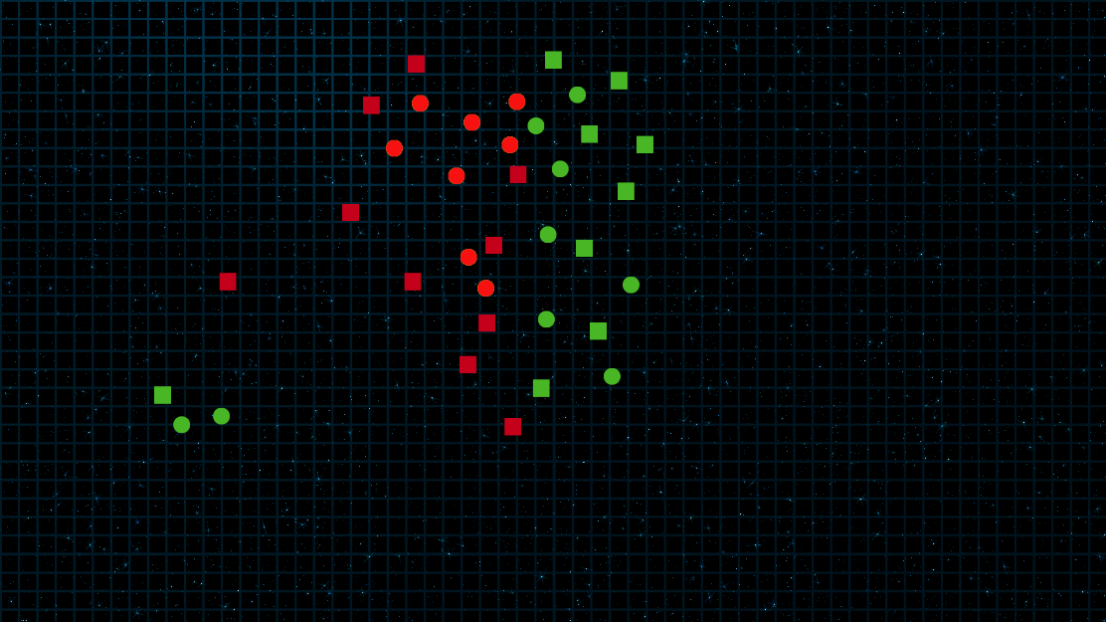

- Most Dangerous Course of Action
  - Friendly fleet arrives simultaneously. All vessels target Mern Mern. Fighters are used only as a screen for capital ships. Friendly fleet attempts to bisect enemy formation. Expect heavy casualties
- Command Heirarchy
  - Flag – ISN Subjugator
  - Fighter Command – TIE Defender – DELTA

